###### https://bwsyncandshare.kit.edu/apps/onlyoffice/s/zwC2DXQ32qbXtRZ?fileId=1620650626 Updates: <https://bwsyncandshare.kit.edu/apps/onlyoffice/s/zwC2DXQ32qbXtRZ?fileId=1620650626>

###### Temporal extension of the datasets (up to now):

|  |  |
| --- | --- |
| **DATASET** | **TIME FRAME** |
| UNIPOL | 2017-2020 |
| ESWD | 1995-2020 |
| LAMPINET:  N strikes - 10km grid  LJ index - 20km grid (for now) | 2014-2020  2016-2018  2015-2020 |
| EUCLID | 2001-2020 |
| OT data | 2006-2020 (??) |
| SPHERA “raw” | 2016-2018 (for now) |
| SPHERA gridded (4 D’Aless. Indices) | 2016-2018 (only 20km, must take10 km and original resolution!) |

###### **PRELIMINAR HAIL CASE STUDY ANALYSIS** (updated 19/11/21)

As a first investigation using SPHERA proxies, OT detections, lightning data (EUCLID/LAMPINET) and UNIPOL/ESSL report cases we decided to consider several case studies of recent relevant hailstorms in Italy, Austria and Germany (Baden-Wurttemberg region) that are:

1. 10 July 2019, central-southern Italy (Pescara hail size record 15cm - <https://www.eumetsat.int/severe-summer-storms-italy-and-greece> )
2. 29 October 2018, Italy (Sardinia) (https://www.lastampa.it/cronaca/2018/10/30/news/maltempo-nubifragi-e-frane-sei-morti-un-disperso-in-sardegna-1.34056226)
3. 4/6/2018 in Parma (Noceto) circa 13UTC, Emilia Romagna, Italy (report ARPAE available)
4. 18/8/2017in Bohringen (Romerstein) 15.35UTC(eswd), Germany (south of Stuttgart)
5. 29/7/2017 in Piacenza (Pontenure) circa 19UTC, Emilia Romagna, Italy (report ARPAE available)
6. 24/6/2016 in Dettingen bei Rottenburg 19.10UTC(eswd), Germany (southof Stuttgart)
7. 4-5 September 2015, southern Italy (https://www.eumetsat.int/massive-storms-over-italy-mediterranean-sea )
8. 28-07-2013 Swabian Sura near Stuttgart, very strong convective thunderstorms with hail that caused very large damages (a paper is going to be written on this specific event considering also large ensemble simulations with ICs and parameters perturbartions to quantify uncertainty in model forecasts for this event) (data are computed with higher temporal resolution (fast scanning) of 5 minutes freq instead of 15). Paper of the event: <https://rmets.onlinelibrary.wiley.com/doi/abs/10.1002/qj.3197>
9. 06-08-2013 Swabian Sura near Stuttgart, hailstorm with record breaking hailstones (14cm)
10. 23 July 2009, Austria (max hail size 10 cm, 833 Million euros insured - <https://de.m.wikipedia.org/wiki/Datei:20090723_Hagelunwetter.svg> )
11. 28–29 June 2006, southwerstern Germany (Supercell thunderstorms, severe damage by grapefruit-sized[[44]](https://en.wikipedia.org/wiki/List_of_costly_or_deadly_hailstorms#cite_note-44) hailstones, causing €150 million damage, more than 100 injuries.) (https://archive.ph/20130212011141/http://www.sueddeutsche.de/panorama/286/374096/text/ )
12. ~~4 August 2002, northern Italy (https://www.eumetsat.int/severe-hailstorm-po-valley-italy )~~OT data not available

9/11/21 + 19/11  
  
Added LAMPINET data to Italian events, + new data received from Kris and OT delta temperature -> events by chronological order:

1. 10 July 2019 - Pescara (central Italy): hail size record 15cm

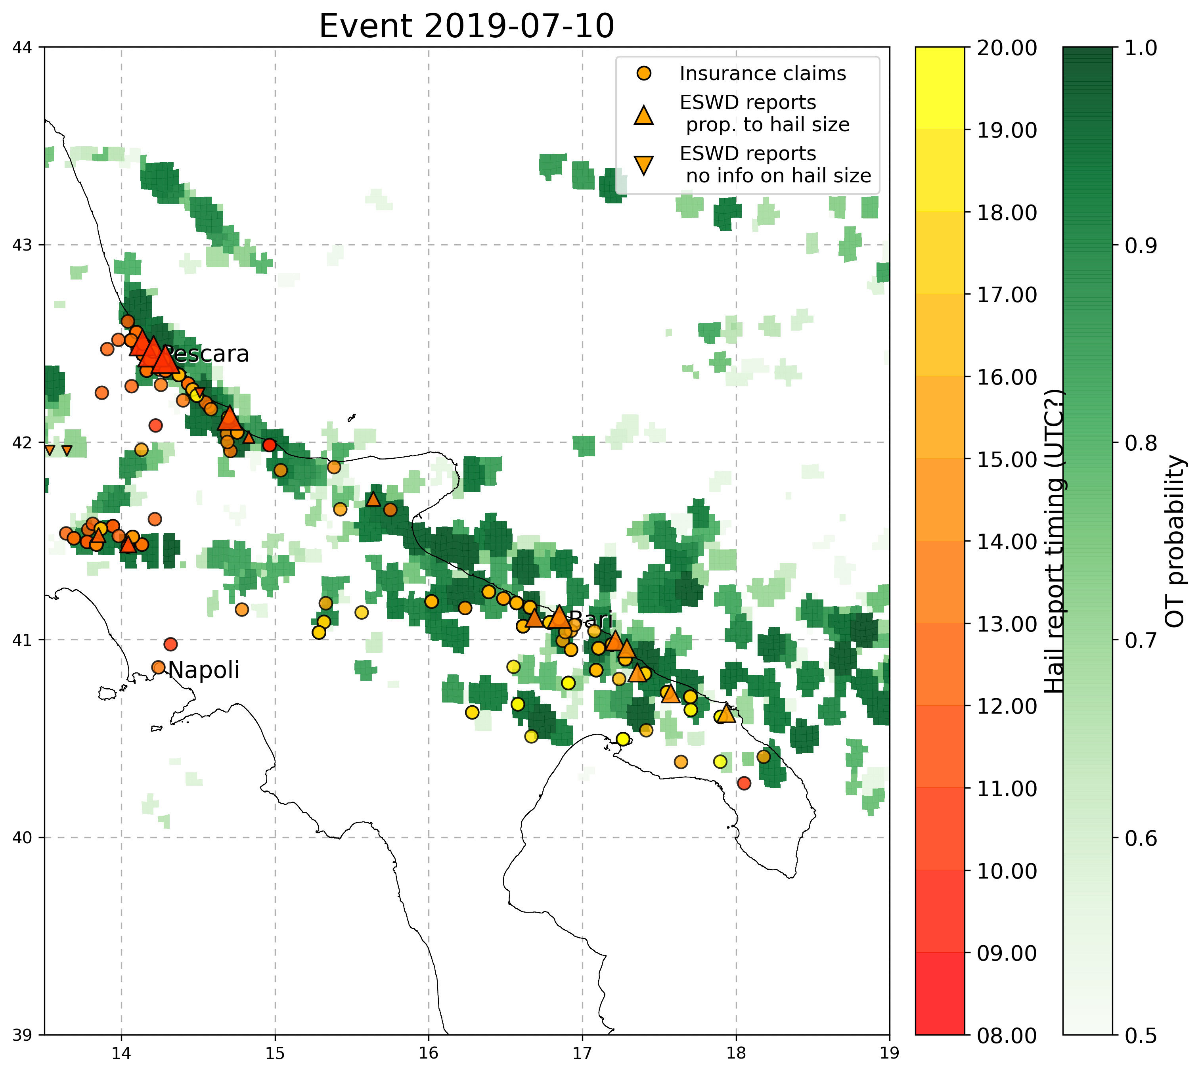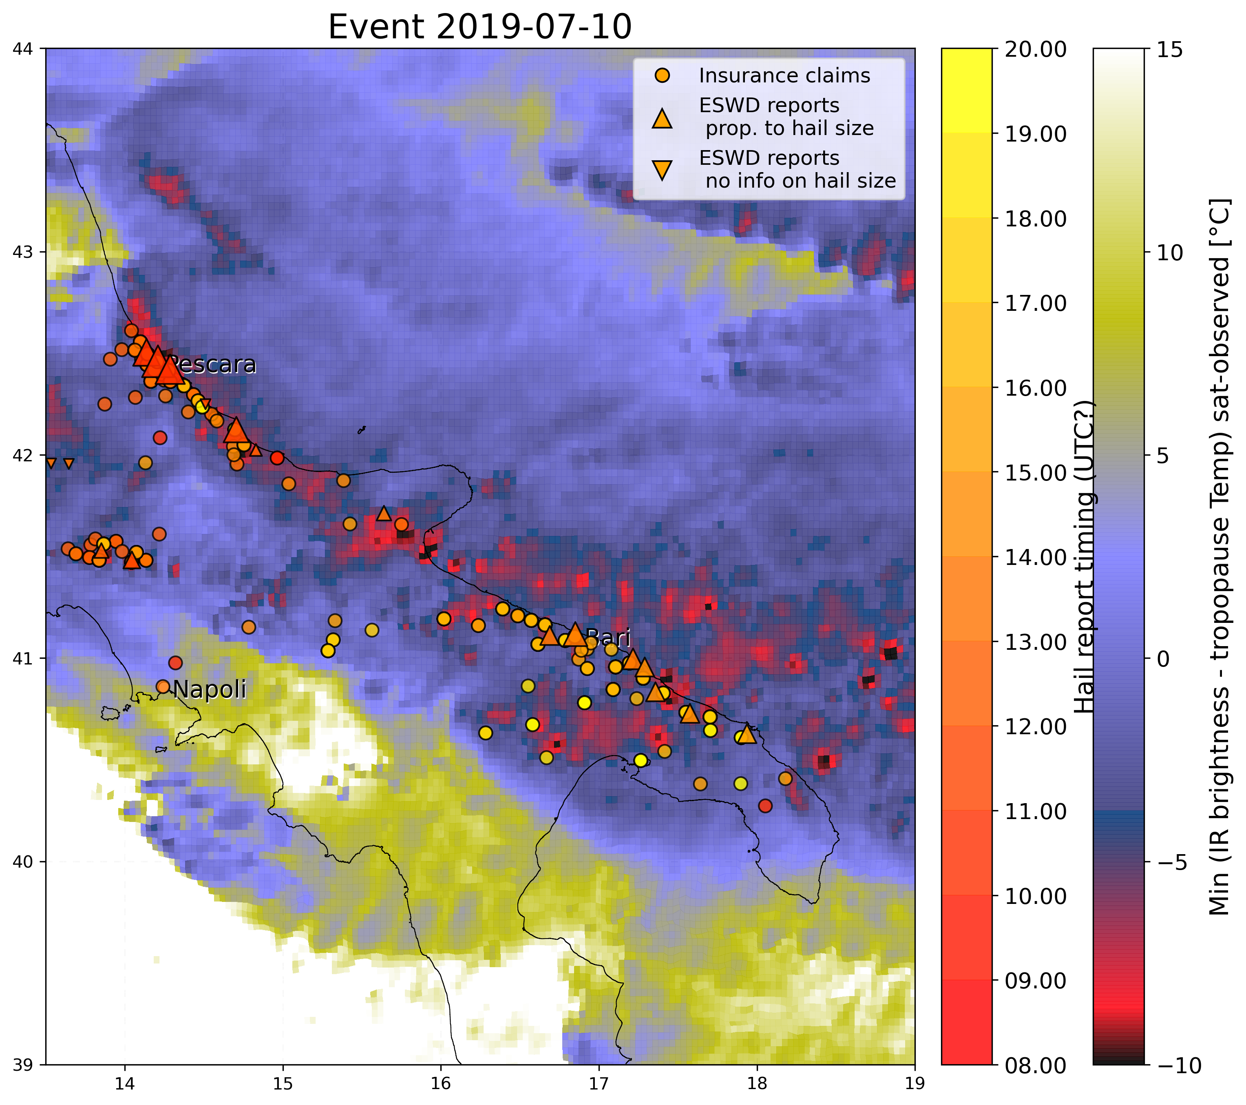

2. 29 **October** 2018 - Sardinia:

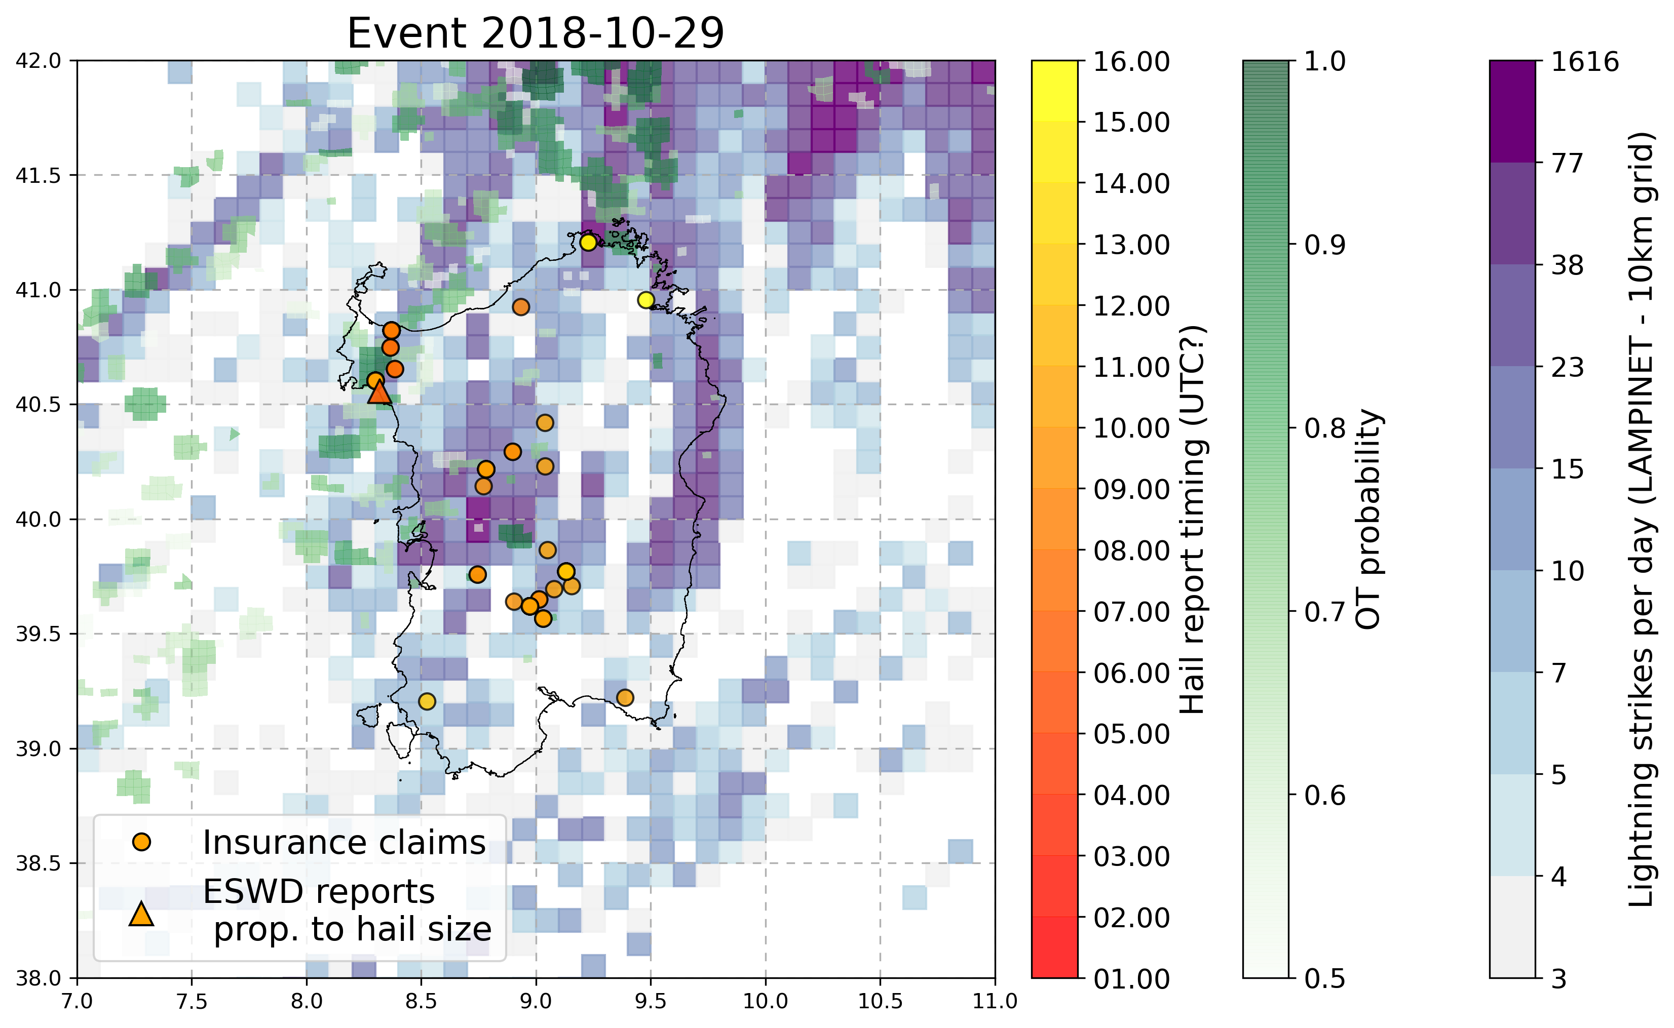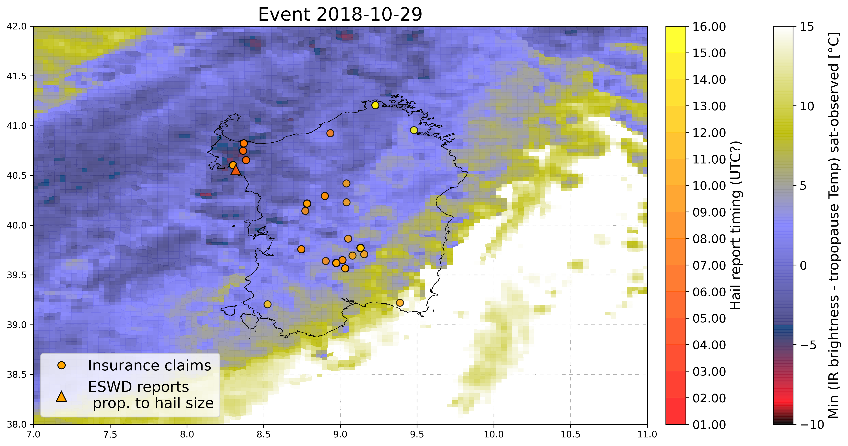

3. 4 June 2018 - Parma, Emilia Romagna Italy

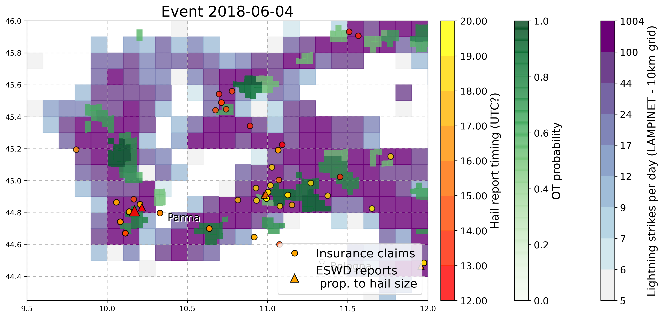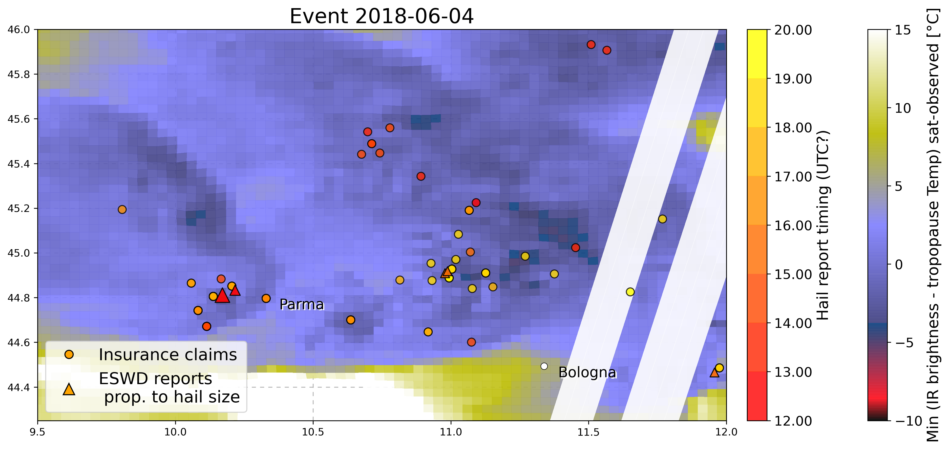

5. 18 August 2017 - Bohringen (Romerstein) SWGermany

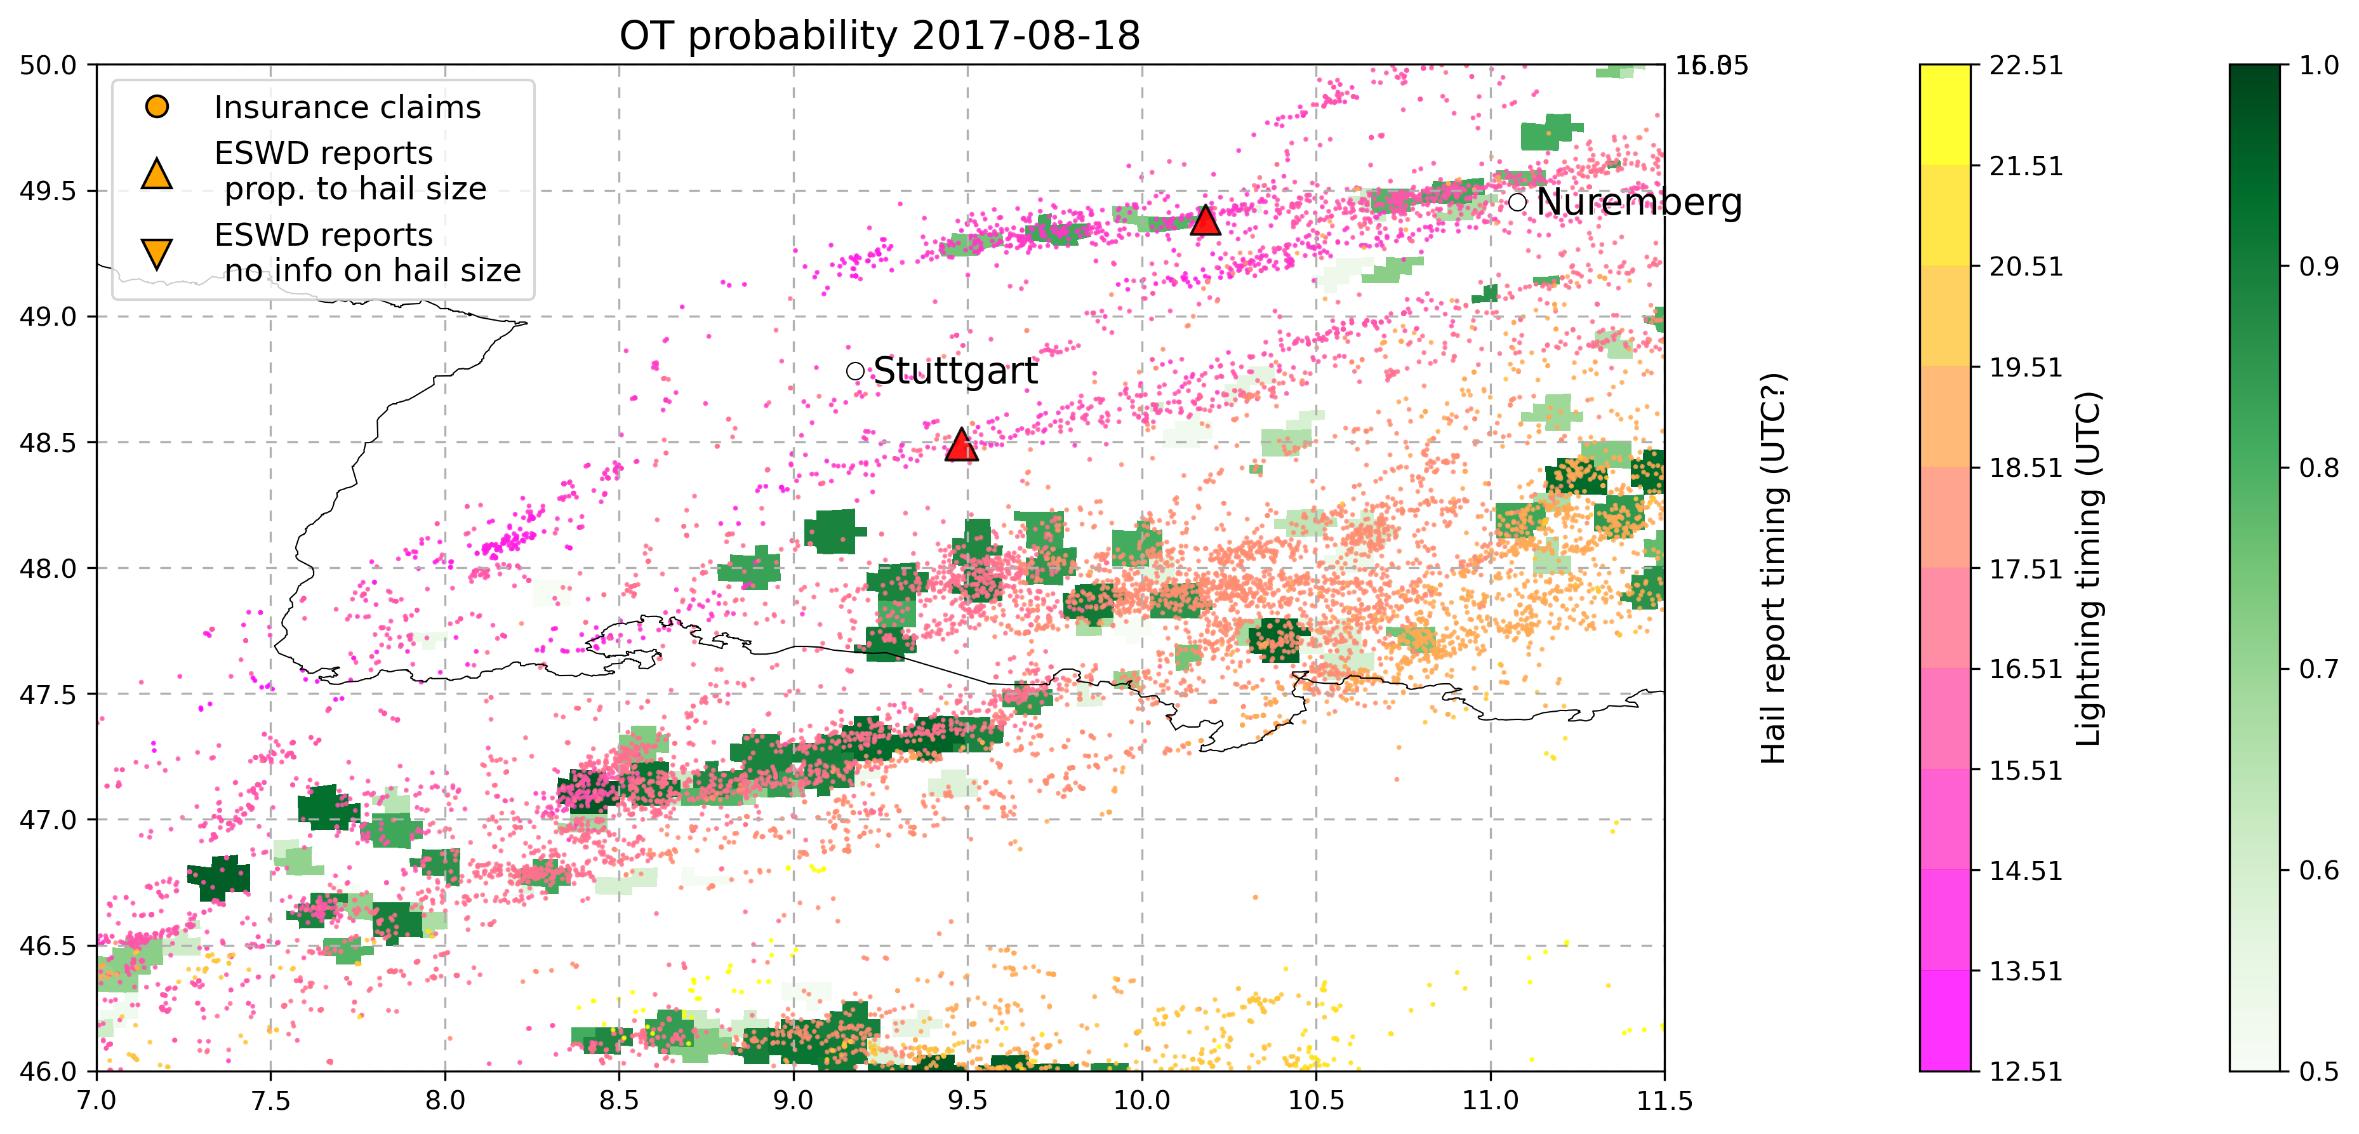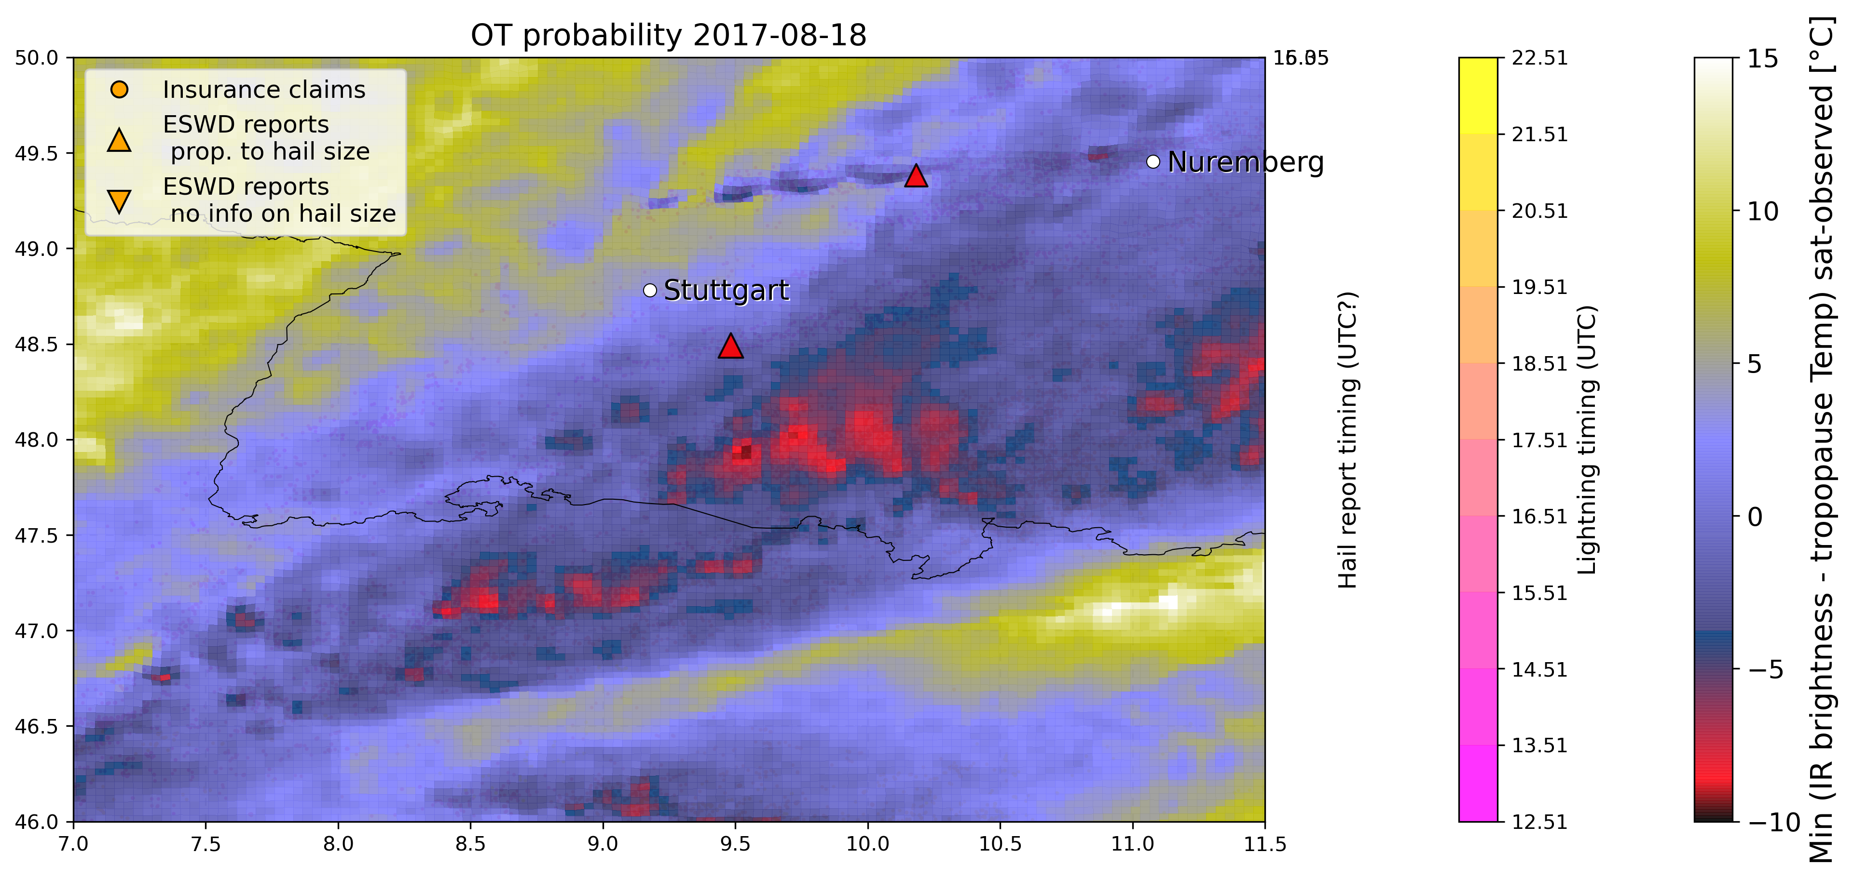

6. 29 July 2017 - Piacenza (Nord Italy)

No eswd nor insurance data available even if the event is well reported in newspapers (https://www.ansa.it/emiliaromagna/notizie/2017/07/29/grandinata-nel-piacentino-allagamenti_bc277294-62b2-464e-a3f0-92030c001810.html), and a well defined OT pattern is very evident coupled with lightning temporal evolution.

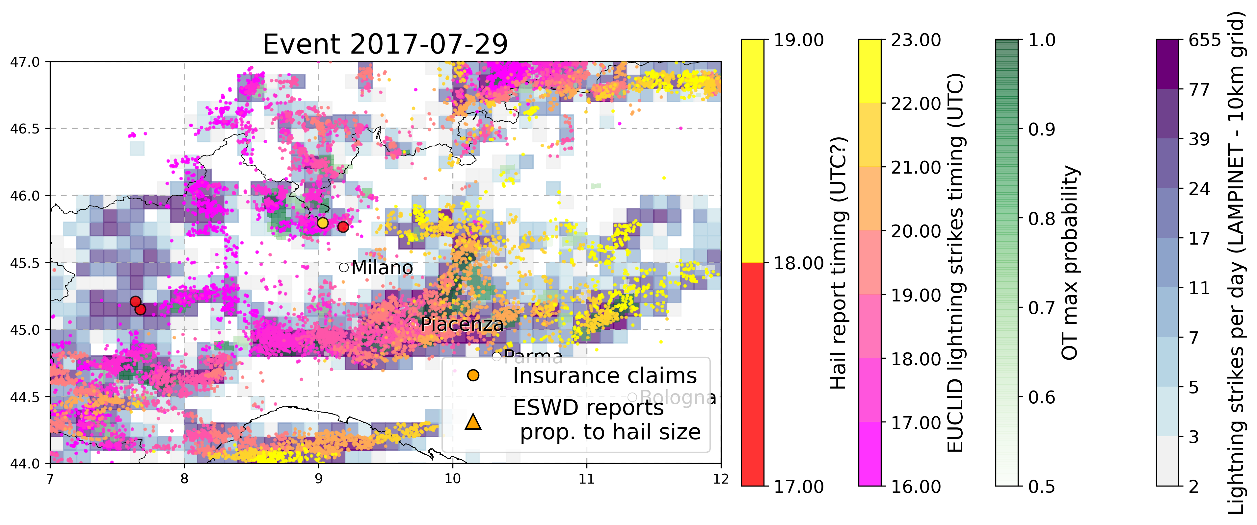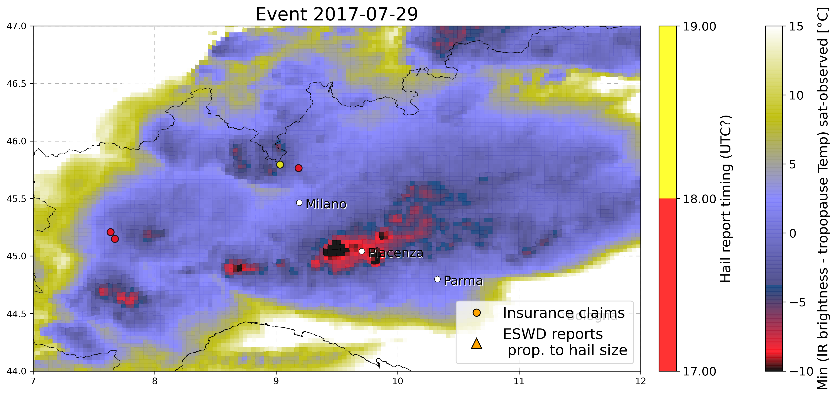

7. 24 June 2016 - Dettingen bei Rottemburg (SWGermany)

Only two eswd reports, still need to add insurance data, OT data MAYBE related to wrong day ?? (julian day of .nc data is 176 while 24 Jun should be 175 - NO it is right as 2016 is a leap year!)

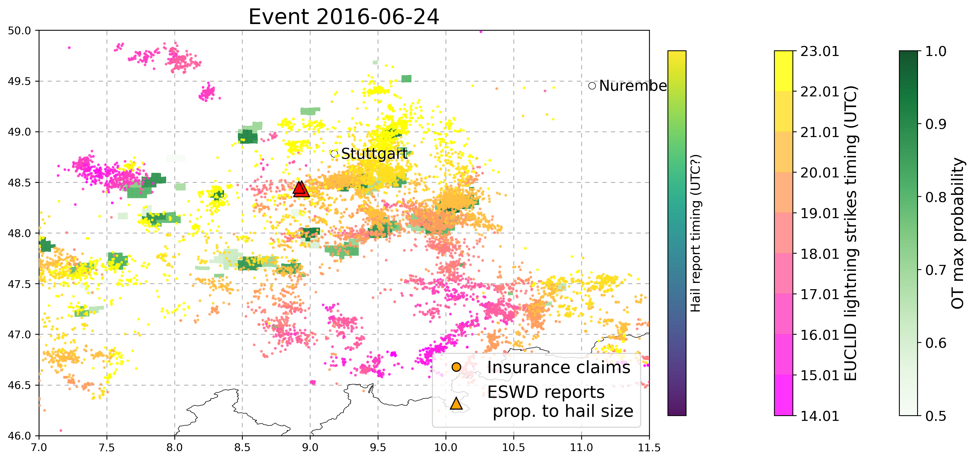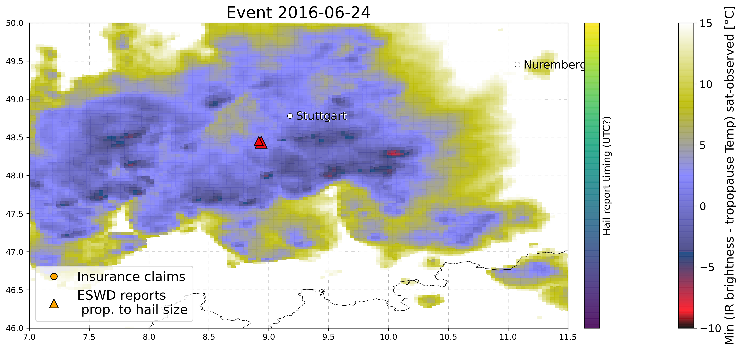

8. 5 September 2015 - Napoli (south Italy)

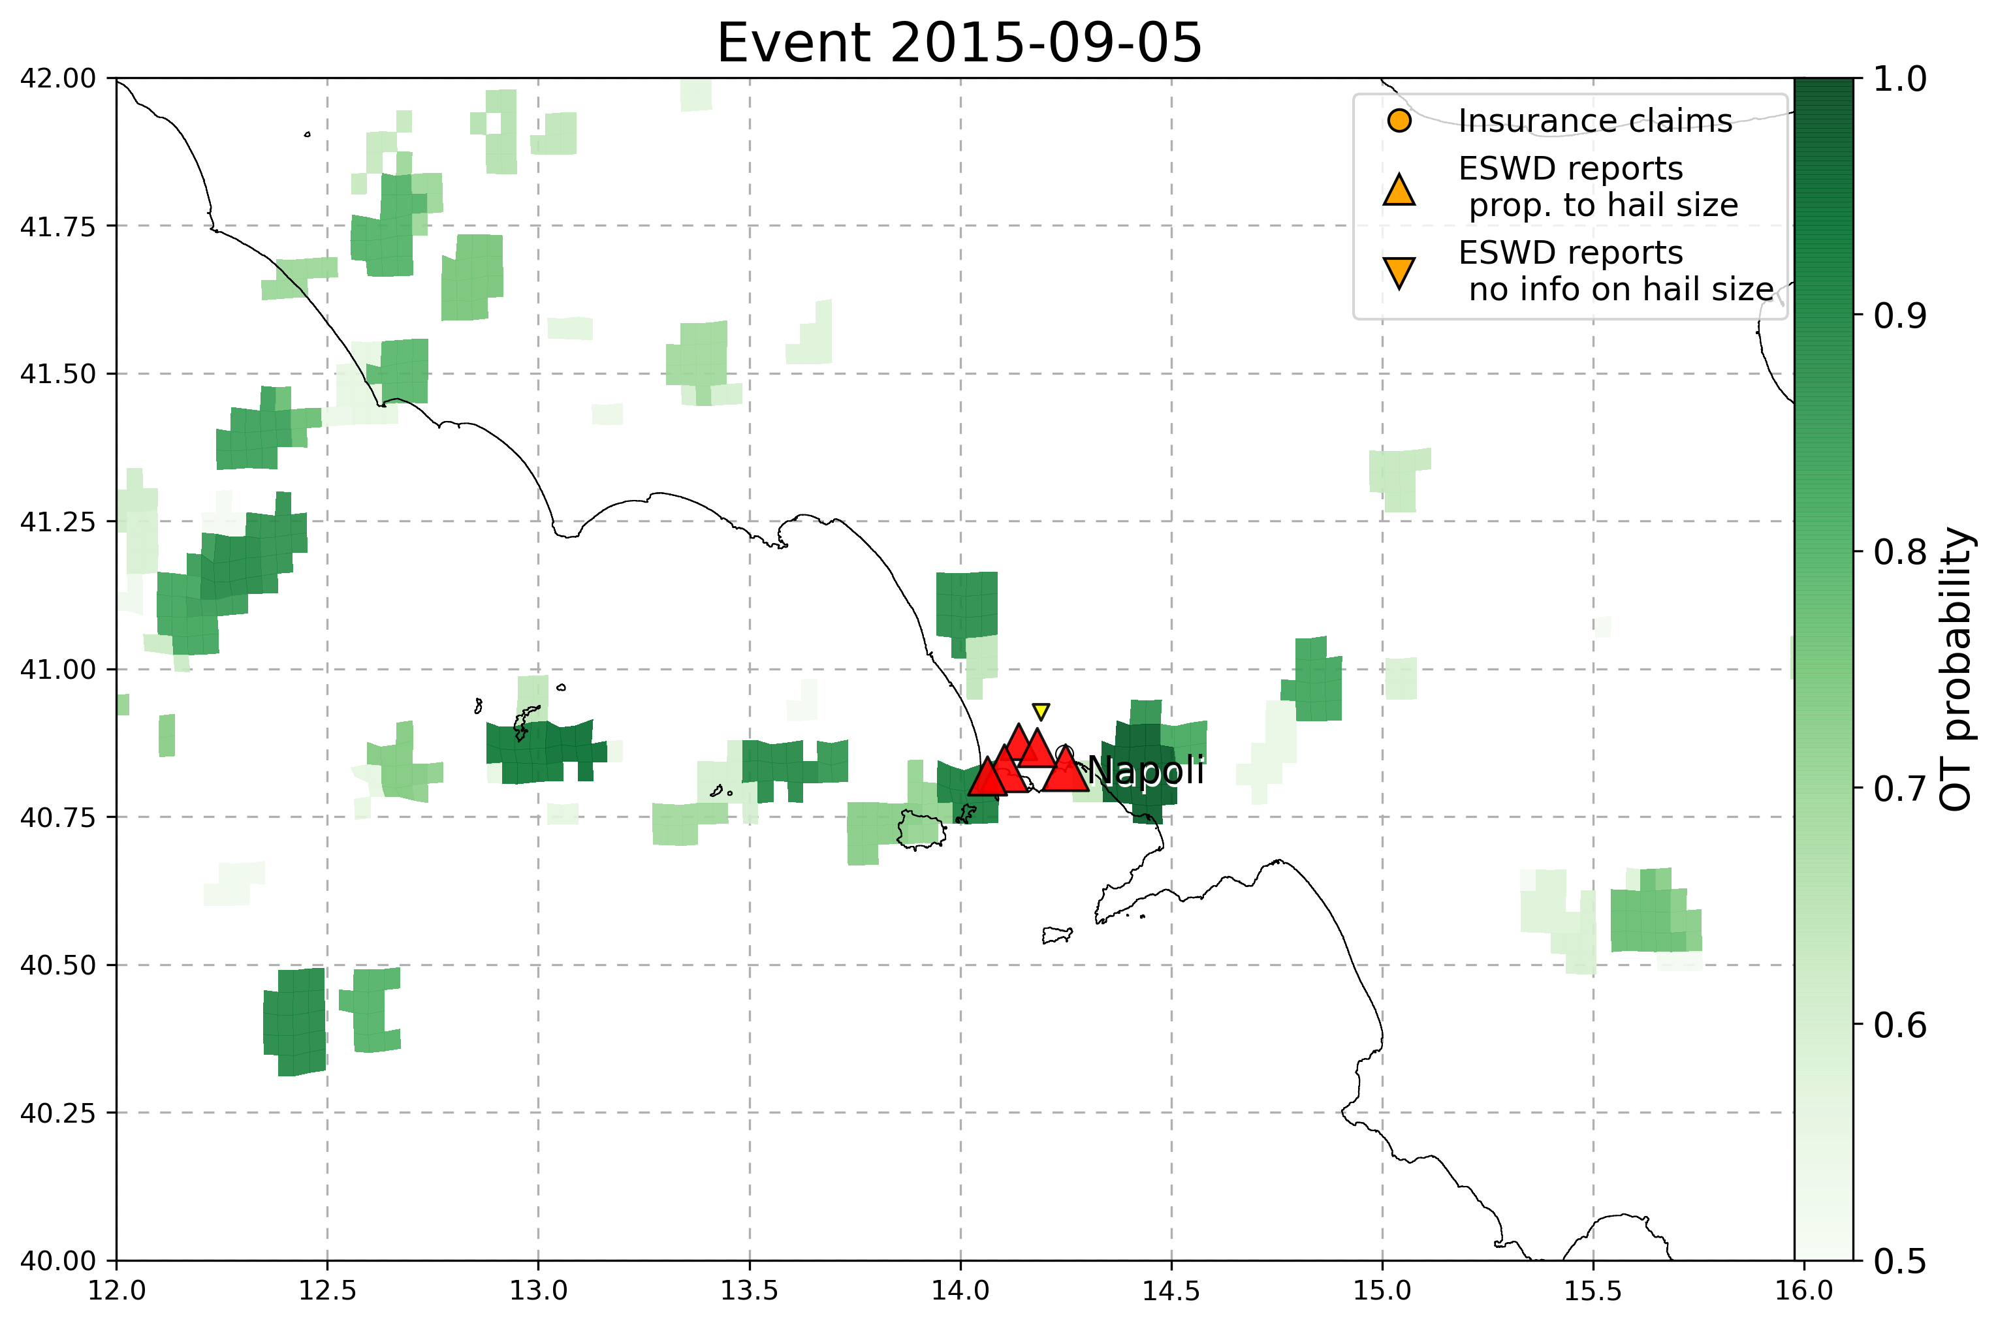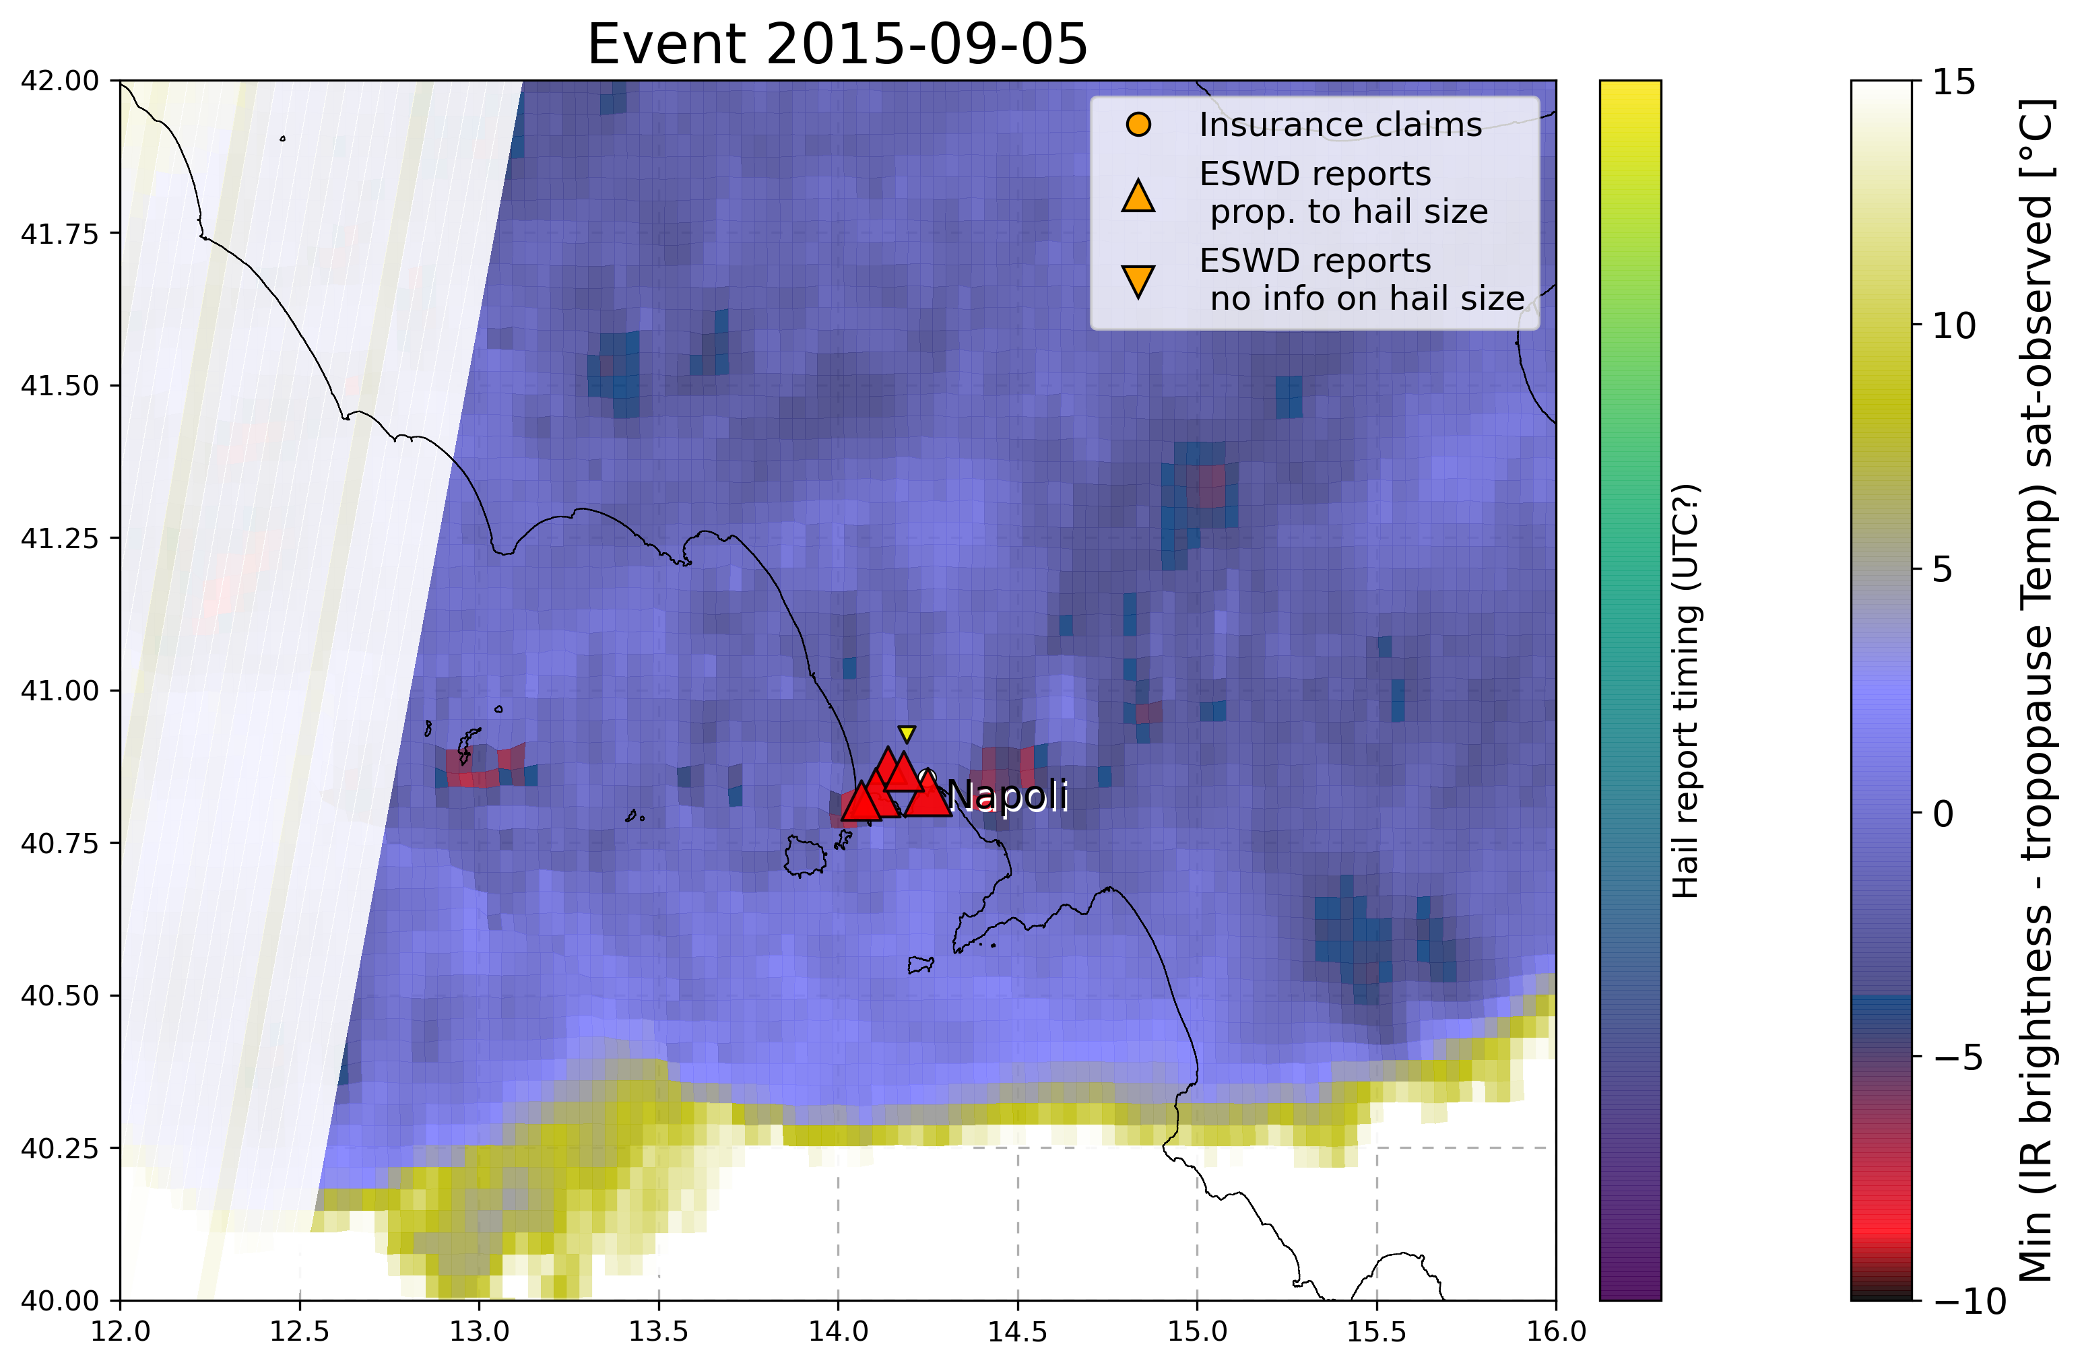

9. 6 August 2013 - Swabian Sura (SWGer) (record hail stones 14cm)  
Not correspondence with lightnings, why?

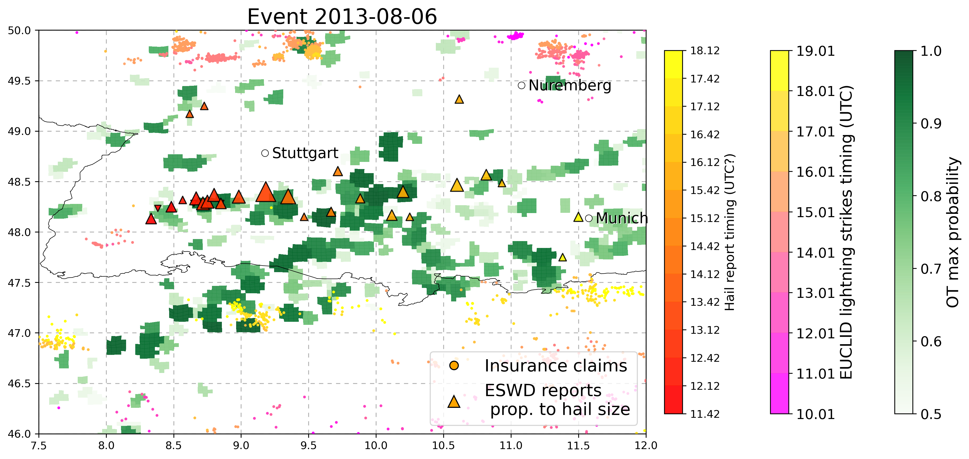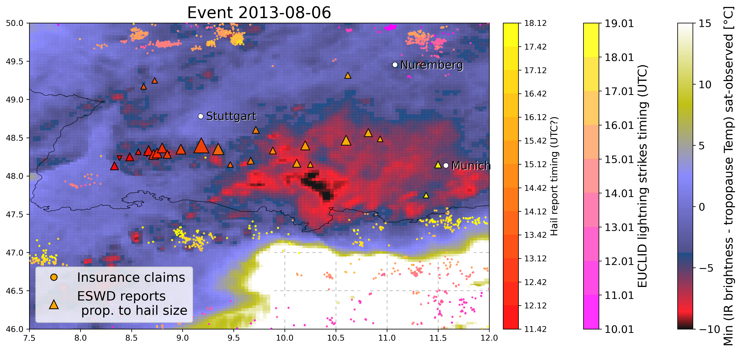

10. 28 July 2013 - Swabian Sura (SWGer)

Good correspondence between eswd, lightning temporal track and OT data! Need to insert insurance data

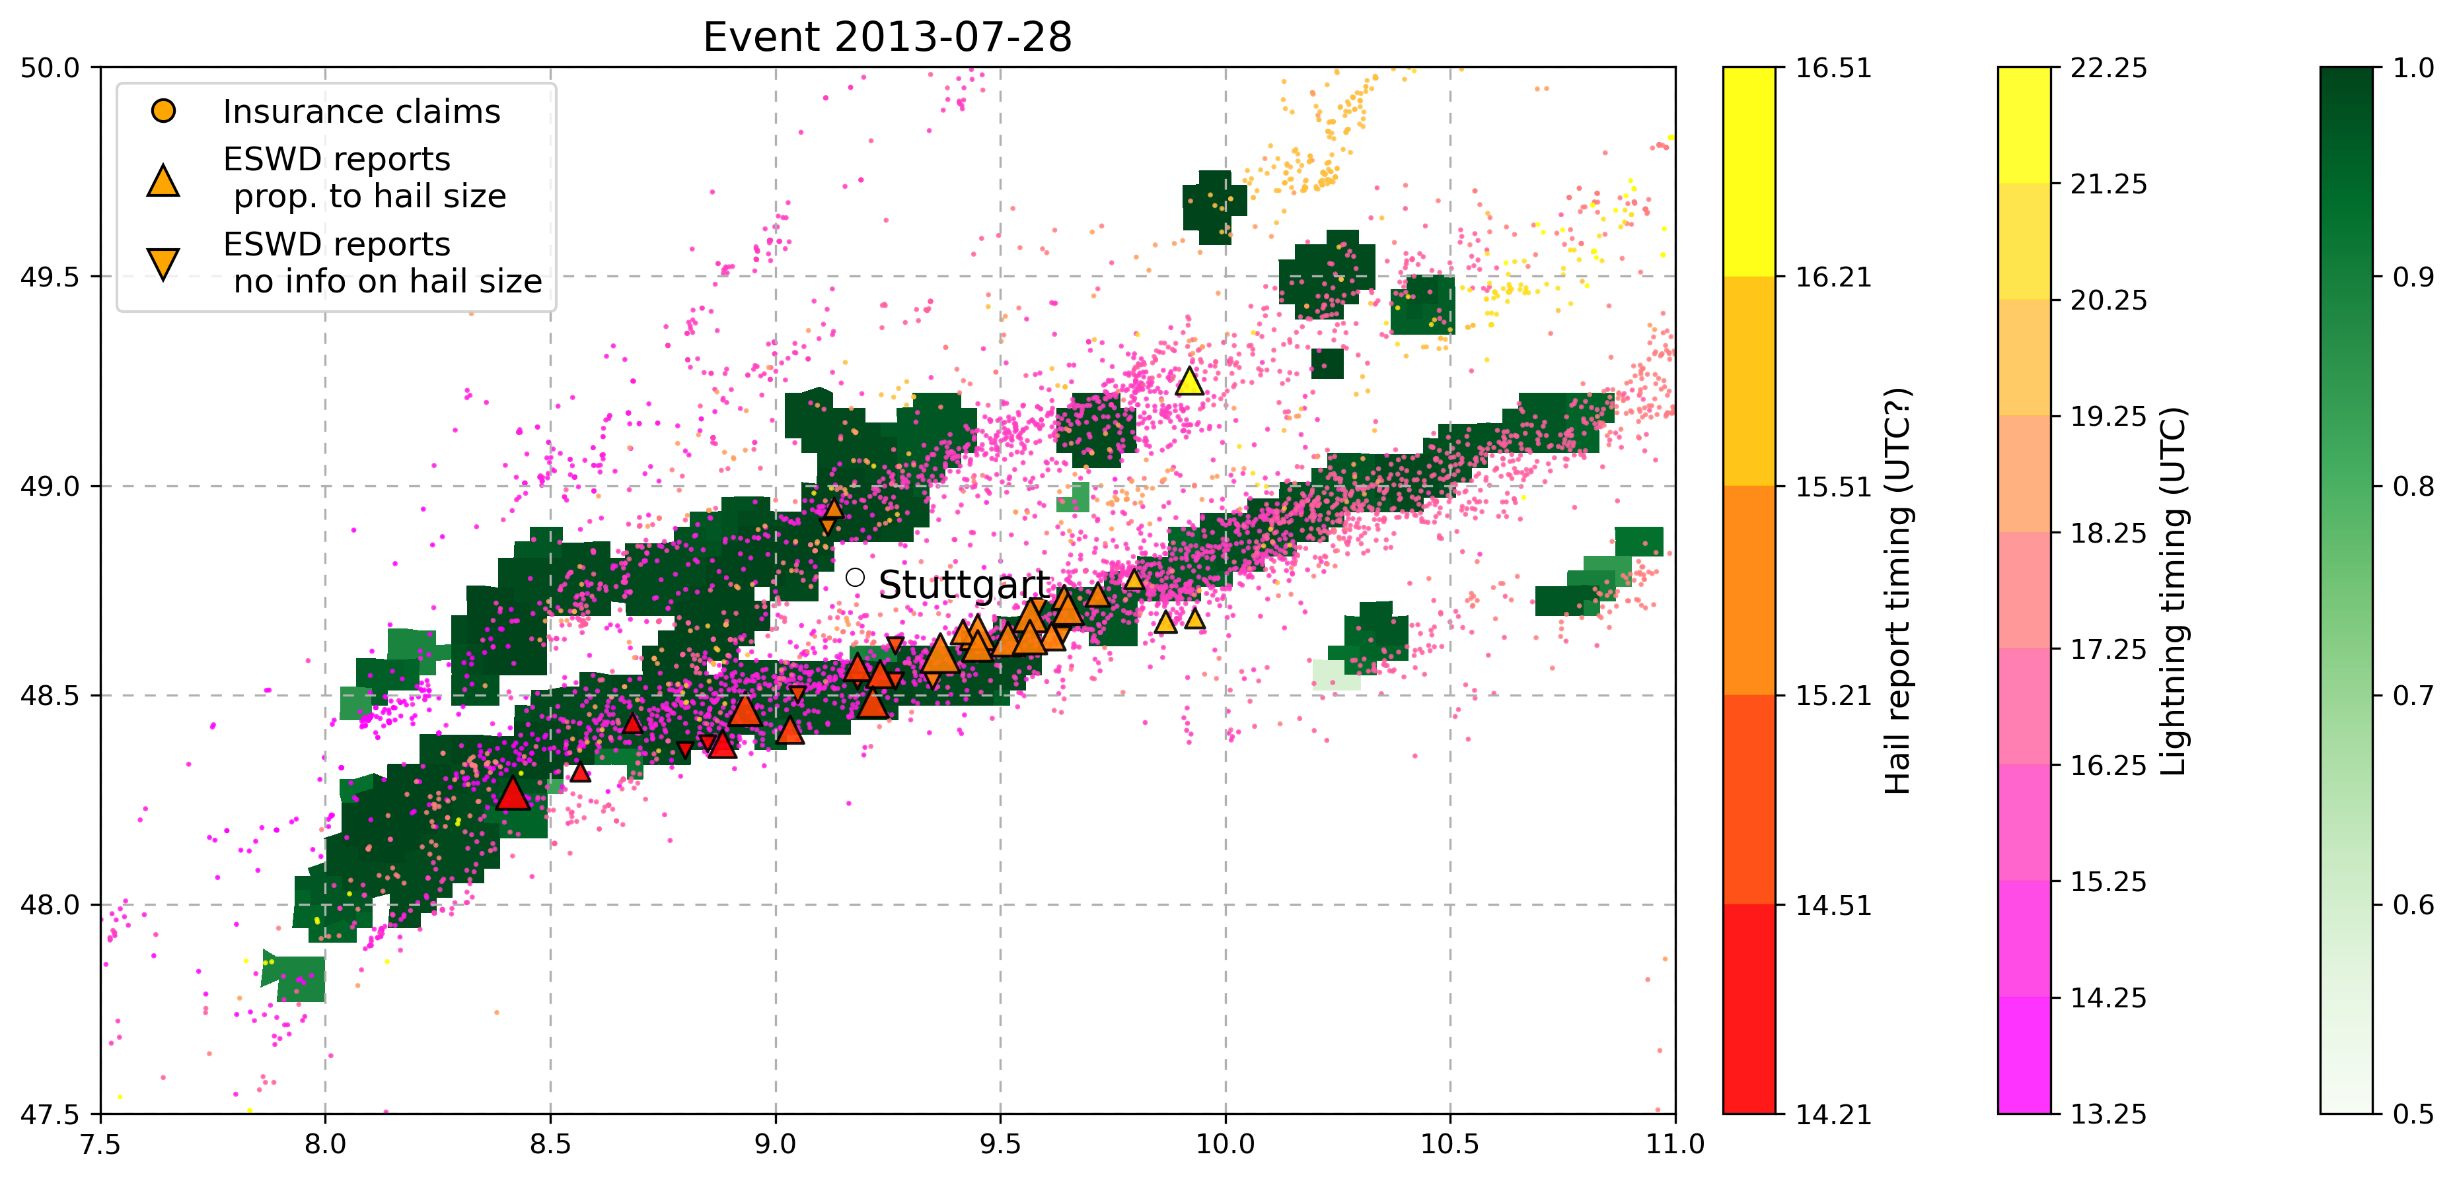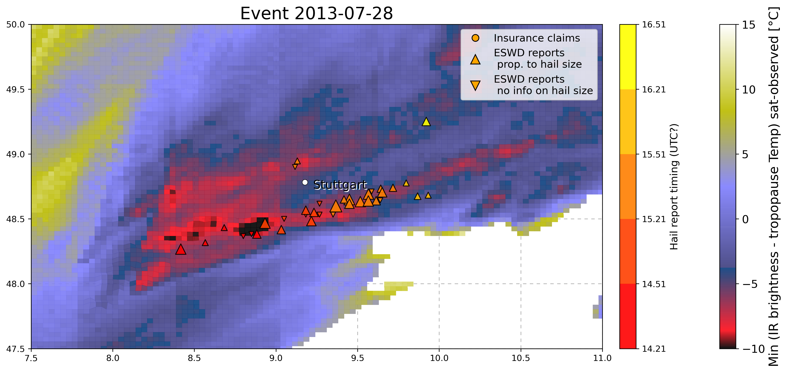

11. 23 July 2009 - Austria (max hail size 10cm, 844 million euros insured)

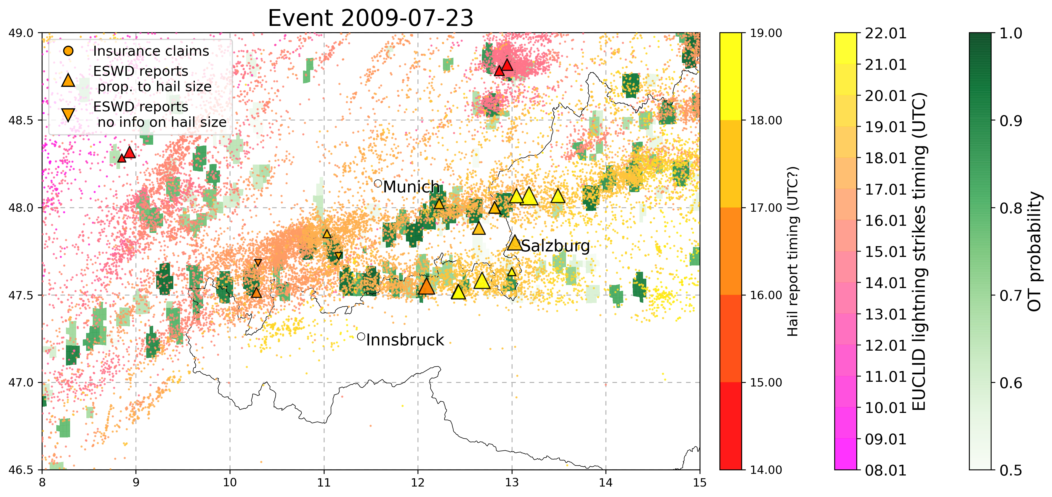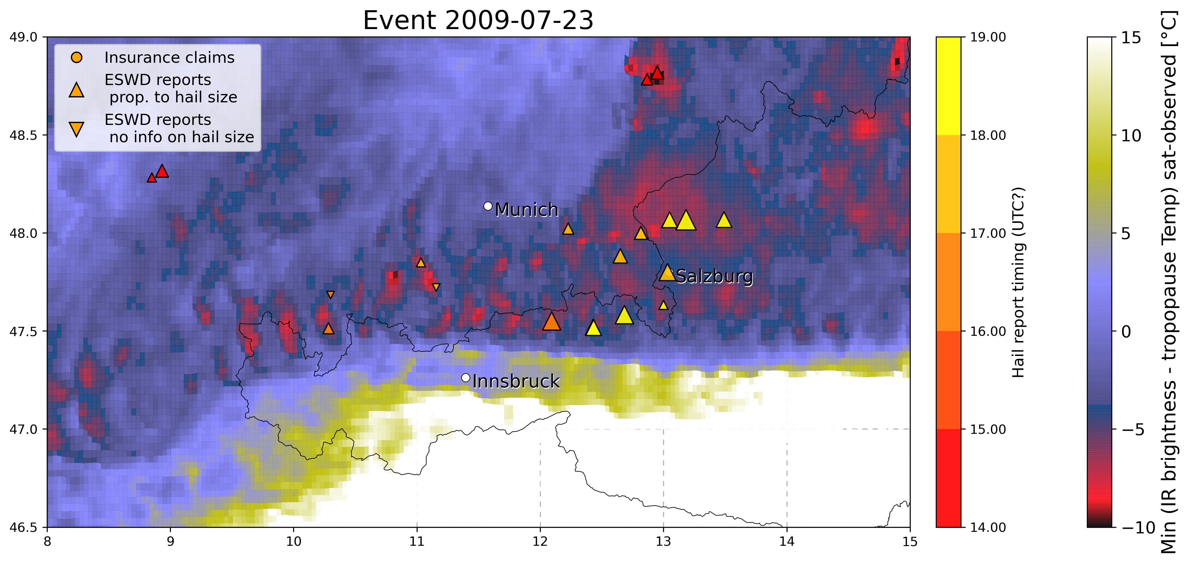

Very nice pattern! Resembles of gravity waves, **why is there some intermittency in the OT/Temp. signal??**

12. 28-29 June 2006 - SWGermany-Austria (150 million euros damage)

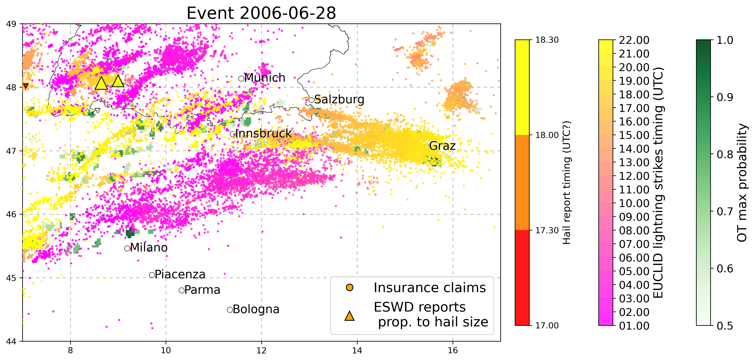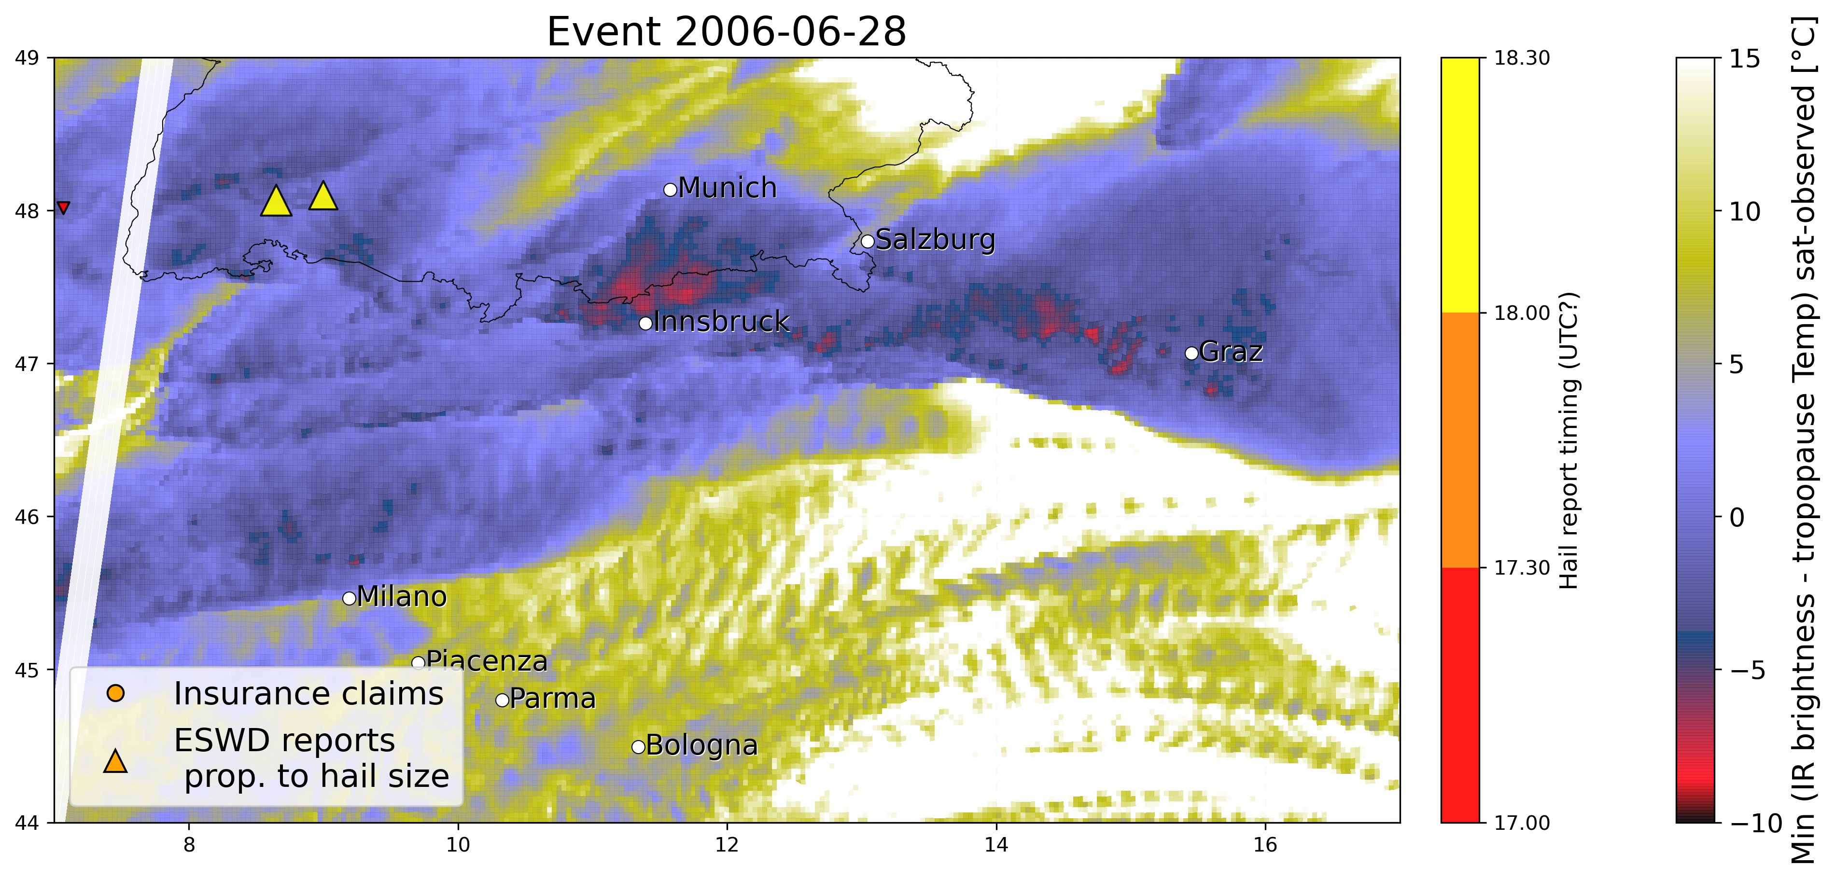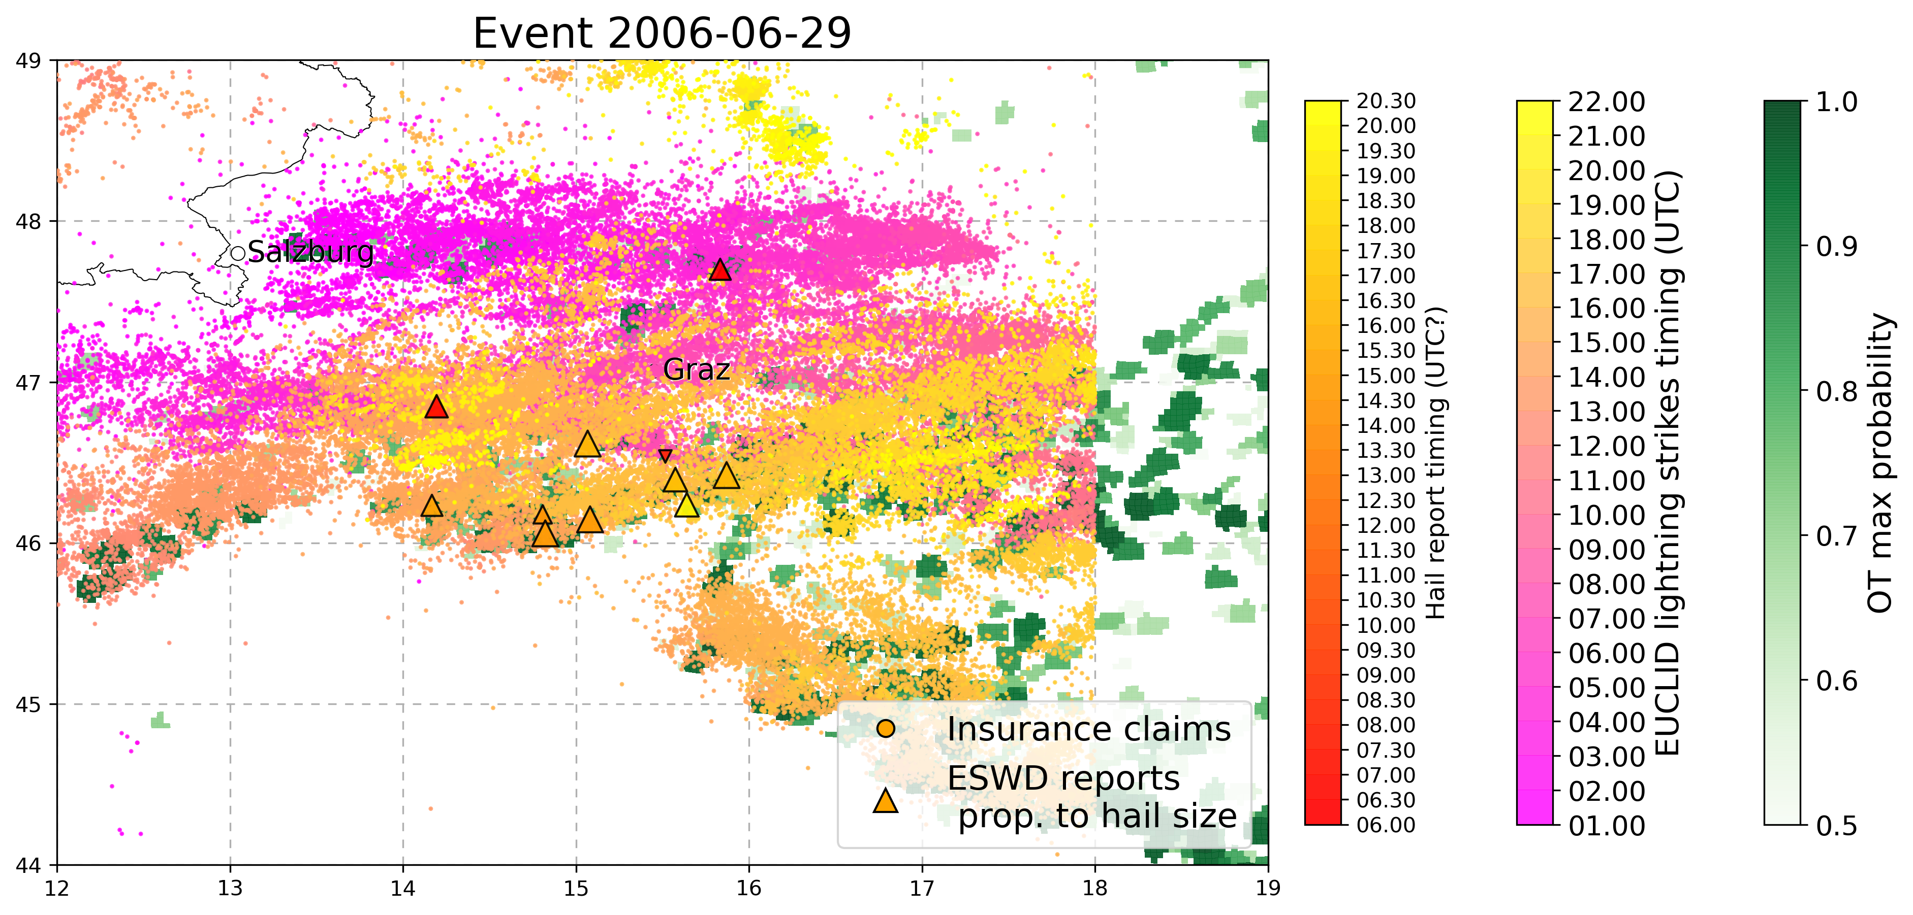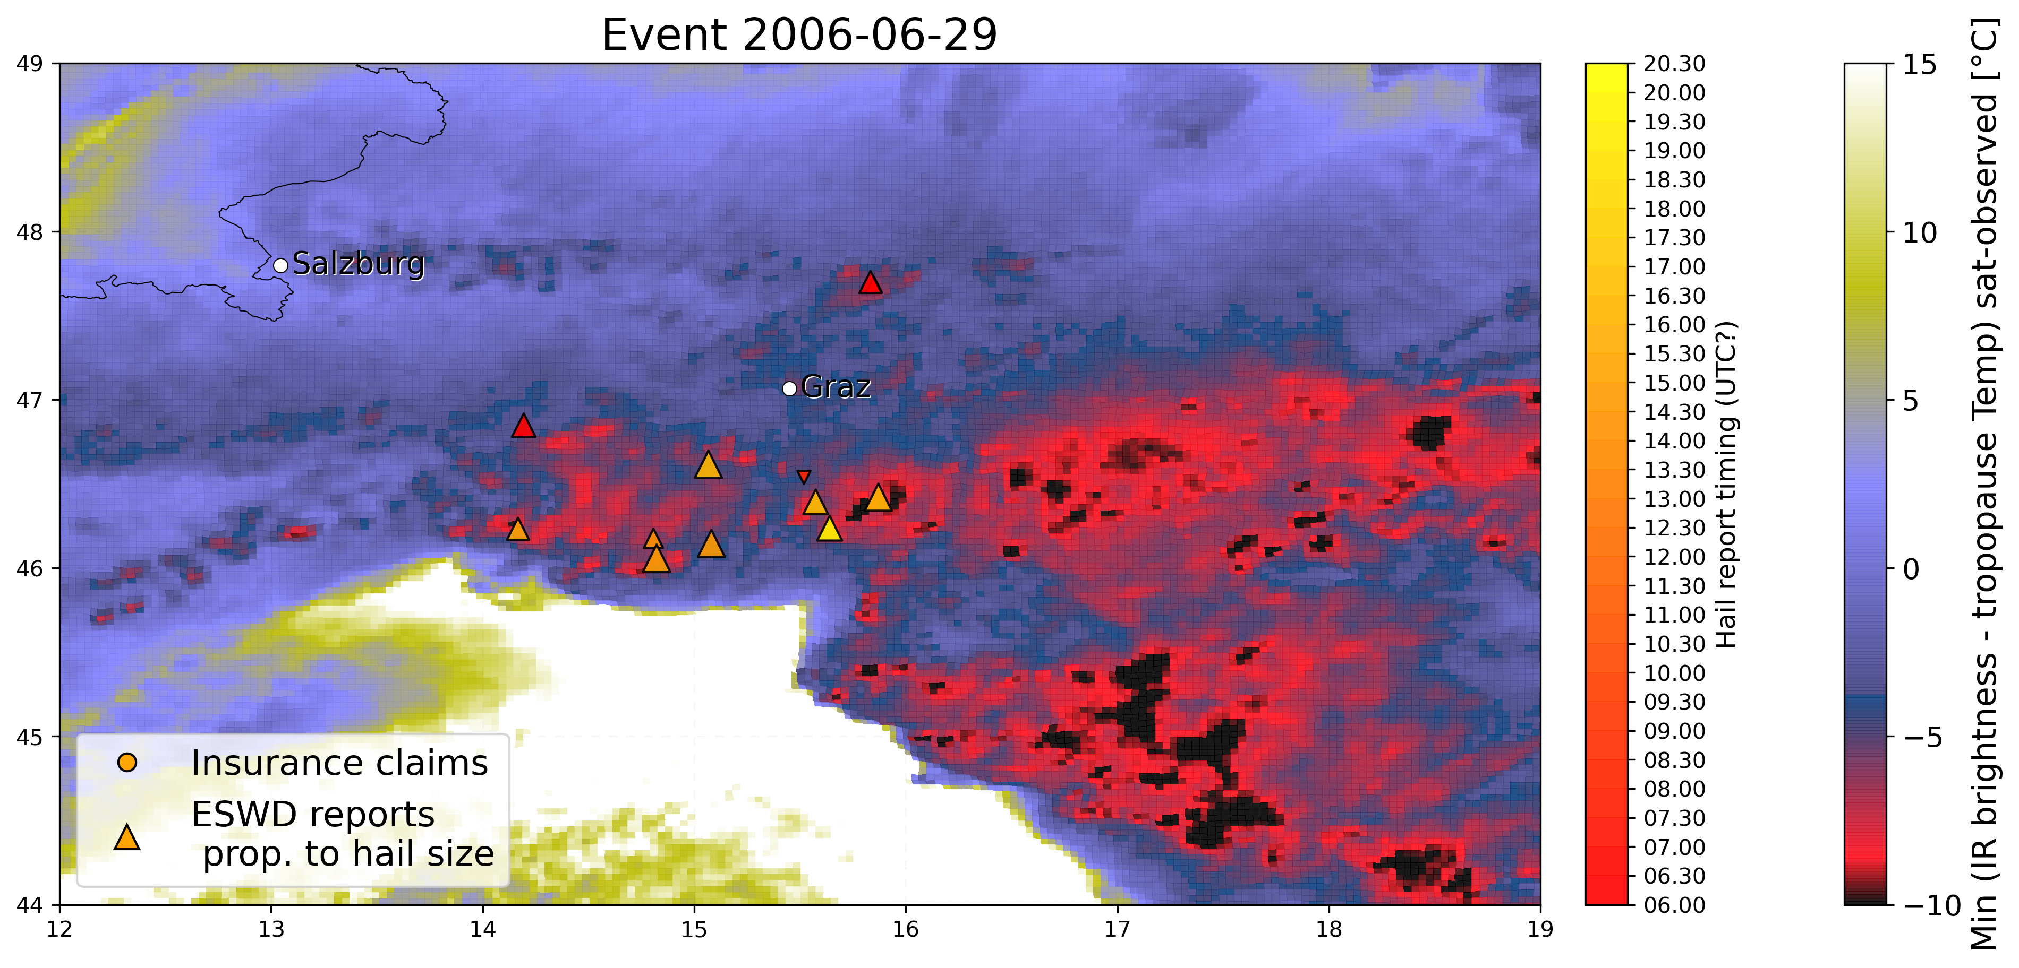

27/10

**OTHER NOTES (meeting with HJ and Michael):**

* Previously similar works were done using reanalysis datasets at 7 and 28 km res.
* Interest also into looking at specific severe hailstorms events with detailed high-resolution on the vertical
* Other interest is also to study in more detail the conditions for triggering of hailstorms as its not well understood, and is not included in the analyses up to now (e.g. Some studies on convergence zones responsible for triggering)
* Must check if we have as SPHERA output convective precipitation (interesting info on how employing for hail studies in a paper from Groenmeijer)
* First investigation with reanalysis after case studies would be to consider SLI in specific cases (instead of CAPE, more valuable SLI info)
* Analysis could be carried on considering “long” summer (April to October) but also considering only JJA to understand if environmental conditions for hail production change very much
* Analysis carried by Markus: cluster analysis on location and season of convective events
* Another possibility in the future would be to use COSMO-DE data at 2.8km resolution as in a previous work many different convective indices (around 60) were computed in analysis mode, every hour for 2011-2016(?), as e.g. Wind shear at 10 different vertical levels instead of the only 0-6 km shear, so would be interesting for a comparison with SPHERA outcomes (especially since using very similar COSMO configuration to quantify the added value of using a reanalysis over an analysis when coming to hail favouring environment description!).
* When HJ will not be at KIT anymore I could ask to Jannik and Susanna for support/guidance given their experience in this field (must meet with them and Michael)
* Kris Bedka for OT data suppliance
* Script avaialble from HJ for estimating matching between OT data and reanalysis proxies by calculation of performance scores, can be found under:  
  /home/punge/scripts/hss_era_nogrid2.py (machine learning appl)  
  /home/punge/scripts/hss_era_grid.py (thresh method without ML)
* HJ: One question will be, whether you focus on the conditions in the location where most of the hail was detected (e.g. 14UTC, south of Stuttgart for event 28-07-2013), or whether to look at the origin of the storm (in this case near Freiburg more like 13UTC). The former is probably more easy to implement.
* Pierre Hasler: analsis on processing of lightning datasets: code almost finished (up to now considering 10x10 km gridded data with 1h temporal resolution) and available to be employed with other datasets, maybe could be useful for post-processing of LAMPINET???  
  Presentation will follow soon
* HJ: suggestion for when moving to reanalysis + hail obs verification: when checking rean. proxies on grid construct a filter to retain only those cells where there is at least 1 insurance/eswd report and compare the results with or without the filter

**10/11/21 MEETING WITH Michael & Kris:**

* Kris: besides OT detections data suggests to use also **Infrared (cloud top) - Tropopause Temp** to get info on the strenght of the storm -> target little cold spots in the entire anvil area and assign a score of how likely they are. In the scripts: used MINIMUM dTemp (infrared brightness - tropopause), why minimum? →because it’s a negative DeltaT if OT is present (lower temperature on top of OT cloud (infrared brightness temp) than tropopause)
* Am I using parallax correction to get satellite data distributed on the right places? -> YES: when plotting e.g. OT max prob. I use cpclon,cpclat coordinates (corrected for parallax displacement of satellite data)
* Kris: for OT probability dont consider values **< 0.5%** -> as they could be related to anvils not well linked to updraft -> Kris could send a paper of a recent validation justifying this threshold (Request it!)
* No problem for having OT data for the 3 years period (2016-2018) over SPHERA domain as it’s pretty small -> just let know Kris when I am ready to use the data and he will provide us
* Kris: filter developed by HJ used thresholds in order to retain all legitimate thunderstorms (i.e. Eliminate storms that there’s no way the could generate hail) VS focusing on likely-hail generating storms, that is quite different, and that is what also Kris and his group are doing for US with random forest ML approach. Both approach are valid but depend on the application
* Since my application is for agricultural hazard assessment, Kris strongly reccomends to use also their data developed with **Passive Microwave Imagers:**

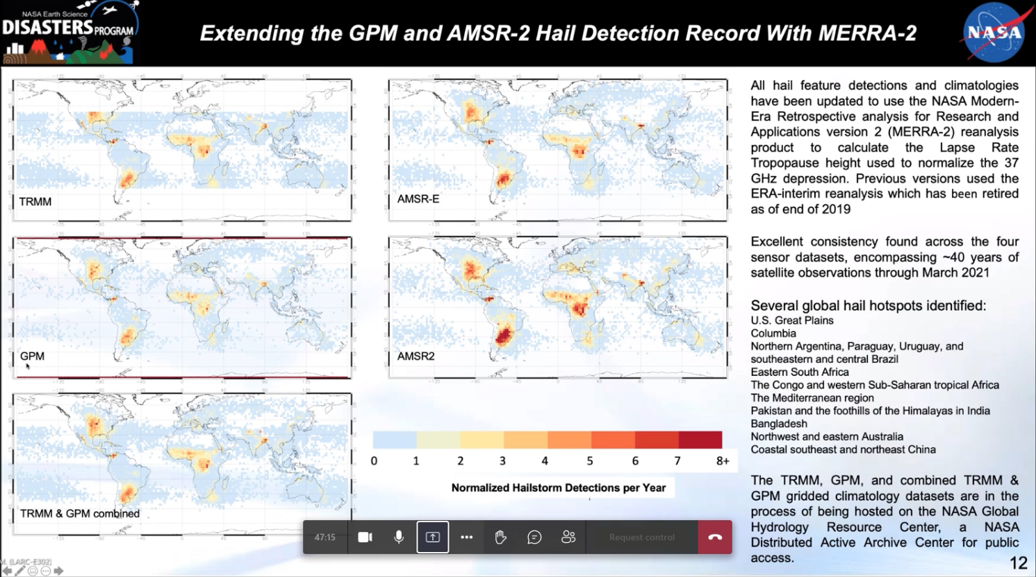

These are global gridded climatologies, with grid steps of 2°, of hailstorm detections per year. It could be useful to take the data-based individual detections over the years and plot them over SPHERA domain maps, to see with this view of hailstorm (that is more robust than geostationary satellite view of hailstorms) how hail detections line up with respect to agricultural applications. I could access these datasets as a collaborator of Michael for free. HJ used them in the South Africa paper. Reference of these datasets: 2019-2021 papers (ask Kris) documenting how they developed these data, the method, and so on BUT still few applications has been made SO it would be very interesting to use these data in my analysis!! -> Just let know Kris if I am interested in that and he will provide them!

Some specs: Obtained from processing over 40 satellite years of convection with different datasets: TRIMM (but does not cover Italy entirely), GPM (2014-present), AMSR-E(died in 2011 circa), AMSR2 (2012-present). AMSRs are sun-syncrhonized (i.e. Only view at 1.30 am and pm), while TRIMM and GPM are ..?? So obs are obtained at random time throughout the day, so you have to be lucky to detect hail events. Coarse resolution of 2° is not related to the satellite data but to the fact that in some regions there are so few passages, so in order to not having data with so much noise is better to keep a lower resolution. From maps:Noticeable is a local maximum in the Mediterranean region

17/11

**SPHERA DOMAIN**: sphera original domain is = COSMO 2I domain (i.e. Includes southern-Germany area) but PROBABLY some grid points were deleted near the borders (around 25 grid point, circa 50km) to avoid border effects (some problems were detected in France alpine area and Dalmazia, but NOT in Germany) -> Checked various original variables as extracted from ECWMF: S Germany included! The problem is in the data gridded (probably to be consistent with more limited LAMPINET domain)

19/11 **MEETING WITH HJ**

* **Hail climatologies from passive microwave imagers:** used a little for South Africa case in a comparison with OT dataset (look at preprint: Michael sent me pdf). Compared to OT data we capture an higher number of events, especially those events with small hail related to thunderstorm not reaching the top of the troposphere (no OT), while with microwave imagers the ice in the atm is detected so it’s easier to not lose events (despite the problem of passing by of the satellite).
* Why minimum in delta T (IR brightness - tropopause temp) to quantify strenght of storm? -> because we are seeking for negative values of this deltaT, meaning an OT colder than environment (i.e. IR brightness temp < tropopause temp), and **the minimum represent the value in which we have the maximum OT extension** (higher temp difference between OT top and tropopause)
* Start to look at sub-daily temporal scales (hourly) with the available data!!
* Study more convective proxies!!:
  + **LI**: must take the minimum not max!! Anything below 0°C is relevant for convection, for strong events reach -10°C
  + **Kindex**: based on temperature differences to quantify atm instability, take max values (the stronger the temperature gradient the stronger the storm). To get some typical values: paper from 2007 Michael (https://nhess.copernicus.org/articles/7/327/2007/), useful also for typical values of many other indices!. E.g comment for the Piacenza case: larger values of 36 °C in almost entire area, indicating that instability conditions in the atmosphere were present in the region so that there was potential for thunderstorm development, but this is only one ingredient not sufficient alone, so it happened in a place where other conditions were fullfilled.

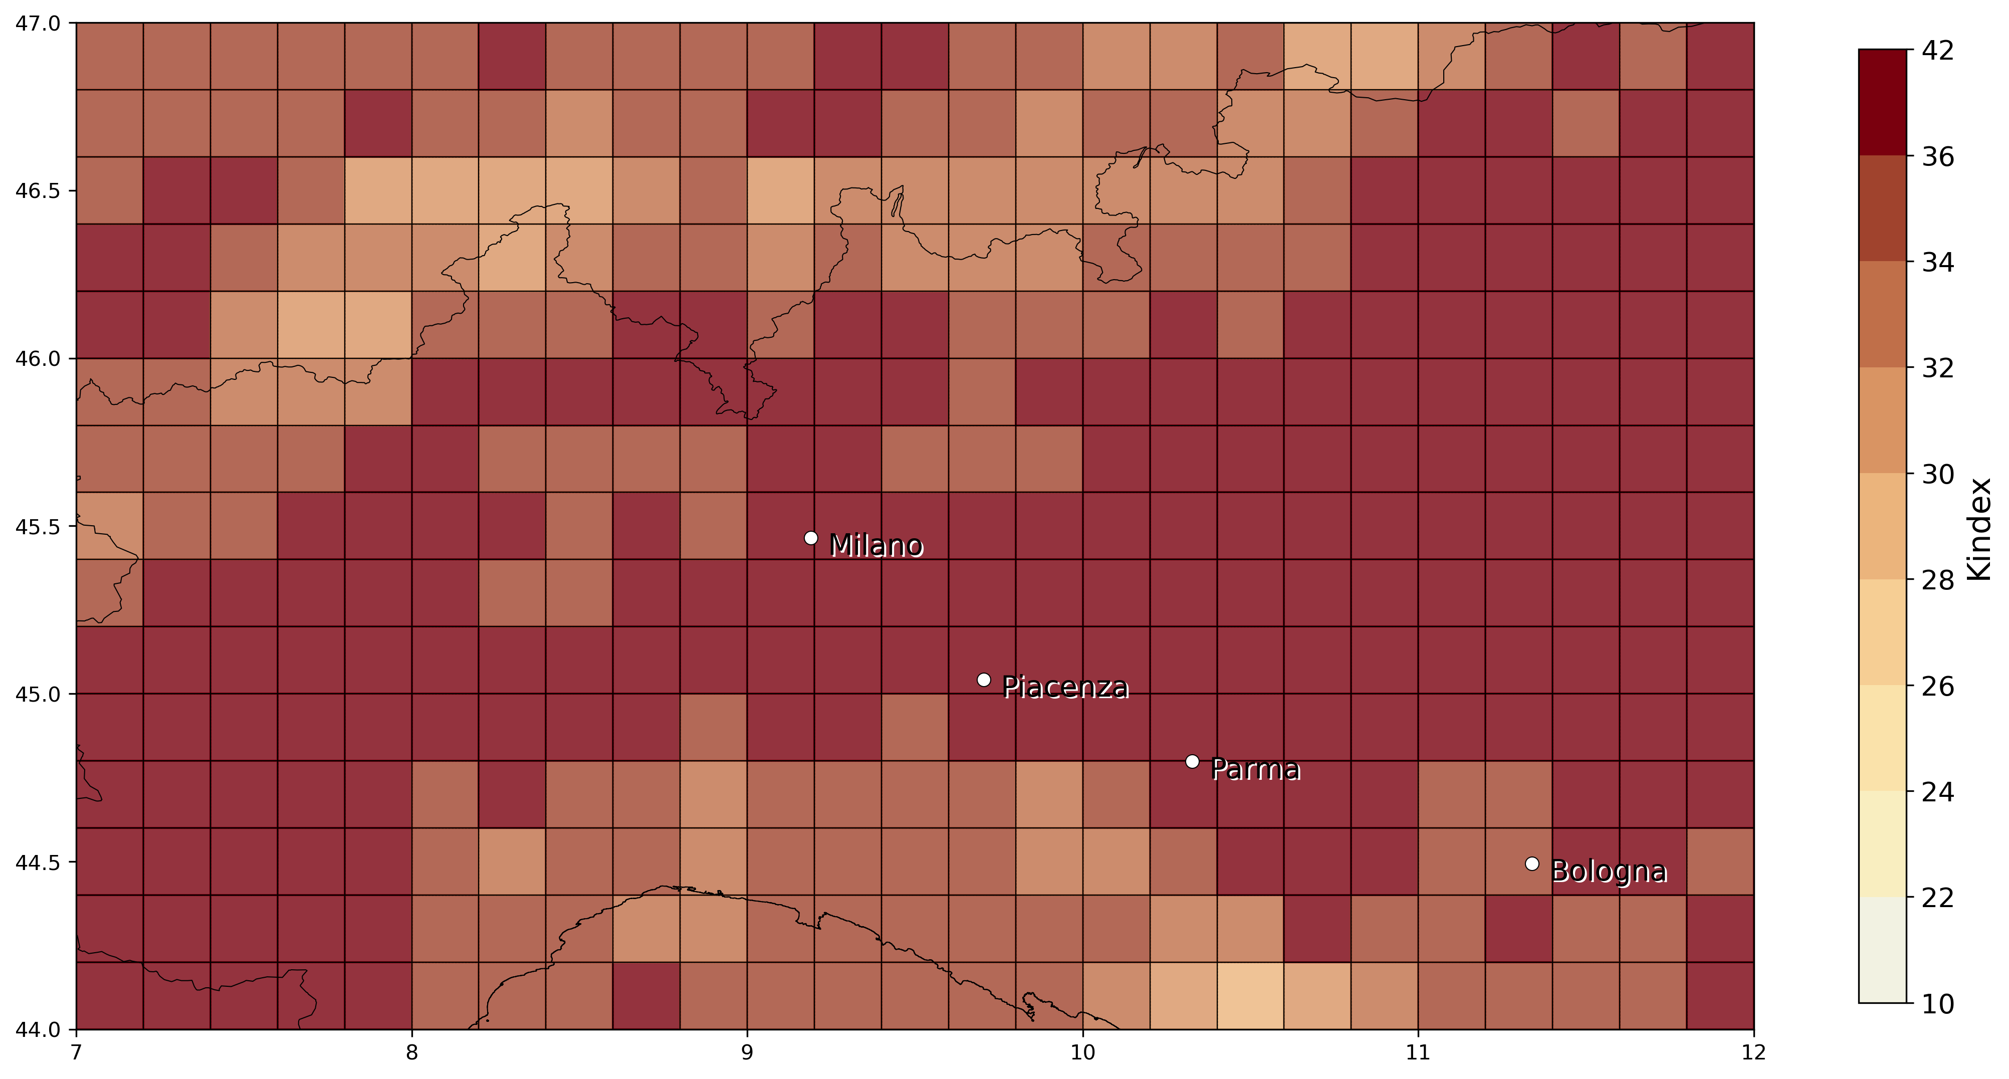

* + **AvvGeoPot500:** quantifying advection: if the geopotential stays the same everywhere all the time this param goes to 0, but when a trough approaces there will form a region of lower geopotential (@500hpa). E.g. in the Piacenza case: West of the thunderstorm there is not much change in geopot as the advective term (velocity * geopotGradient) is low, while in the region of the thunderstorm this parameter increases very much (e.g. if it is a trough initiating convection an increase in the advective term of geopotential will be present). Maximum of the day can be used but since it depends very much on the timing -> take a look at hourly temporal res! (must also check how stable this param is, since noise is detected in the plot,but maybe do to non optimal scale used)

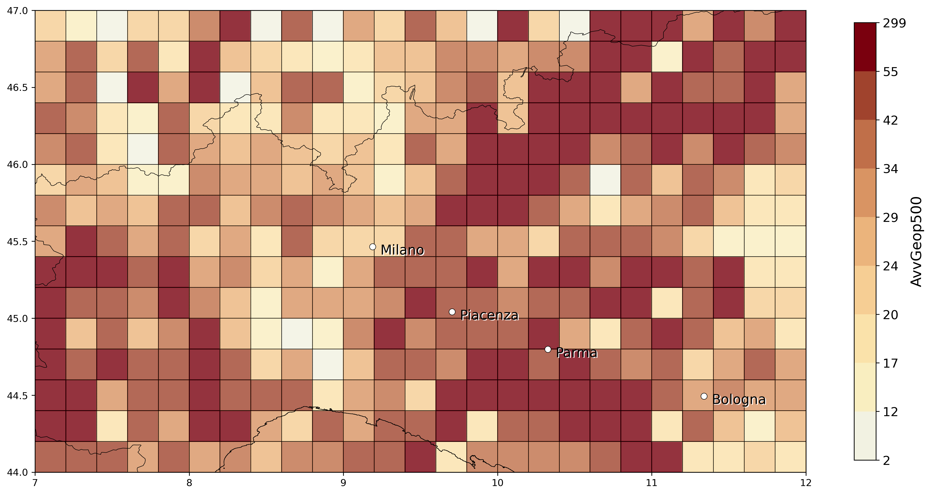

* **%VV700**: quantifying vertical velocity strength (if model represents convection in right location high values of %VV700 should be expected), right to consider the maximum. As definition this param is expressed in isobaric coordinates (Pa/s): for an ascending motion the pressure will be lower for larger altitudes -> that’s why threshold for param calc is set to -0.5Pa/s. Also for this we should take a look at hourly data!

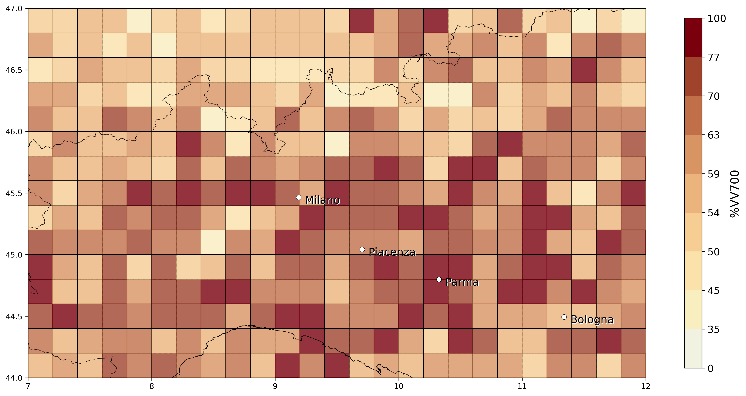

* To proceed: find timing from obs. Of maximum strength of the storm and then look at model parameters and compare them for the same hour, even if it is tricky to get appropriate matches on high temporal scales it is necessary for our purposes!! However different parameters must be considered with care: for atm. Instability the pre-convective conditions are more relevant while for e.g. %VV700 parameter the conditions of maximum intensity of the convective storm is more relevant. e.g. for LI, if there is strong convection occurring in the model means that instability in atm is already established so at that moment you have lower values of LI -> so it should be considered before (1-2 hours) where convection occurs (pre-convective parameter?) -> Could be useful to take a look at modeled precipitation as it should be aligned, temporally and spatially, to region of convection.
* To start with is better to look at events that took place in a limited region and that didnt last too long (otherwise it is more difficult to produce good matches).
* Maybe consider other events in 2016-2018 to compare the most possible data available -> in case request other events data to Kris.
* A nice comparison would be to do the same analysis and **compare with ERA5** once the filter with proxies obtained with SPHERA is optimized, must check at appropriate time if data available.

22/11**- MEETING WITH DAVIDE**(SPHERA data domain, 10 and 2.2km res)

* Procedure start to have csv data on larger domain (including southern Germany) and at high resolution (10 (1/10 degree) km and original 2.2km (for this must try how much time it takes given the much increased number of grid cells!)). These data will include, besides the 4 D’Alessandro indices (leaving out %VV700 for the original SPHERA high-res. as it is calculated from a certain number of grid points entering a cell, that becomes 1 grid point when considering the original resolution), also CAPE (MU and ML) and HZEROCL (two direct outputs of SPHERA).
* SPHERA data are instantaneous: related to model hour at the time the model produced the output (differently than LAMPINET where data are cumulated over the last 15 minutes).
* Once Davide fixed the procedure I will have to maintain it to obtain the data:  
     
   Davide: ho documentato un po' le procedure per la generazione degli indici temporaleschi e relativi file di appoggio, spero sia comprensibile, potete modificarla, l'ho inserita nella cartella condivisa indicata sotto. Ho creato su richiesta di Antonio una seconda serie di griglie e maschere estese di 1 grado a N (49N) per coprire parte della Germania. Attenzione però che alle risoluzioni più alte (sicuramente _5 e _10, cioè 0.2 e 0.1 gradi) non tutte le box sono coperte da SPHERA, per cui ti ritroverai meno punti nel risultato rispetto al numero di punti nello shapefile, e possibilmente alcuni senza dati validi (ma comunque tutti etichettati correttamente).

Ora sta girando il 2018 con la griglia "vecchia" fino a 48N, passo 20 km, poi credo che sulla base delle istruzioni tu ti possa calcolare autonomamente gli indici su 10 km e/o sulla griglia estesa 49N, se hai dubbi fammi sapere.

Resta da estendere gli indici con i dati puri di HZEROCL e CAPE_MU (espandere i dataset grib e modificare il programma per farli uscire così come sono, solo mediati sulle box) e fare il lavoro punto per punto, quest'ultimo lo lascerei da parte per ora, sono un po' scettico, almeno dal punto di vista tecnico.

<https://drive.google.com/drive/folders/1CzBYl9_btHQpDeFnCUxyd8XFCtWvUQCD>

**23/11**

Other events to (maybe) be considered for the initial validation of SPHERA(must request OT data!):

* 15 October 2016: Casalbordino, Abruzzo - hail with 7 cm diameter
* 9-10 August 2017: Trentino - Südtirol, moving thunderstorm that caused many hailfalls in the region
* 14 May 2017: Altovicentino, Veneto
* ... CONTINUARE (TROVARNE 10-15 ALMENO)

**MEETING WITH MICHAEL:**

* Good to extend the sample of preliminar events for the analysis, especially since an important point in the preliminar analysis for specific case studies is to consider hailstorms related to **different generating processes**: not only supercells, but also hail formed in multicells, clusters, MCS, or squall lines (relevant case: 11/09/2011 named Felix, squall line extending from north to south of Germany that produced strong damages especially in Eastern Germany (with old buildings destroyed), as well as hailstorms in different periods of the year not only related to summer deep convective processes but convection triggered by other causes such as fronts (e.g. considered event in Sardinia of 29 October 2018).
* Another important source of data could be **DWD app** of individual reports, new dataset useful also for hail (should be more comprehensive than ESWD, but dataset starts from 2020?)
* Understand when SPHERA data for 2019-2020 will be generated and made available?? Because for this period we could use also DWD data!
* SPHERA convective proxies: besides using %VV700, AvvGeop500, Kindex, LI and now when I add CAPE and HZEROCL,is necessary to include also a variable related to change of wind in the vertical. Optimal would be to use Storm Relative Helicity SRH but, due to lack of extracted data from SPHERA, it would be enough to **consider the Deep Layer Shear DLS from 10m to 500hPa**. **Must understand how to calculate them from grib files!!**  
  SRH, from a past study of Michael student, has shown to better discriminate than DLS hailstorms with small hail and short tracks than storms with large hail and longer tracks. Also Jannik in his phd thesis considered many different convective parameters, but used DLS instead of SRH, ask him why.

So, “Final” **set of SPHERA convective parameters** to be used as proxies are:

1. Kindex, (already available)
2. SLI, (already available)
3. %VV700, (already available)
4. AvvGeop500 (already available),
5. CAPE, (to be gridded but direct output of SPHERA)
6. HZEROCL (to be gridded but direct output of SPHERA) **-> key Q: is this altitude relative to sea level or to topography??**
7. DLS (to be calculated as from 10m to 500hPa and gridded)

Update 26/11:

* Finished to obtain new SPHERA data (4 D’Alessandro indices) for 2016-2018 (April-October) gridded on 10km, extending to 49°N! -> **next up: obtain data on same grid for CAPE,HZEROCL, DLS**

**Questions for Meeting with Michael (and HJ?):**

* ~~Discuss how to proceed~~
* ~~Insight from SOuth Africa paper~~
* ~~Discuss data transfer/mainteinance when i leave KIT~~
* Passive microwave imagers usage: use them as a comparison a posteriori for validation of the OT filter constructed with SPHERA proxies, or in another way?
* ~~Letter for reporting of the activity carried out by at KIT~~

20/1/22 MICHAEL

* Collaboration with KIT after phd: could be interested in post-doc positions, project as ClimXtreme (so natural hazards in climate change perspective), but will see in due time in case...
* **DLS**: parameter that in US is very much important for describing hail/severe convective events, while in Europe much less, probably due to the much more complex topography, and has shown no added skill when combined with LI in a study (of Michael), BUT still it needs to be considered when considering hail renalysis proxies (as it is widely accepted in the scientific community, and they would ask for it for sure in a potential review)
* **CAPE**: with COSMO 2.8km in assimilation mode gaps in CAPE (i.e. going to 0) have been detected when convective event has started due to the explicit representation of convection, so this must be considered with care also in my case having high-res model! -> look for CAPE gaps in event after convective initiation and development, before hailfall!

21/1/22

HAIL EVENTS EXAMPLES (see .pdf) first comments:  
<https://bwsyncandshare.kit.edu/s/zwC2DXQ32qbXtRZ?dir=undefined&path=%2FHail&openfile=1800609919>

* Comparison of daily and (especially) hourly estimates of OT max prob, eswd/unipol, euclid, Delta temperature (IR bright - tropopause), and daily total number of lampinet lightnings/hourly LJ index:

From two case studies (Piacenza 2017 and Pescara 2019): very good match between all different data sources (despite maybe unipol data sometimes due to large temporal uncertainty) especially when going to high temporal resolution (1 hour), indicating good ability in detecting strong convection going on on limited temporal scales, and also a good ability in representing the evolution of the events.  
Try with more events and extend analysis to available SPHERA proxies for these events.

FOR MEETING WITH HEINZ JURGEN + meeting on 25/1

Insights from **Punge et al 2021 paper (South Africa):**

* OTs: “*An advanced version of the OT detection algorithm described bi* ***Kholopenkiv et al. 2021*** *delivers a 3km gridded probabilistic estimate of OT likelihood based on a statistical combination of tropopause-relative IR brightness temperature, prominence of an OT relative to the surrounding anvil, and the are and spatial uniformity of the anvil cloud surrounding an OT candidate region.*” -> this means that the Delta T (IR brightness temp - tropopause temp) is already included in the OT probability data (and so i should not consider also the other parameter when studying hail events)?? **Ask Kris**
* ERA5 filter proxies: “*for South Africa the filter design used for EUrope and Australia has been retained (****Bedka et al. 2018****)*” -> HJ: was actually developed for Europe and then applied to Australia and South Africa but **must try again**, especially now with high-res conv-perm proxies, if it is still valuable AND useful also for doing sensitivity analysis on filter threshold proxies also to quantify uncertainty in the method (as Michael suggests)!
* ERA5 filter proxies design: “*for hazard modeling purposes the focus is on the identification of larger clusters of severe convective storm events likely to have produced hail in the event lifetime rather than detecting each isoletad storm with enhanced hail potential*” -> keep valid also for my case? I would say YES since the main goal is to assess probability of hail hazard for agricultural reasons -> HJ: probably yes, **must ask also Kris opinion**
* Produce OT count map as Figure 3, and filtered OT as fig6 for Italy for the period 2016-2018 and 1995-2020 (??)
* Hail reports processing: “*A uniformly distributed random number between -0.5 and 0.5 was added to each reported hail diameter to compensate for rounding in the hailstone measurement process and to obtain a smooth distribution*”, apply procedure also for ESWD data Im using?? -> think on it later in due time if hail-size analysis are going to be performed
* **Algorithm for identification of convective (hail) events** from OTs: could I apply it also to my analysis or criteria should be changed (e.g. spatial/temporal distance between different OTs associated to the same event)?? -> HJ: in principle yes, it’s a matlab code algorithm, but depends on the analysis im intending to perform: if considering hourly-based statistics for hailstorms it does not make sense as these events are defined on multi-hours, so let’s see in due time
* Approach of using generated **stochastic events** to investigate with a larger sample size OTs associated to hail events occurrences: something needed/useful/suggestable also for my analysis or not? Maybe not the main focus, as I would be more interested in using the same algorithm with OT filtering by forcing the filter with different reanalyses: SPHERA and ERA5 to assess benefits of high resolution, also since my main purpose is to develop a hail risk map for italy this is a little out of scope maybe, but in the future could be interesting.
* **Marion et al. 2019** suggest that convective storm severity be linked to OT area -> look at paper?

24/1

Reading Review **Raupach et al. 2021**, “The effects of climate change on hailstorms” -> SUPER interesting and useful, very well explained the main factors influencing hail formation (convective instability and low-level moisture, melting level height and vertical wind shear) and how they could change hail frequency (strong convective events) distribution region-dependently due to anthropogenic global warming.

IMK meeting 26/1 - Michael:

* Insurance data, besides being really uncertain for the temporal resolution, spatial localization, also they could be false when people try to fraud a bank and flag an insurance claim when there was not a meteo event (relevant issue at least in Germany) -> understand if this is relevant also for UNIPOL data? Ask ADA meeting
* Way of quantifying uncertainty related to hailstorm events based on the data i have available, two suggestions: 1) sensitivity analysis on the reanalysis proxies (CAPE; DLS....) to quantify their impact on outcoming “verification” with hail obs, if there is a lot of impact with small changes in the proxies probably the uncertainty is large.... 2) stochastically simulate uncertainty (not as in SOuth Africa stochastic approach that was used to enlarge the sample of events), but in case discuss at due time with Michael

Find out if there are other reanalysis proxies studies on hail/deep convection based on finding favourable environemnt**s on a hourly basis** (because it can be very challenging and tricky to set up proxies thresholds on hourly basis, especially for indices such as LI or CAPE which could decrease very much when convection has initiated in the progresive hours since the storm formation) -> ask Michael?

Meeting with Michael:

* For analysis of matching different gridded data for individuating storms and calculating statistical skill scores ask Jannik/ look at his phd thesis (unfortunately in german) because he did something very similar in his phd, maybe ask if in python code if he could give me the code?
* Book reccommendation: **Robert Trapp - Mesoscale-Convective Processes in the Atmosphere**
* Suggestions on how to proceed for the analysis: since hourly-based analysis with convective proxies is very hard (due to too many uncertainties going on such as model uncertainties, spatial uncertainties, temporal uncertainties and so on..) it would be useful perhaps to find some methods to **filter out irrelevant spatial boxes** where certain conditions on the proxies are not met (e.g. values of LI > certain threshold, based on percentiles or on fixed value) BUT keeping those boxes around them of at least a certain distance (like in fuzzy verification) in order to have information restricted only on an area where the storm potentially could be, and another way could be by **finding a daily “footprint” of the event** (e.g. taking the minimum of LI over the day and retaining only the boxes where there was a minimum of at least a certain value, and doing the same with other proxies). Also I need to understand VERY WELL what the proxies I use represents, especially not-so-obvious proxies such as AvvGeop500 or %VV700 in order to construct an optimal filtering for them!!!

**8/3/2022 RECAP: TO DO AFTER PAUSE (per articolo):**

* ~~Check if j-notebooks work~~
* ~~Find a sample of events to extend analysis on 2016-2018 (for now only three events: Piacenza,Parma and Sardinia), at least 10-15 events~~
* Read paper Australia 2018
* Write to Kris for OT data for events + ask for any doubt regarding OT data/application in my case
* Write to Davide to understand how to get SPHERA data gridded on 10 km 2016-2018 of DLS, z0 and CAPE
* Set up a set of thresholds for SPHERA proxies based on literature/quantiles?
* Understand how to start a spatial matching analysis (for the moment between OT and SPHERA proxies) and define score metrics, start the analysis for the sample of hail events considered, perform sensitivity analysis on proxies thresholds?
* A main issue is: how to perform hourly analysis since (for the momtn) no previous literature is found at this temporal resolution? Start maybe with daily analysis to tune thresholds and method of matching, and then move to hourly somehow

**Enlarge sample of hailstorm events in Italy 2016-2018:**

For the moment we have:

1. 29 October 2018, Alghero (Sardinia) (https://www.lastampa.it/cronaca/2018/10/30/news/maltempo-nubifragi-e-frane-sei-morti-un-disperso-in-sardegna-1.34056226)
2. 4/6/2018 in Parma (Noceto) circa 13UTC, Emilia Romagna, Italy (report ARPAE available)
3. 29/7/2017 in Piacenza (Pontenure) circa 19UTC, Emilia Romagna, Italy (report ARPAE available)

Plus to add (selected from ESWD):

* 7 October 2018, Melpignano (Lecce Salento), circa 12UTC, <https://www.trnews.it/2018/10/07/grandine-come-neve-sulla-lecce-maglie/230825>
* 7 September 2018, Carapelle/Orta Nova (Foggia), crica 14.20UTC, 5cm hail, <https://www.foggiatoday.it/cronaca/grandine-carapelle-orta-nova-cerignola-maltempo.html>
* 2 September 2018, Pescara, circa 13.30UTC, 5cm hail, <https://www.facebook.com/tornadoinitalia/photos/a.370143886500651/1056898884491811/?type=3&theater>
* 23 July 2018, Turi (Bari), circa 11UTC, small hail, <https://www.baritoday.it/cronaca/pioggia-grandine-adelfia-turi-casamassima-putignano.html>
* 9-10 August 2017: Trentino - Südtirol, moving thunderstorm that caused many hailfalls in the region
* 28 June 2017, NORD ITALY:
  + Brisighella (Ravenna), 14.25UTC, hail with 2cm, <https://www.ravennatoday.it/cronaca/nubifragio-28-giugno-2017-danni-agricoltura.html>
  + Songavazzo (Bergamo), 10.17UTC, hail with 2cm, <https://myvalley.it/2017/06/grandinata-cerete-songavazzo-danneggiato-mais/>
  + Cartigliano,Mussolente,San Zenone degli Ezzelini (Vicenza), 12:30 UTC, hail with 4-6cm, <https://www.inmeteo.net/2017/06/28/violenti-temporali-veneto-maxi-grandinata-cartigliano-vi/>
* 27 June 2017, Frinco (Asti), 21.15UTC, hail with 8cm, <https://www.inmeteo.net/2017/06/28/disastrosa-grandinata-piemonte-chicchi-10-cm-nellastigiano/>
* 25 June 2017, NORD EST ITALY:
  + Gussago (Brescia), 15.45UTC, 6cm <https://www.quibrescia.it/cronaca/2017/06/26/grandine-e-temporali-molti-danni-nel-bresciano/521053/>
  + Cremona, 17UTC, 3cm
  + AltoTrevigiano (Vittorio Veneto), 6UTC, 5-10cm <https://www.instagram.com/p/BVwJGx4lC7N/>
* 14 May 2017: Veneto-Emilia Romagna:
  + Altovicentino, Veneto 19.30UTC, 5-7cm
* 4 May 2017: Oderzo (Treviso), 12UTC, hail with 2cm, <https://www.trevisotoday.it/cronaca/grandine-a-oderzo-oggi-4-maggio-2017.html>
* 15 October 2016: Casalbordino, Abruzzo - hail with 7 cm diameter
* 29 August 2016, Torino, circa 20.10UTC, hail with 5cm, <https://www.inmeteo.net/2016/08/30/grandinata-torino-immagini-impressionanti-rivoli-collegno.-ancora-lastre-ghiaccio-al-suolo>
* 16 August 2016, Albenga (Savona), 18UTC (in articolo scritto “poco dopo le 20), hail with 2cm, <https://www.savonanews.it/2016/08/17/leggi-notizia/argomenti/attualit/articolo/forte-grandinata-ieri-ad-albenga-continua-linstabilita-in-provincia-di-savona.html>
* 5 August 2016: Mondolfo (Pesaro-Urbino, Marche), circa 17UTC, hail with 4cm, <https://www.inmeteo.net/2016/08/05/maltempo-marche-violenti-temporali-fra-pesarese-anconetano.-forte-grandinata-mondolfo-foto>
* 18 June 2016, Asiago (Vicenza), circa 13UTC, 3cm hail, <https://www.inmeteo.net/2016/06/18/veneto-ancora-temporali-violenti-pazzesca-grandinata-nel-vicentino-altopiano-asiago/>
* 8 April 2016, Condove (Torino), 14.30 UTC, hail with 5cm, <https://www.inmeteo.net/2016/04/08/maltempo-piemonte-devastante-grandinata-condove-torino-.-fiumi-ghiaccio-le-strade-video>
* 7 April 2016, Berbenno (Bergamo), 6.30UTC, hail with 2cm, <https://www.inmeteo.net/2016/04/07/maltempo-fitta-grandinata-berbenno-nel-bergamasco/>

Julian date conversion:

2016098  
2016099  
2016170  
2016218  
2016229  
2016242  
2016289  
2017124  
2017134  
2017176  
2017177  
2017178  
2017179  
2017221  
2017222  
2018204  
2018245  
2018250  
2018280

Insights from **Bedka et al., 2018:**

* Analysis of OTs temporal spatial distribution: maybe useful to do something similar also in my case, since OT detected with new algorithm (Khlopenkov et al., 2021) not already employed in Europe, and also to give a sense of the impact of reanalysis-based filtering to retain OT associated to hail

15/3/22

Prepared SPHERA data of CAPE, HZEROCL, 10uv e 700uv (2016-2018, April-October) for gridding to 10km, must calculate DLS and then grid all hourly data to obtain csv tables (asked Davide for help in calculating DLS)

29/3/22

New set of hailstorms (OT data received from Kris), first comments:

* 7 October 2018, Melpignano (Lecce Salento): 1 eswd report, event missed both by OT max probability detection (even if a localized dTmin is visible) and by LJ index, while SPHERA simulates well the LI daily minimum peak, or the Kindex daily maximum, while the maximum of %vv700 fails at giving a useful information (at least on the daily basis):

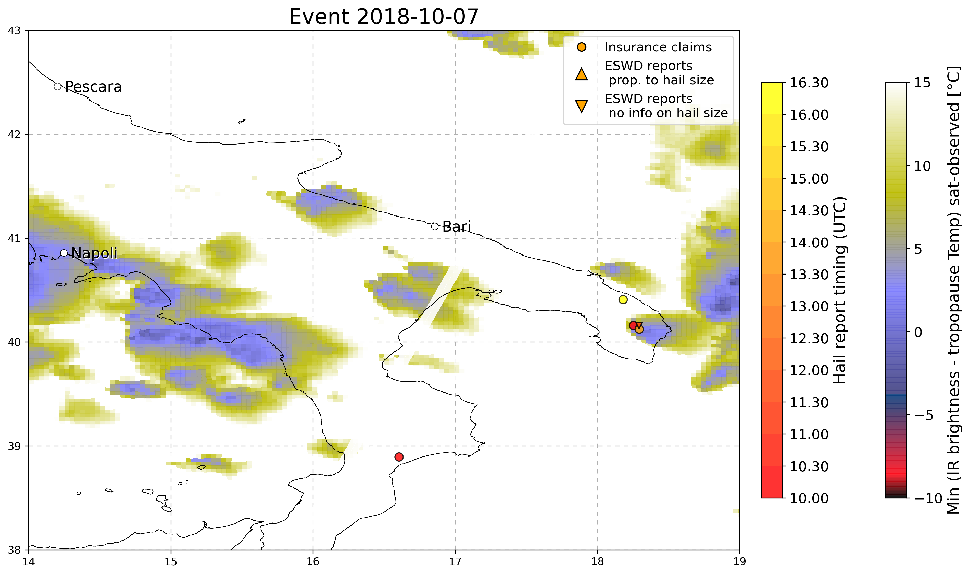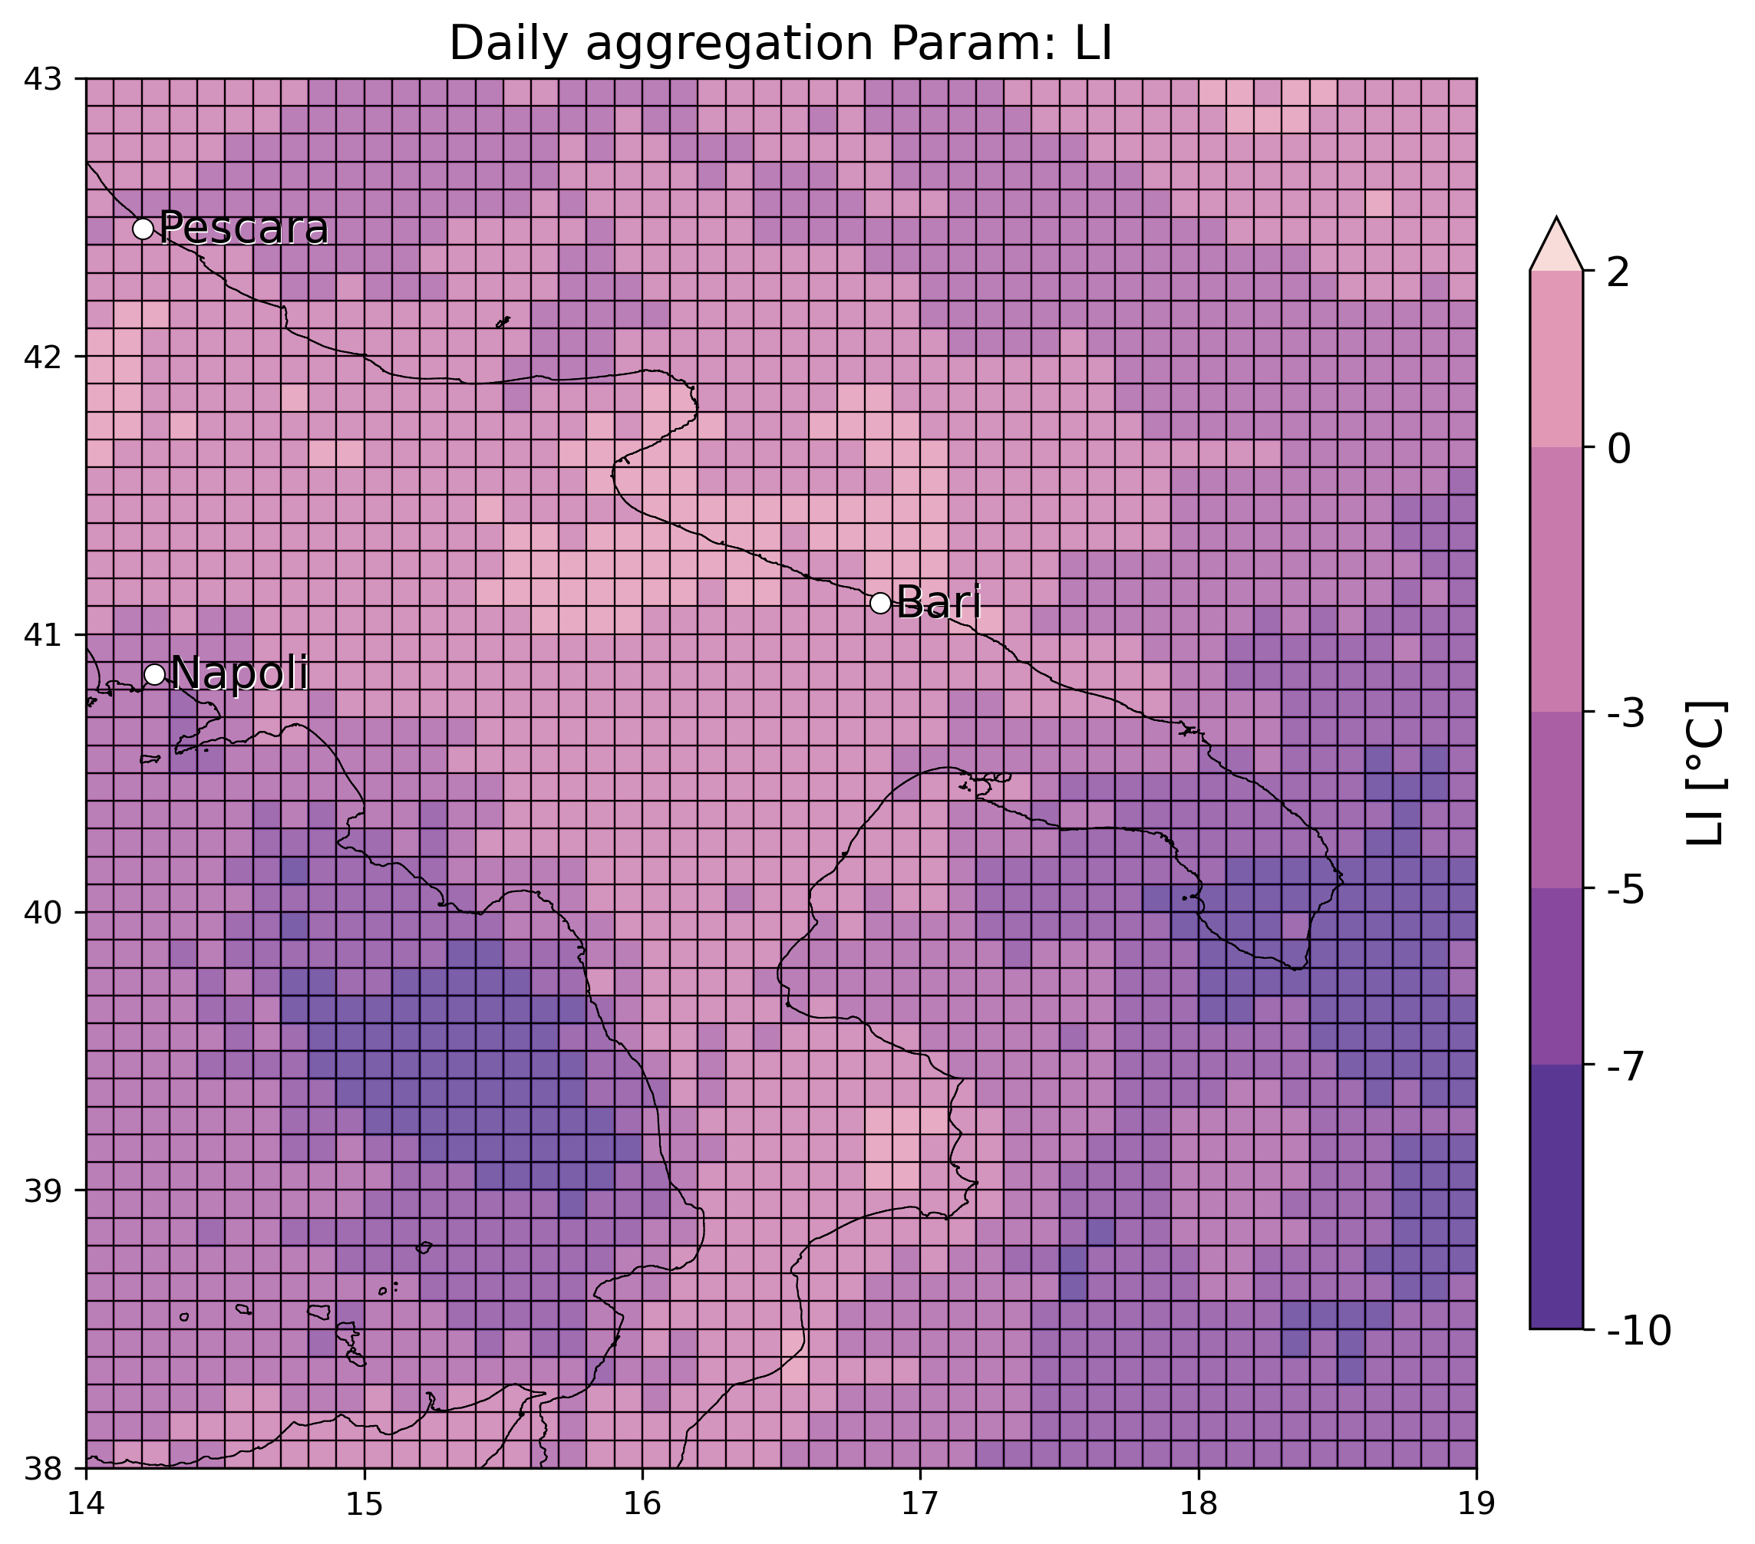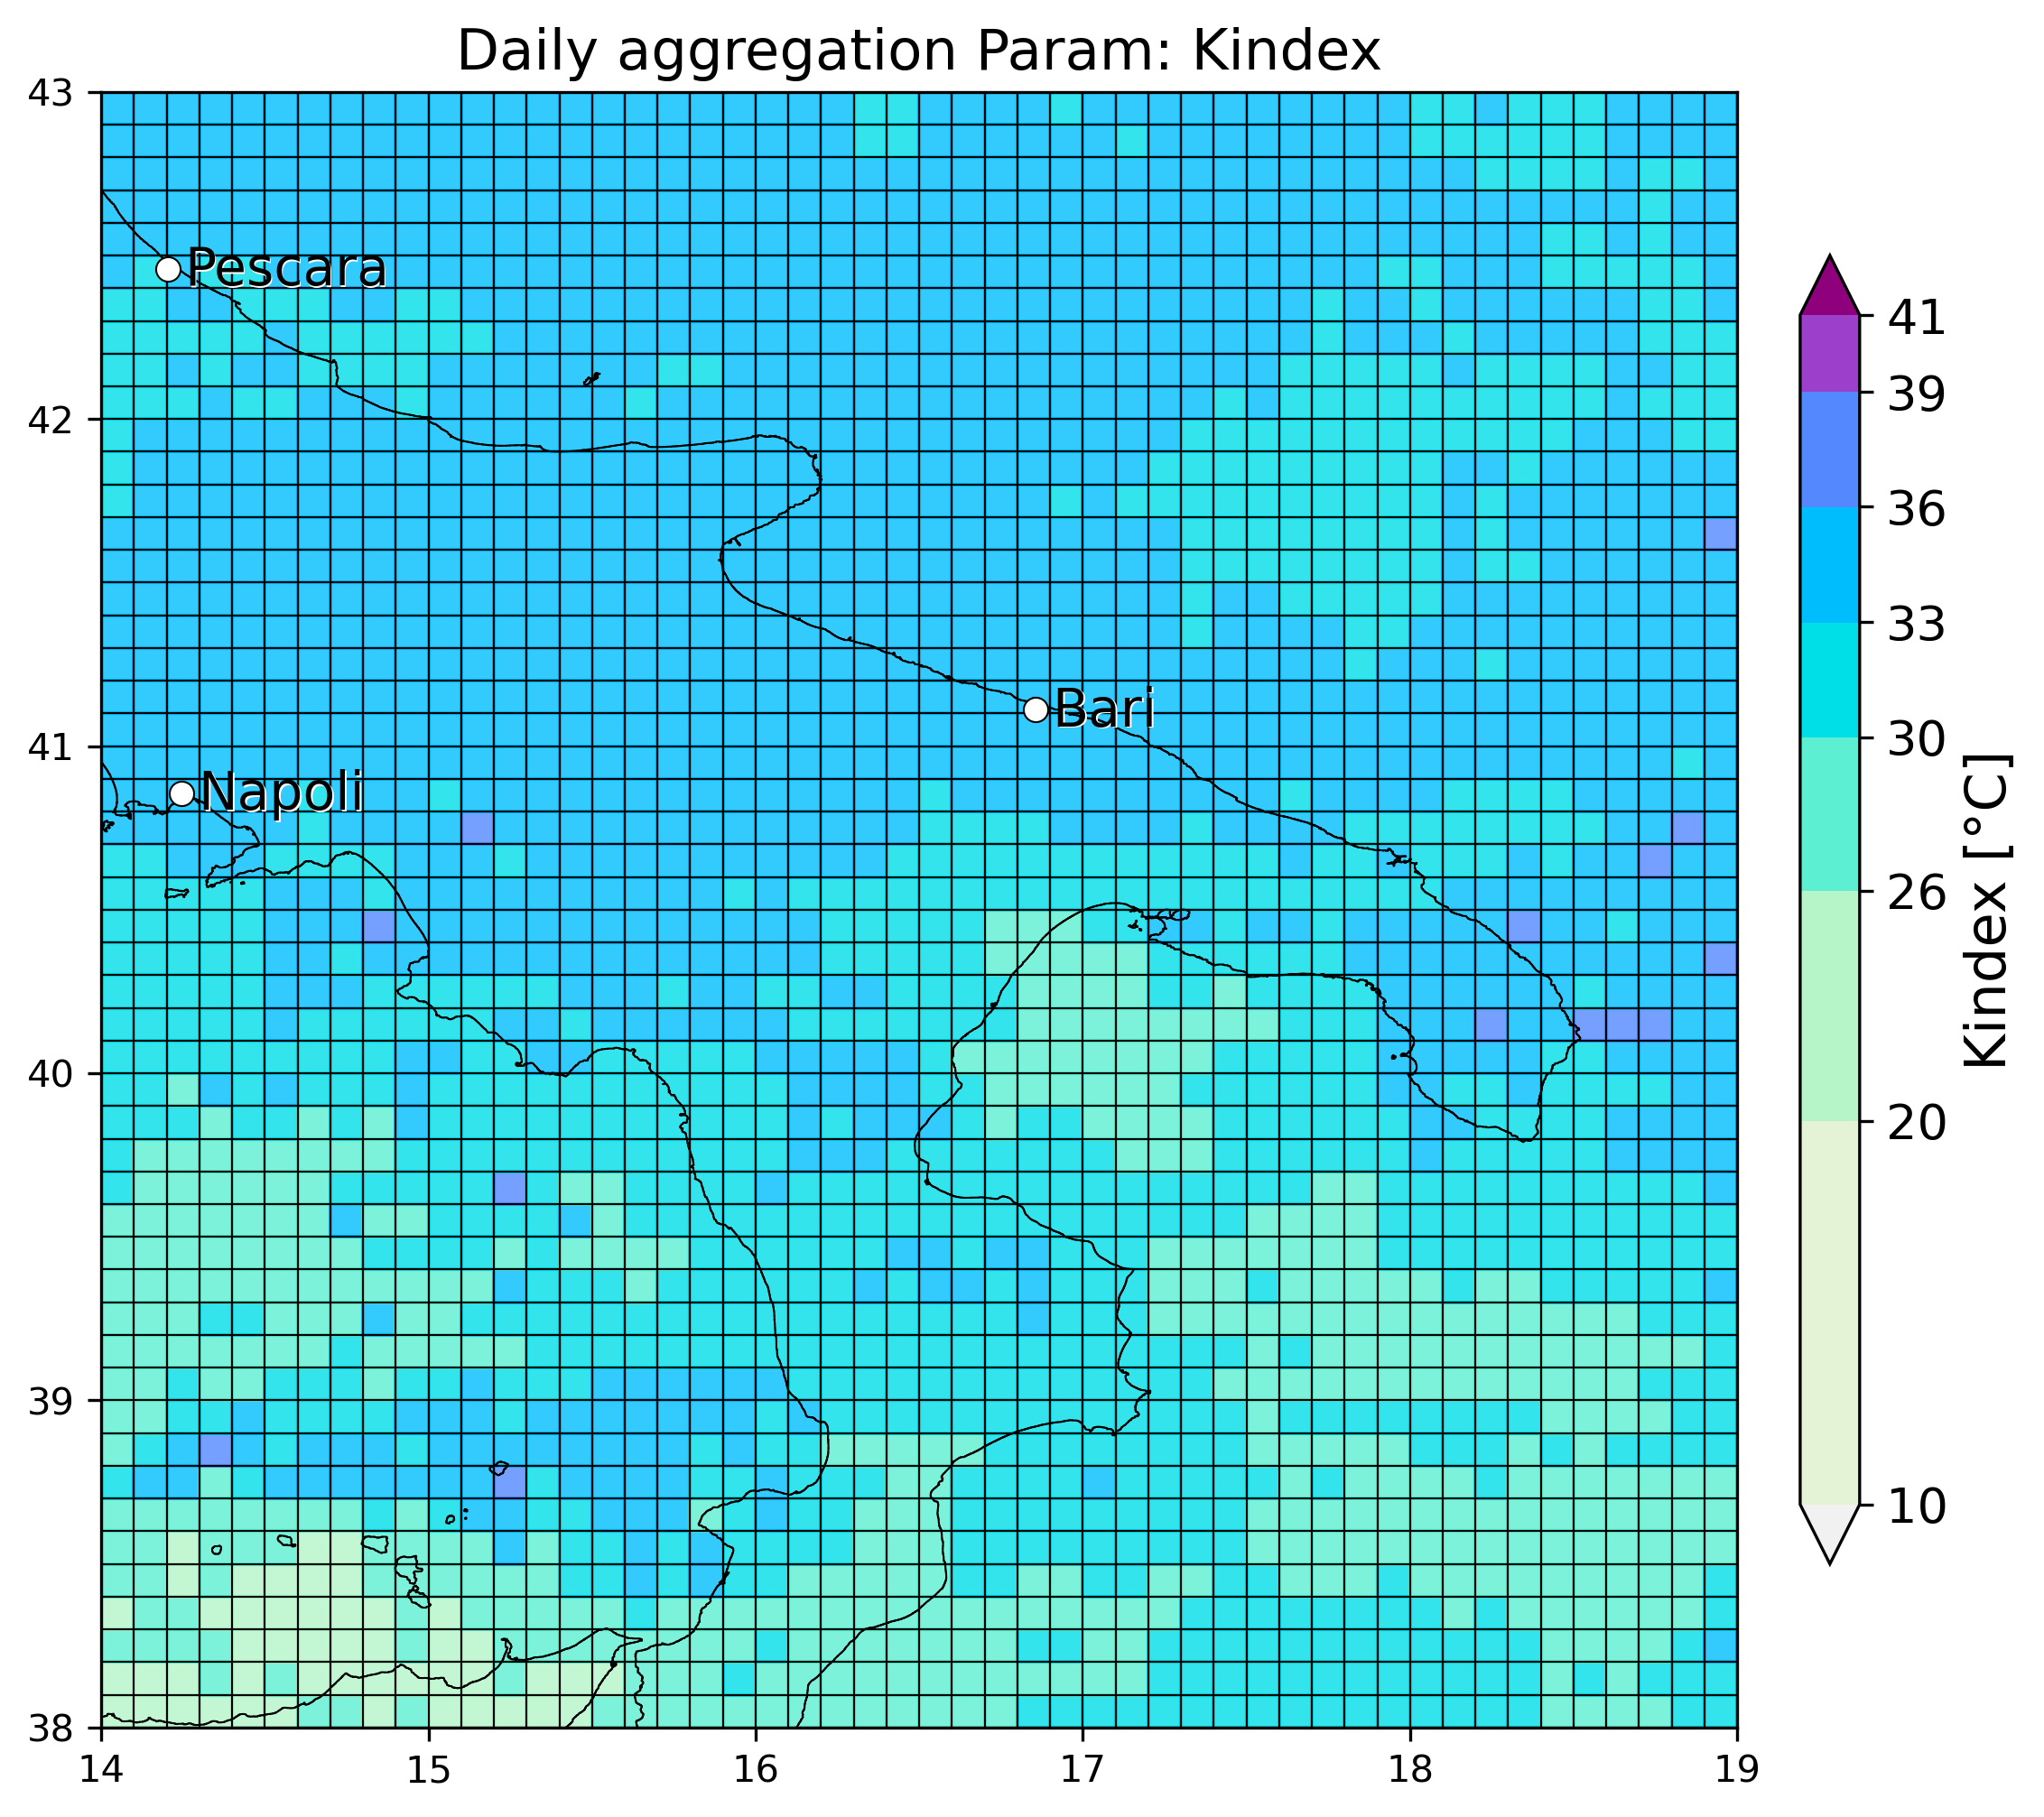

* 7 September 2018 (Carapelle/Orta Nova - Foggia): 2 eswd reports 5cm, event almost missed by OT max probability while also here a dTmin is well visible, while LJ index miss event near Foggia but see well the hourly evolution of organized convection offshore. SPHERA miss in finding a daily min of LI, or max of Kindex in the area of the reports:
* 2 September 2018 (Pescara):various eswd/unipol reports, good matching with OT max prob, OT dTmin and also LJ index, SPHERA LI daily min detected offshore but close to the reports location, while Kindex fails in giving useful indication:

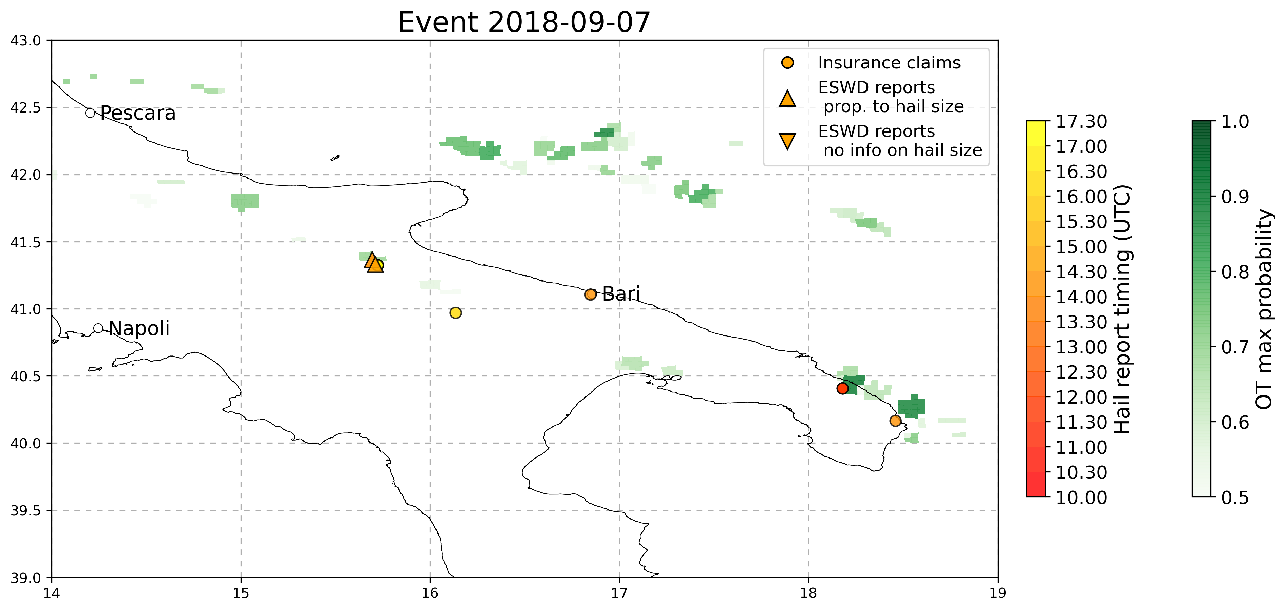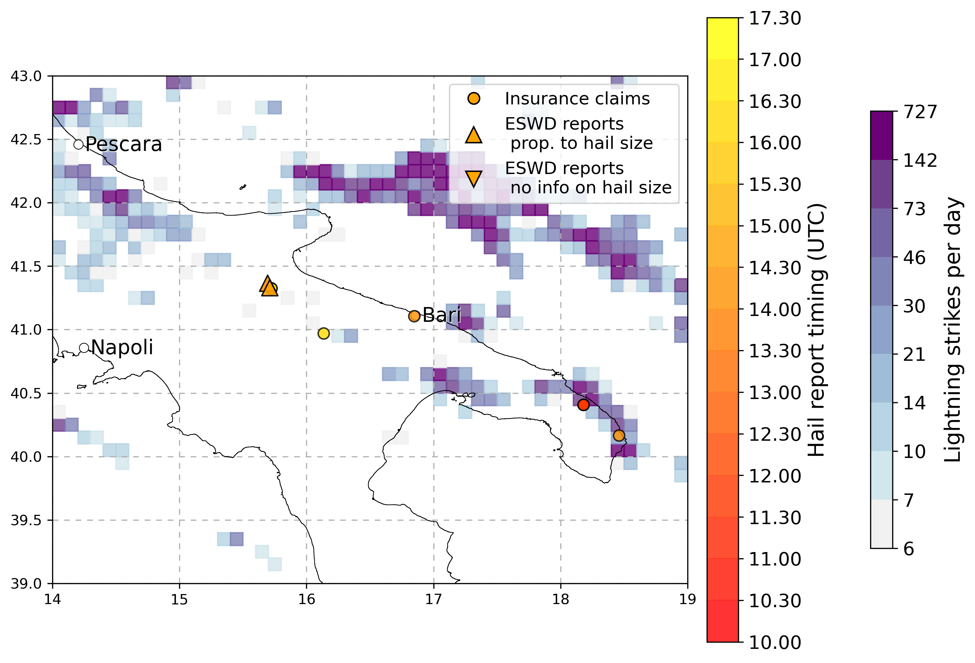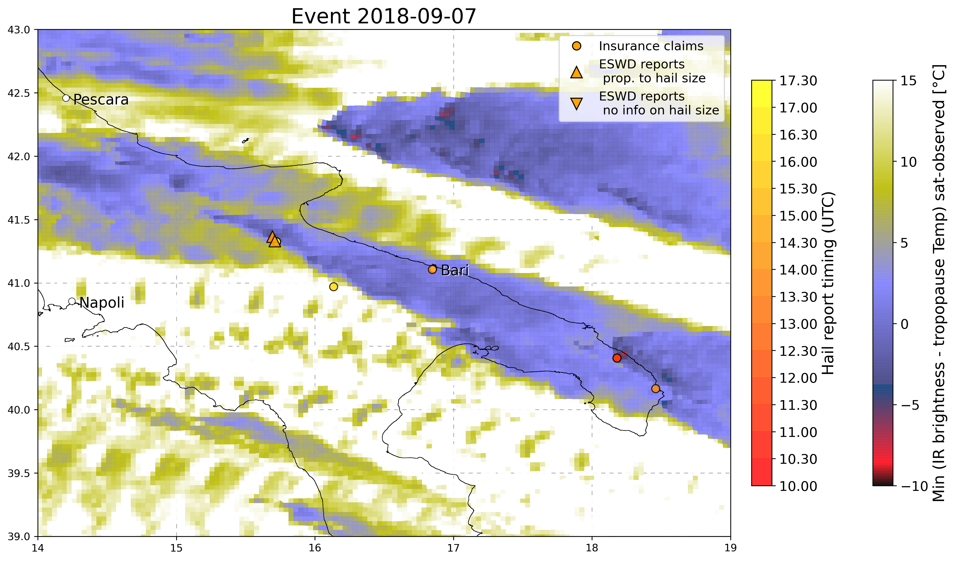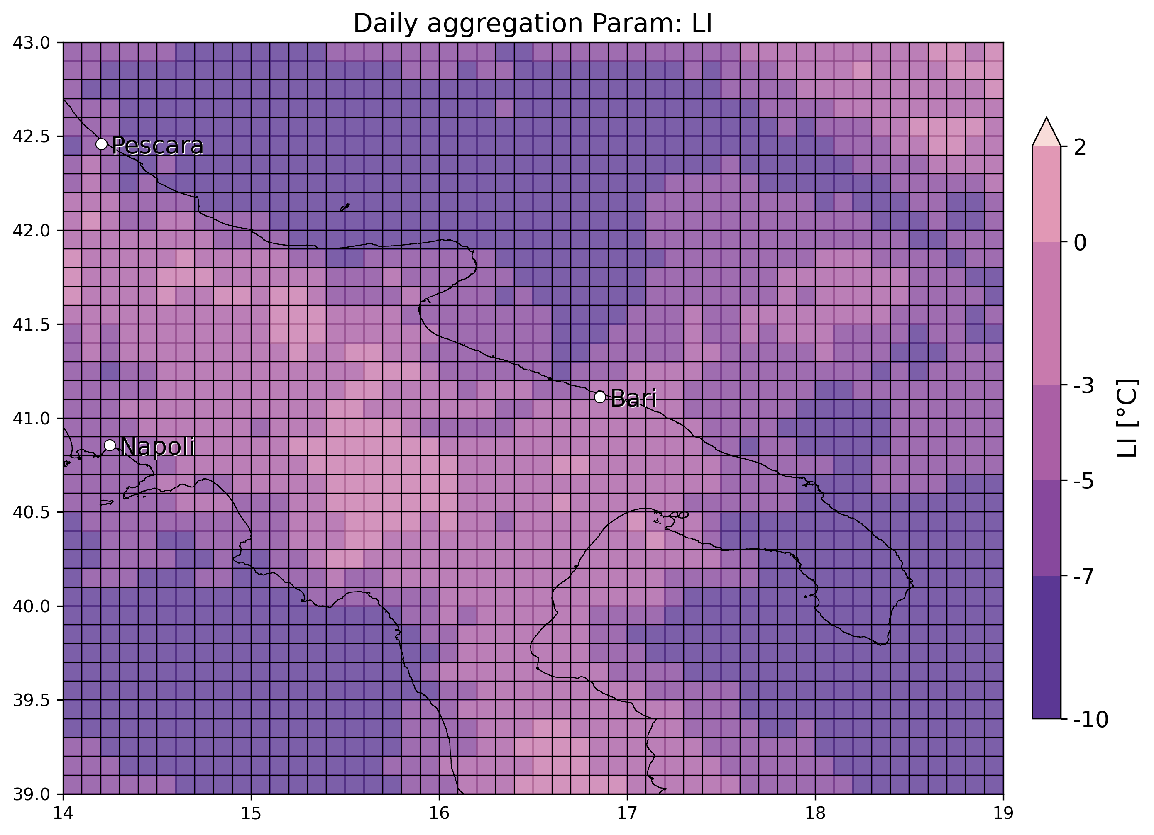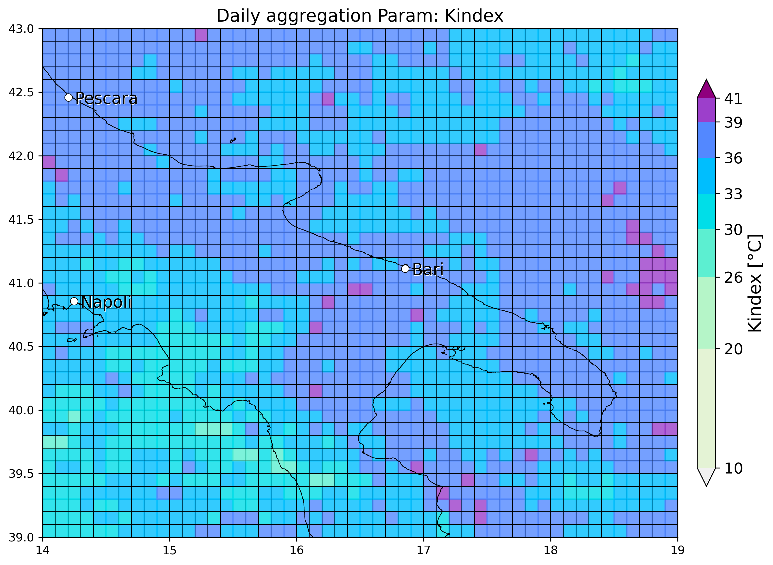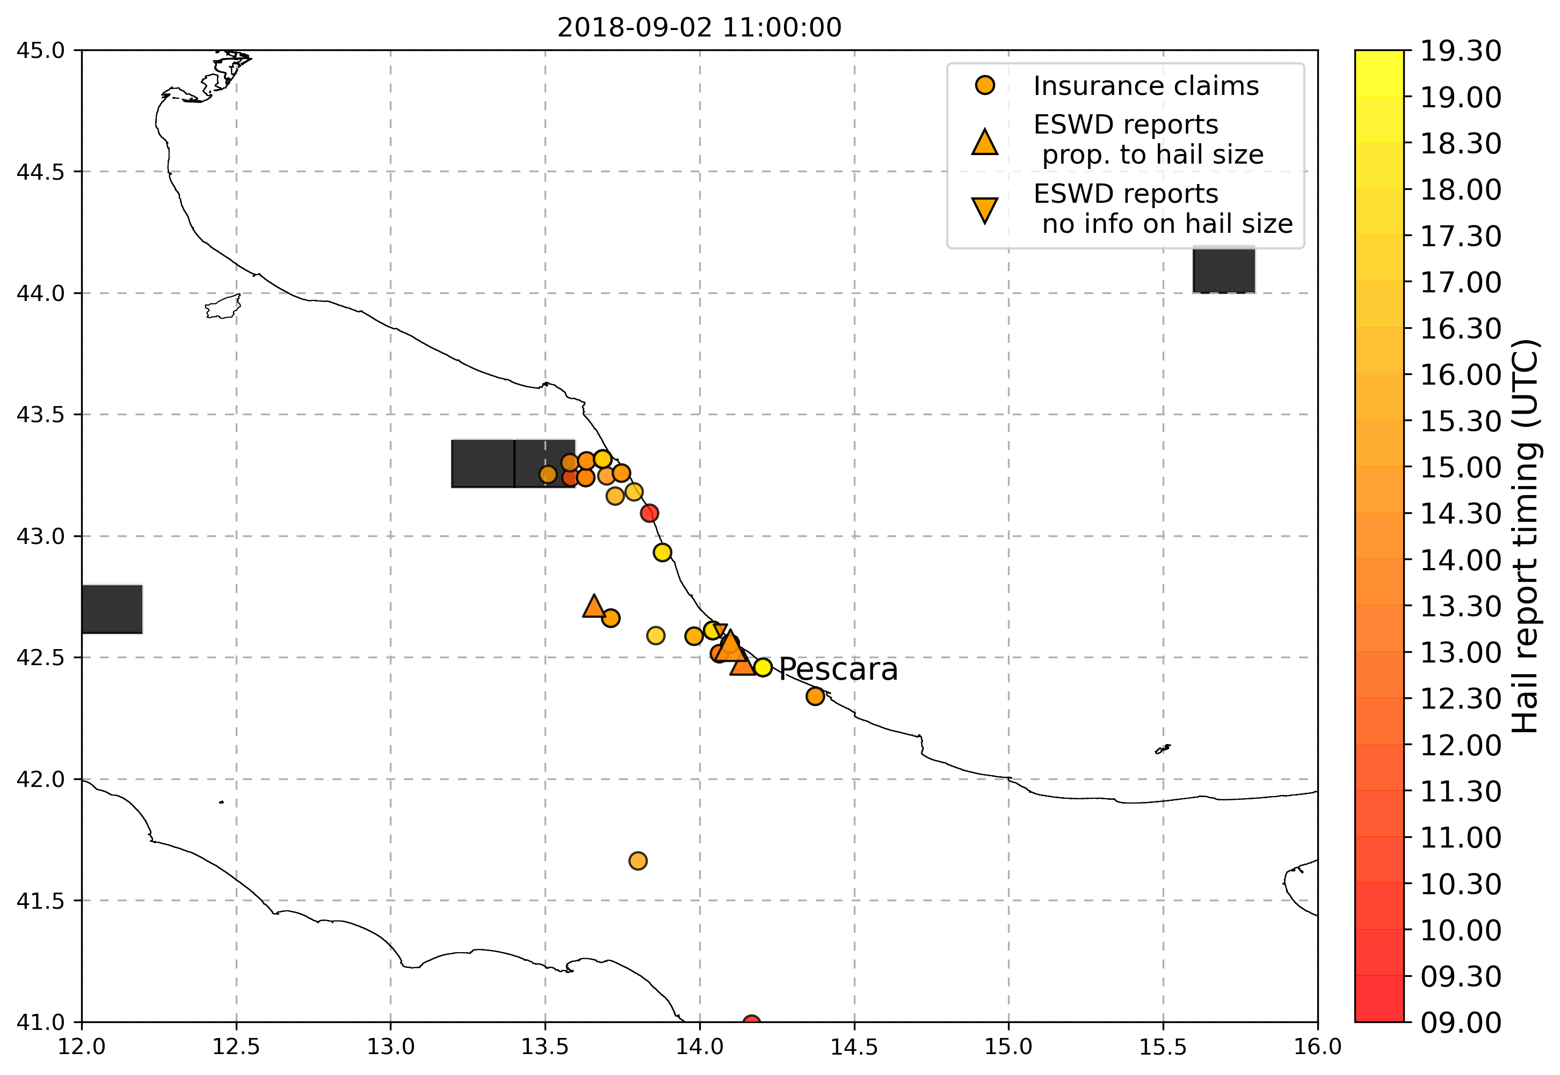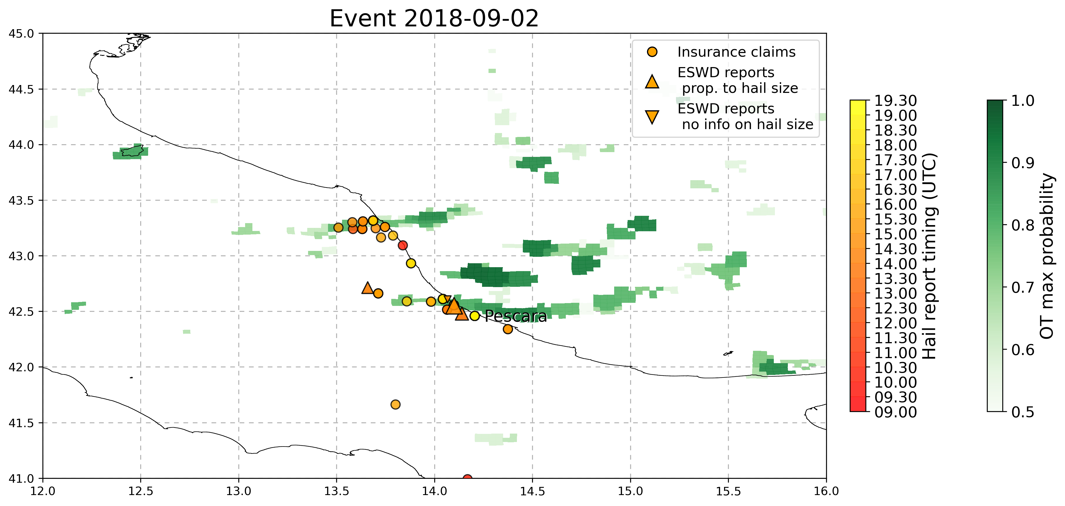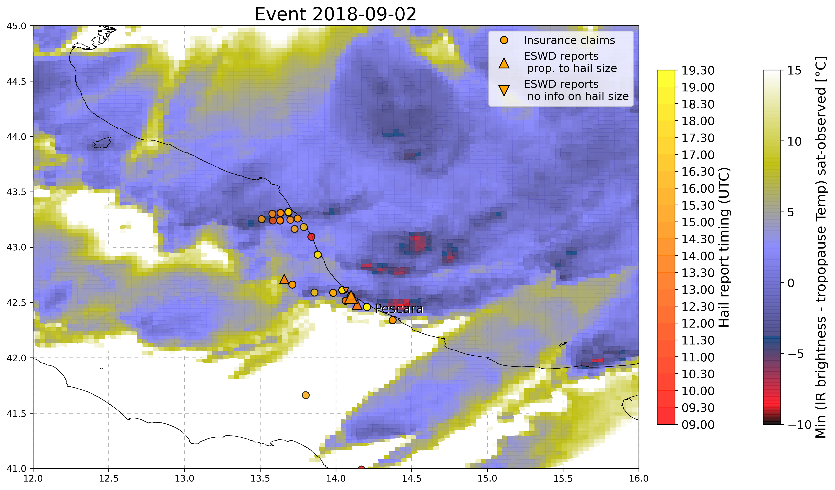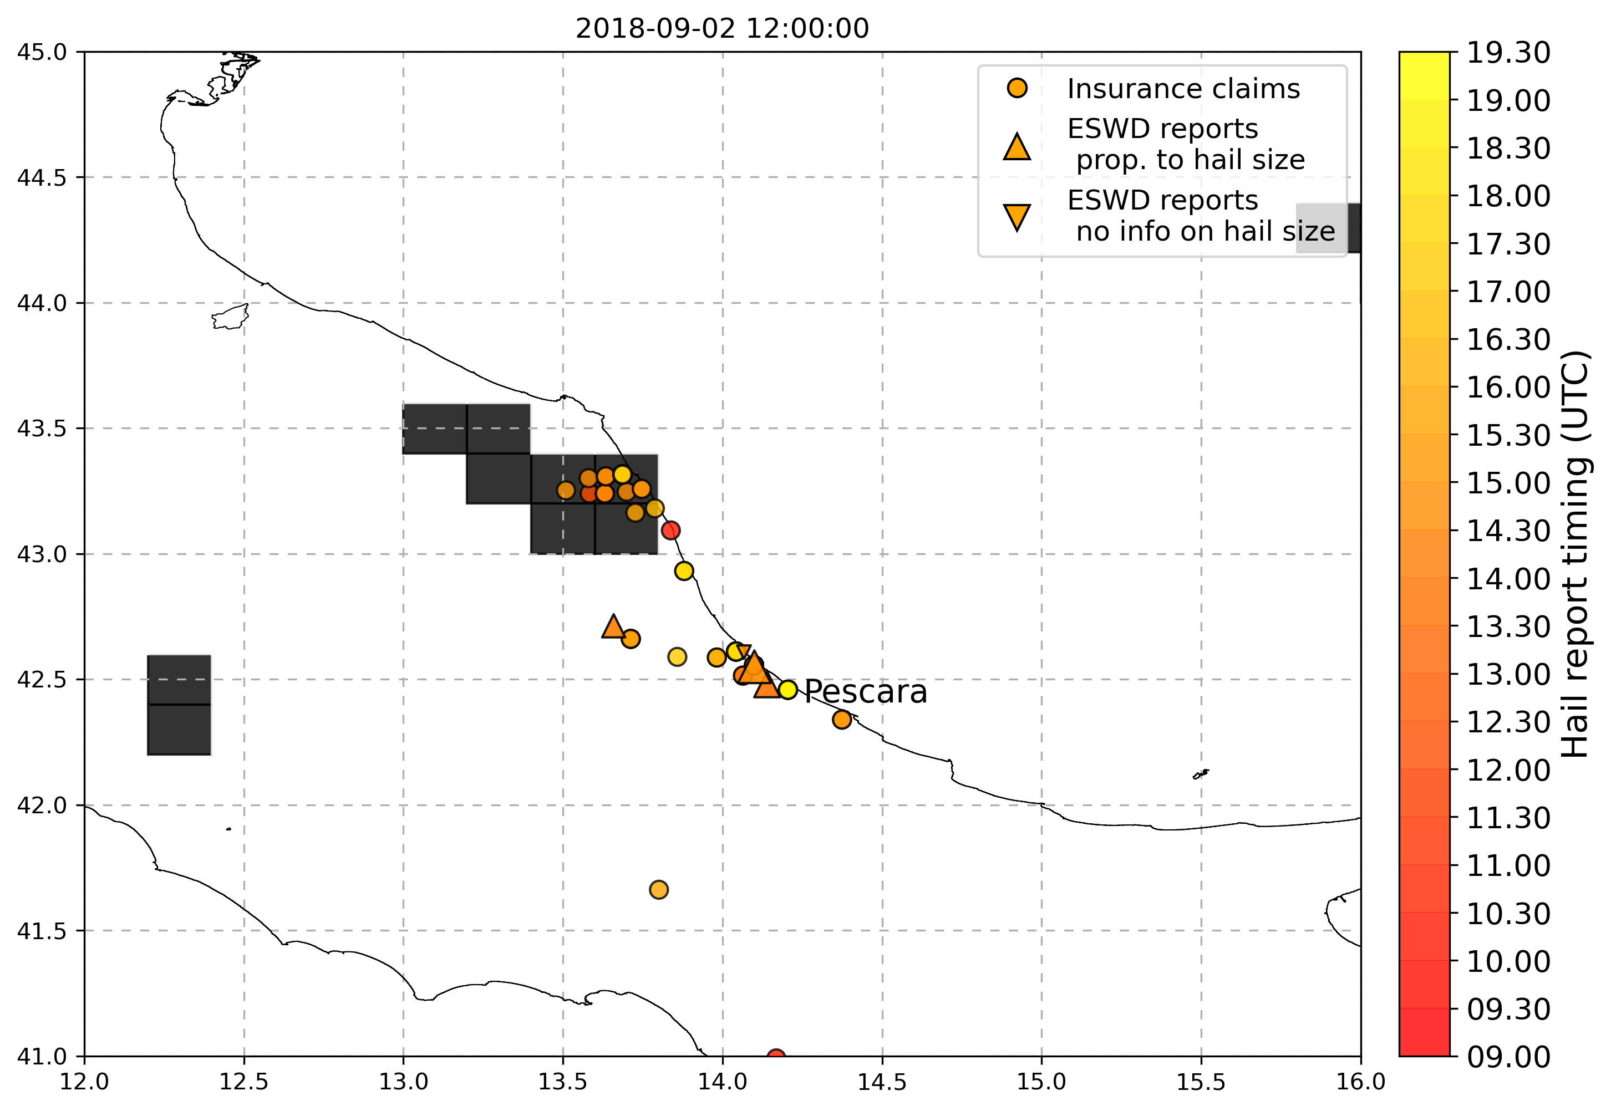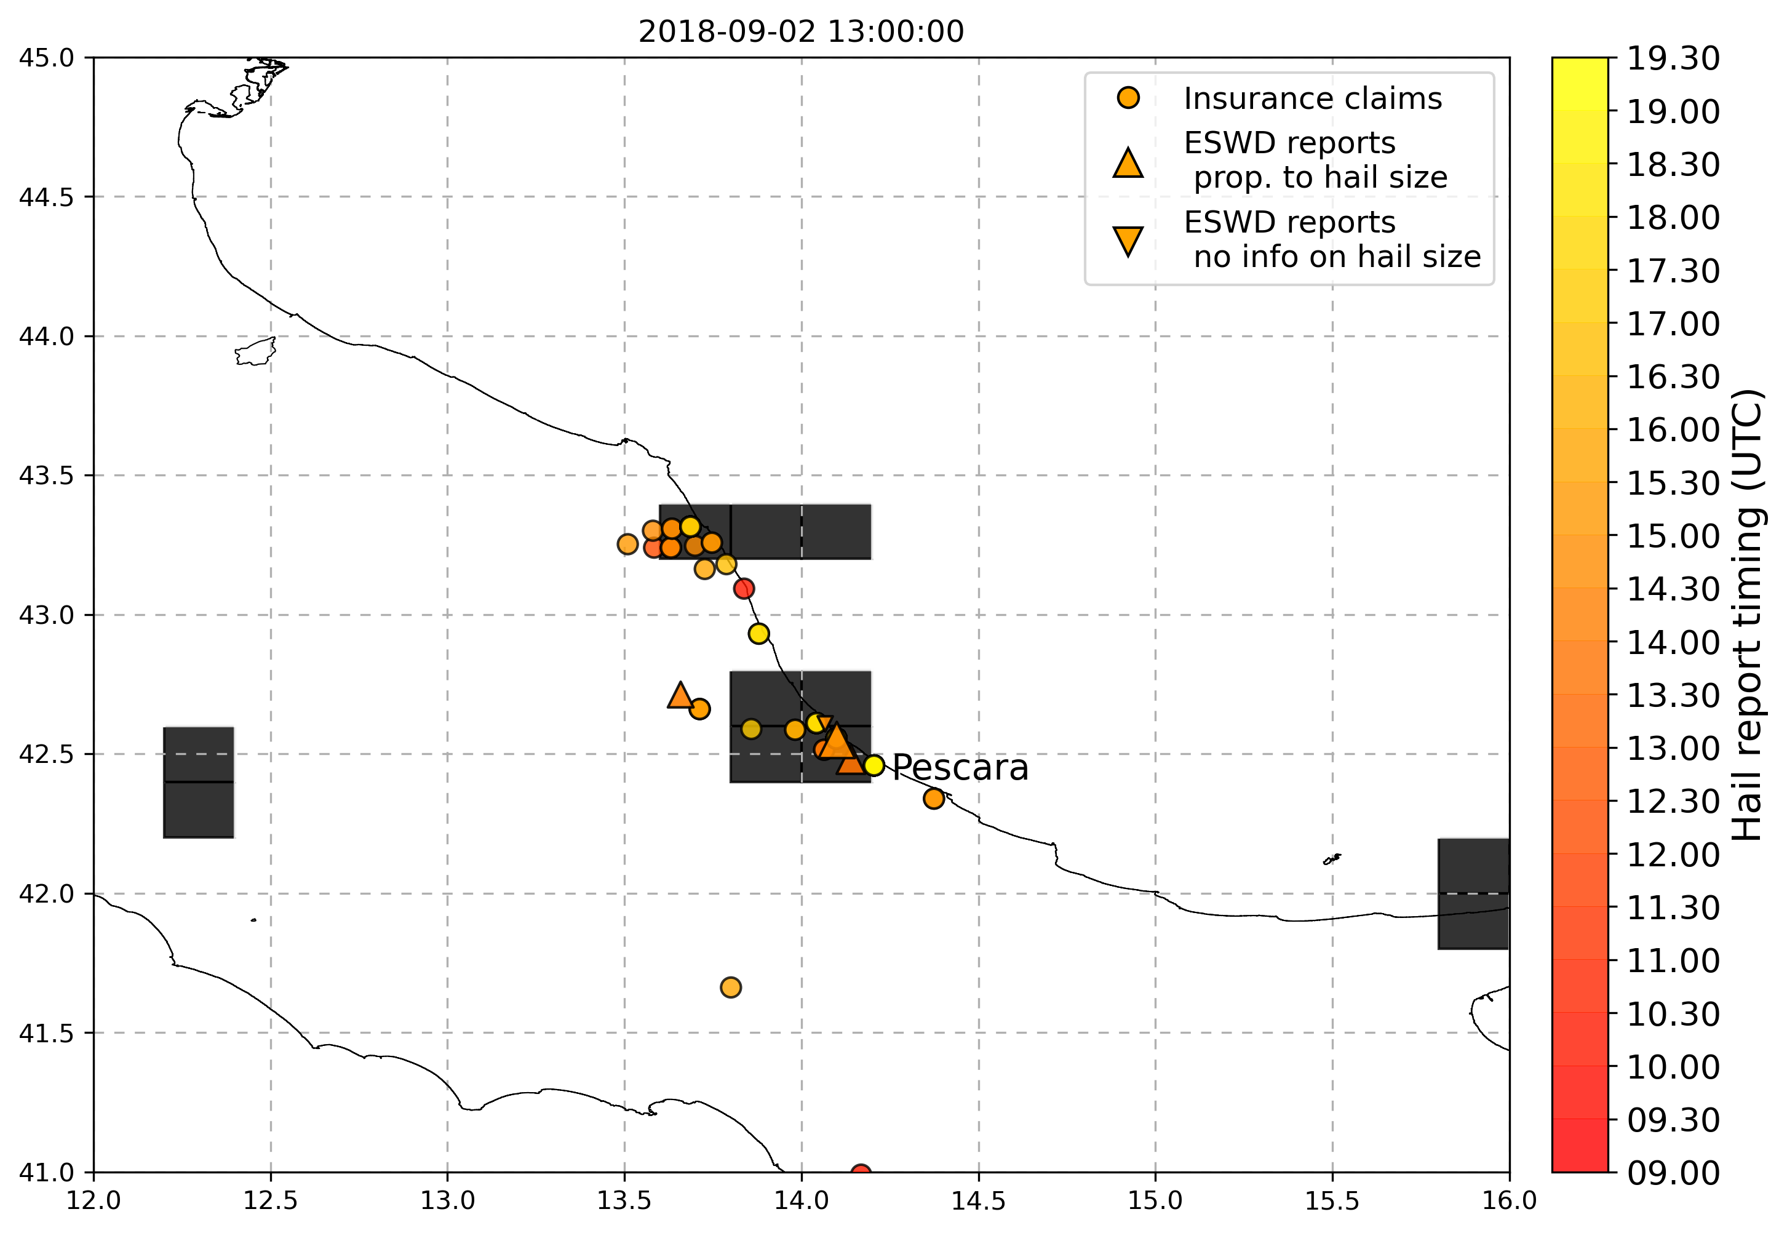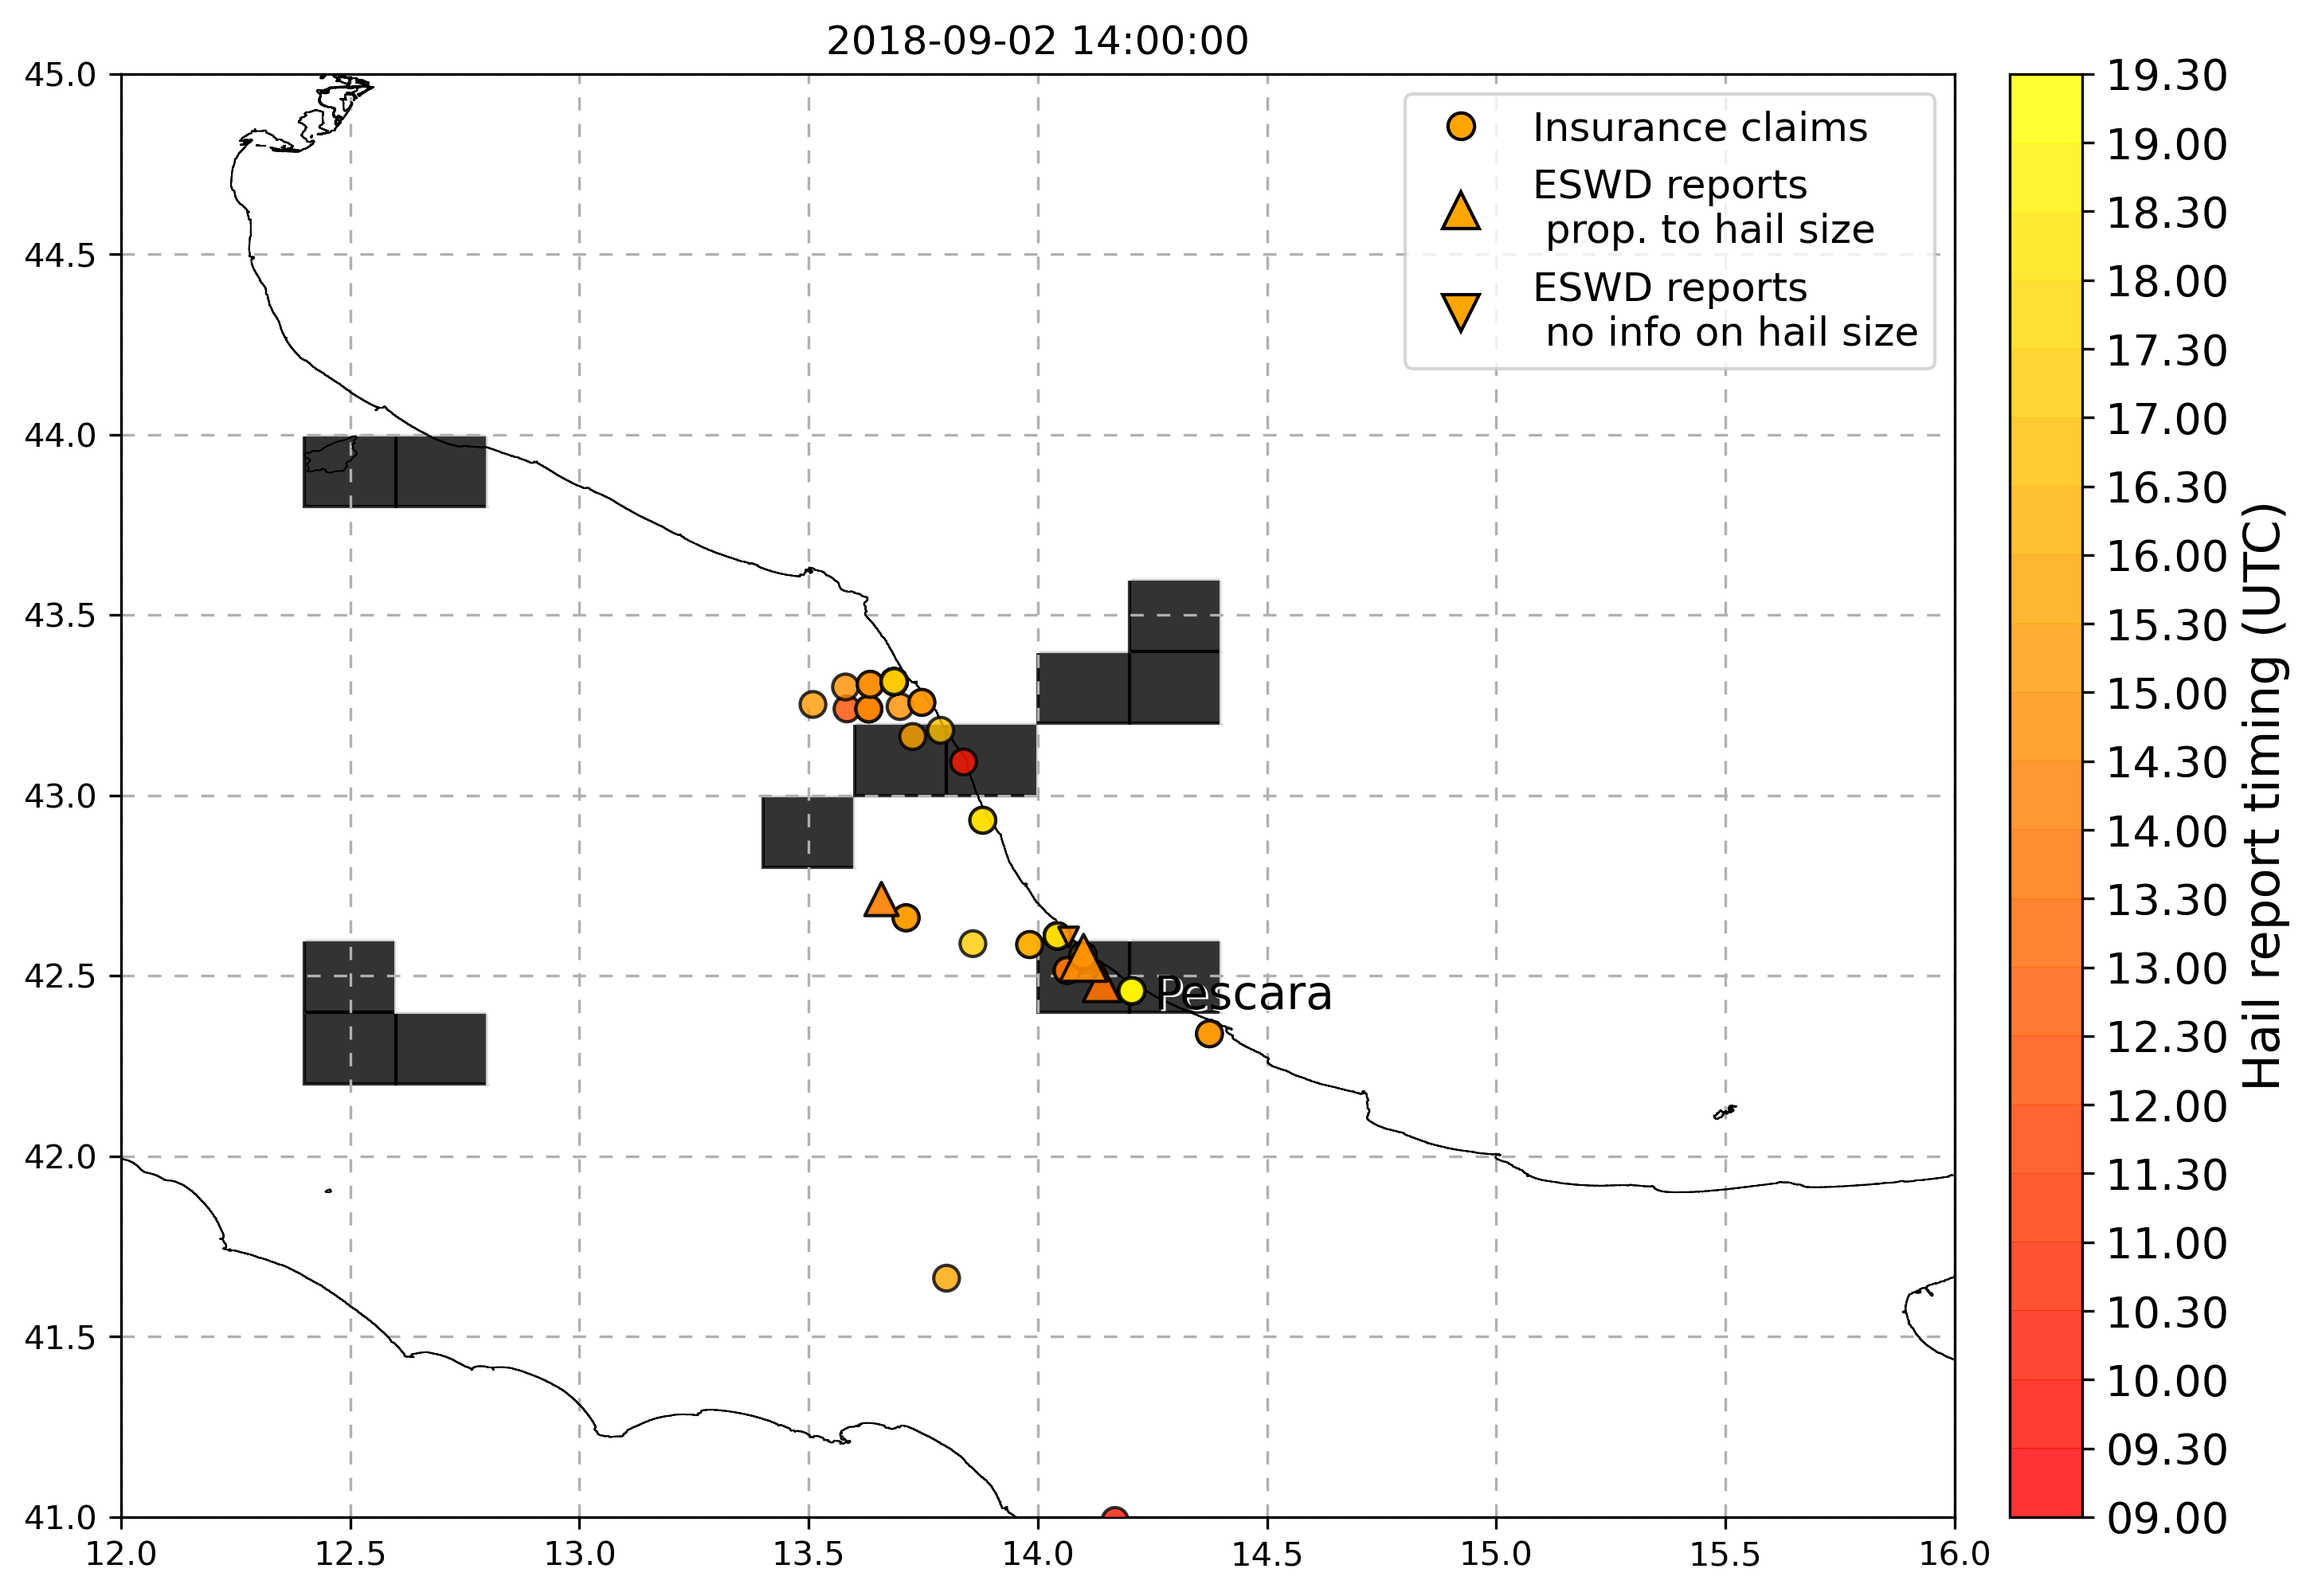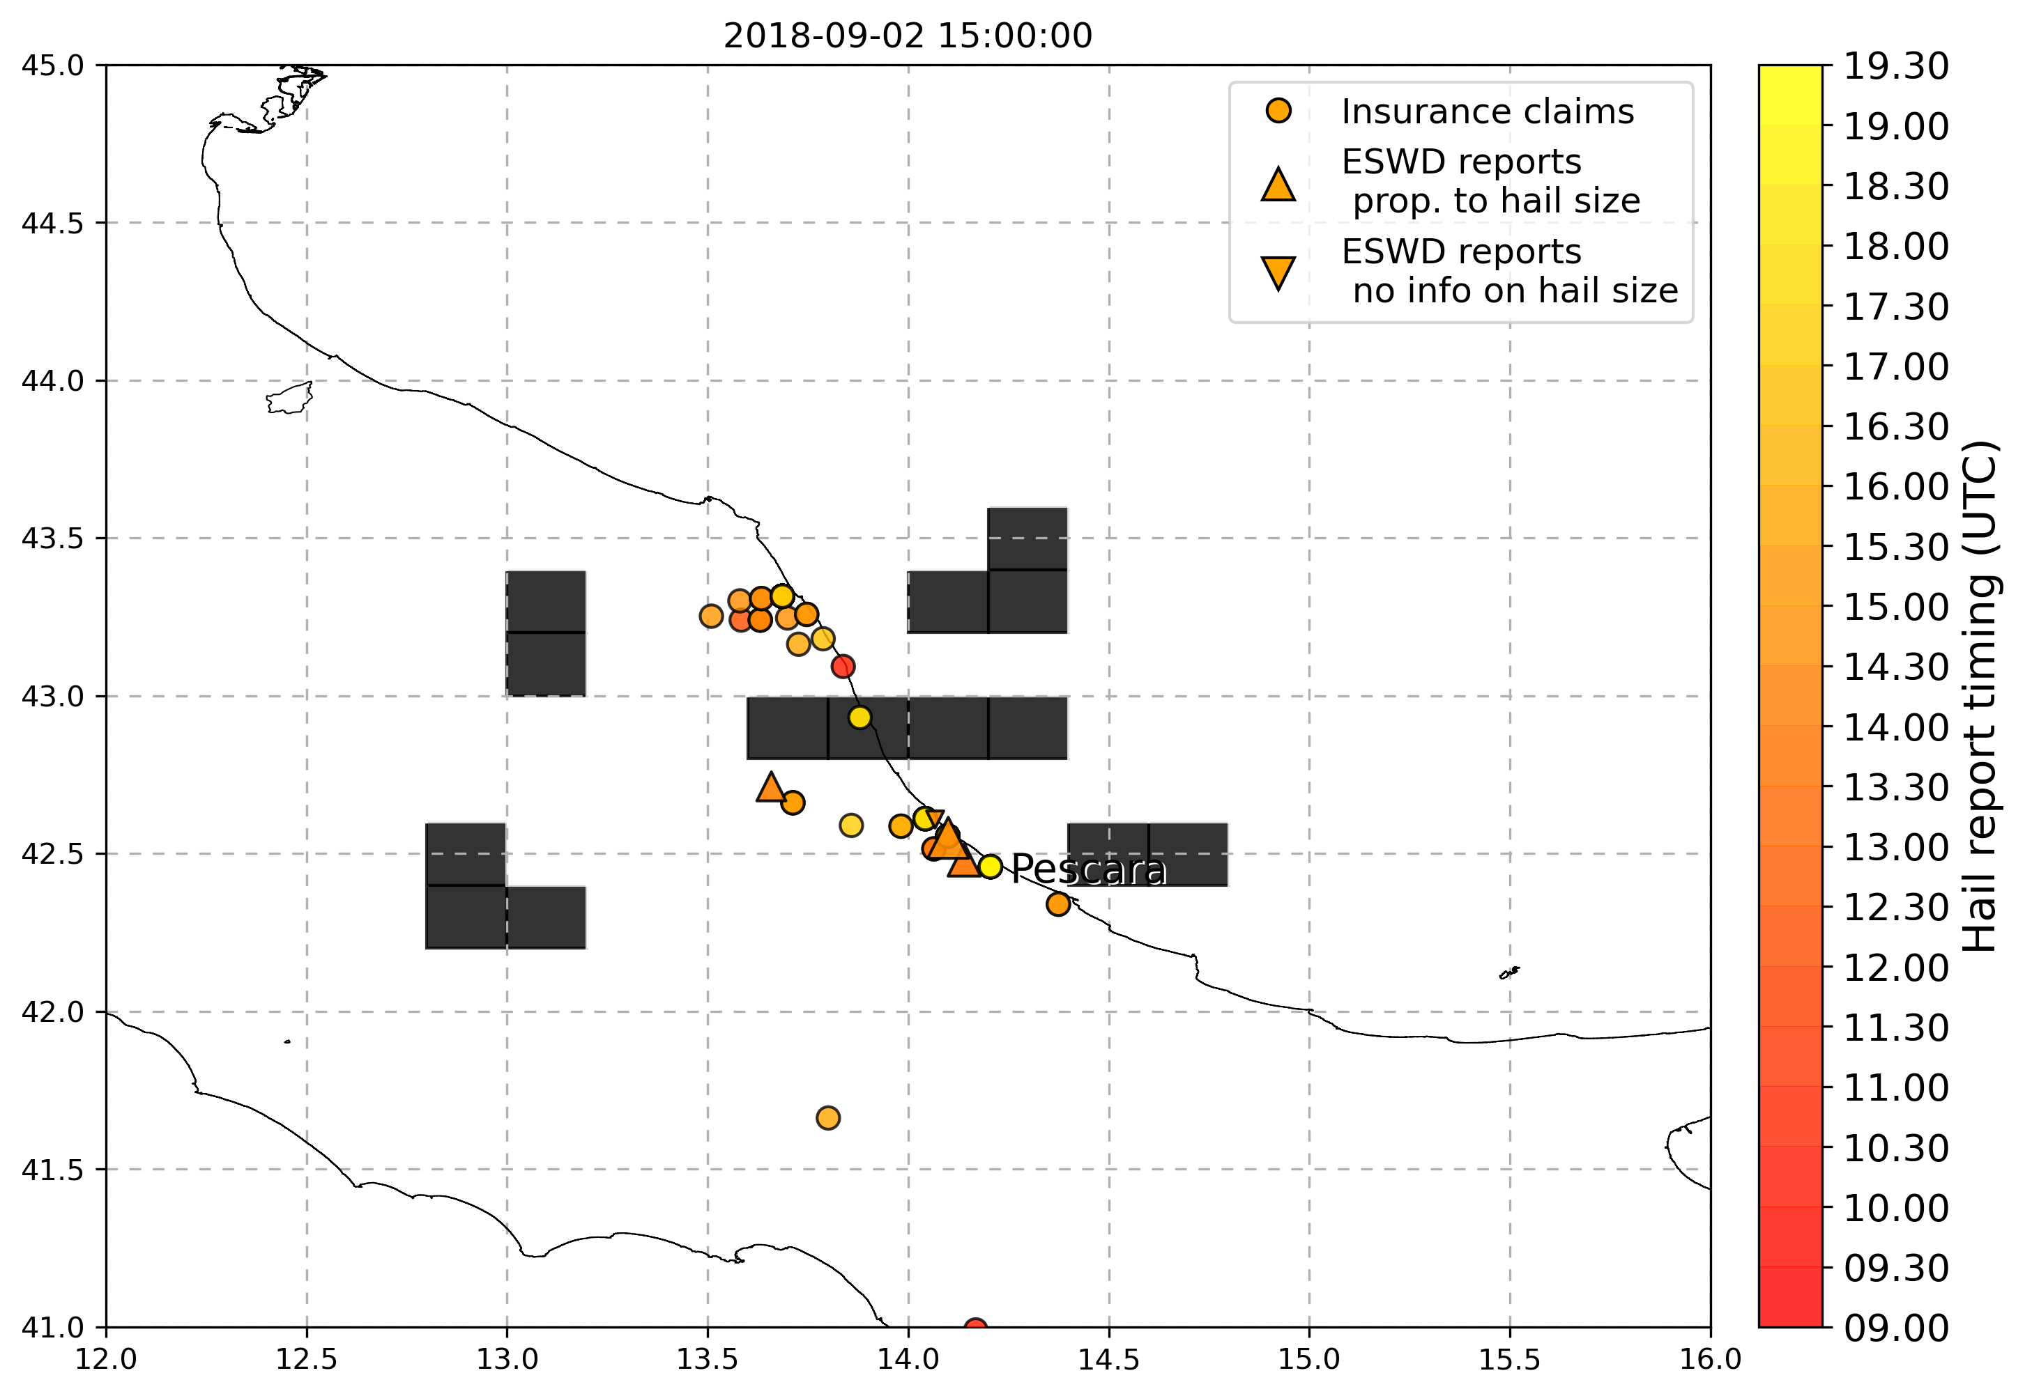

* 23 July 2018 (Bari): various eswd/unipol reports, good match with OT max prob and OT dTmin, and also with LJ index, SPHERA LI daily min instead does not match with hailstorm event location, while Kindex is a little better but both params present peaks associated to hail in a large region nearby the event but not specifically in the location of the event

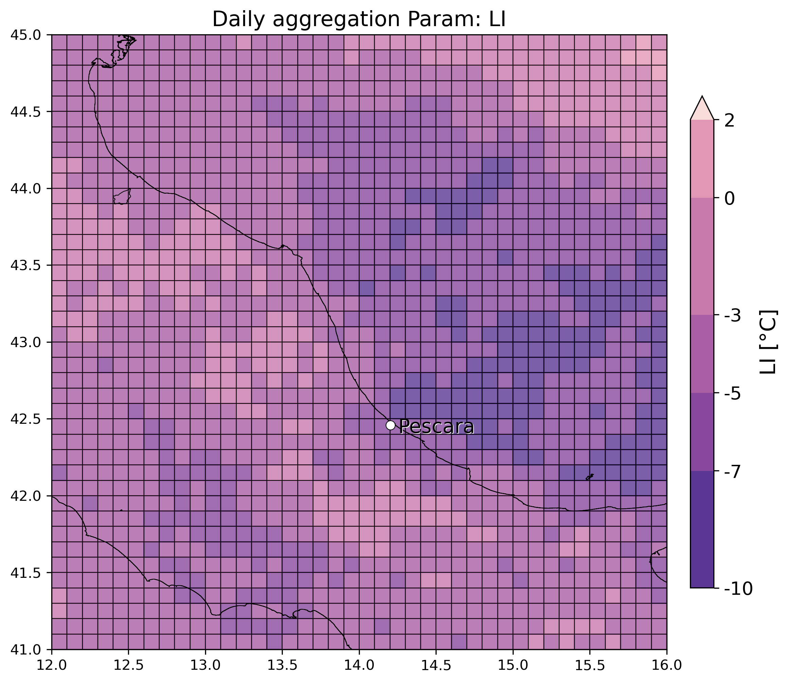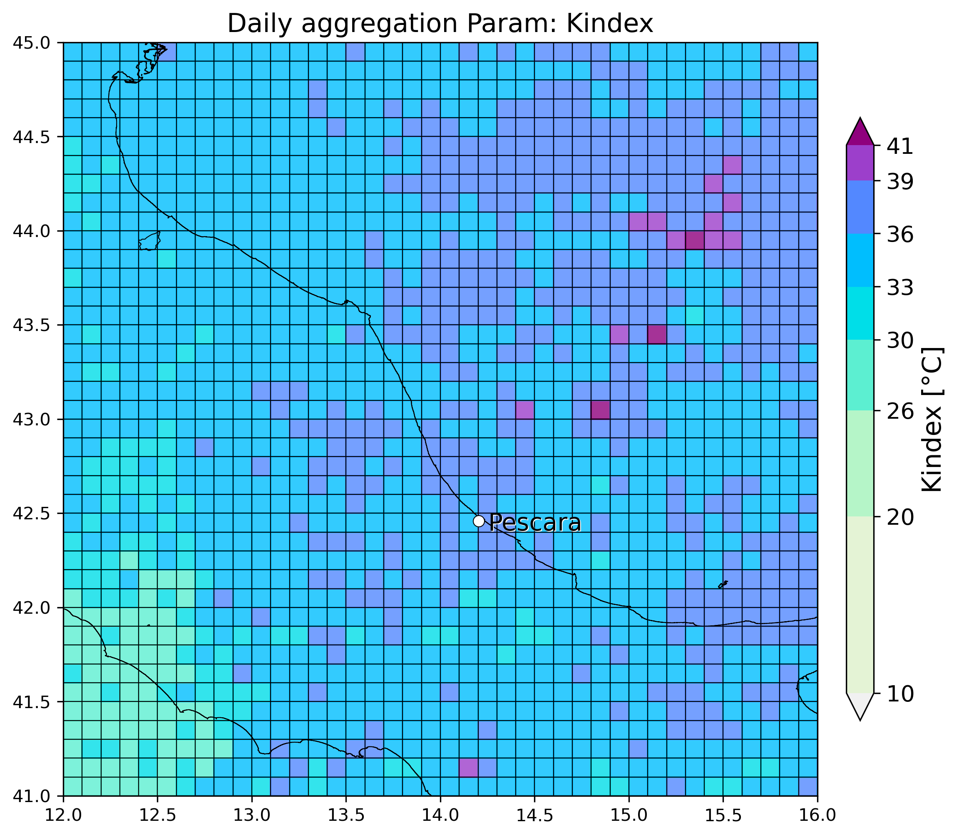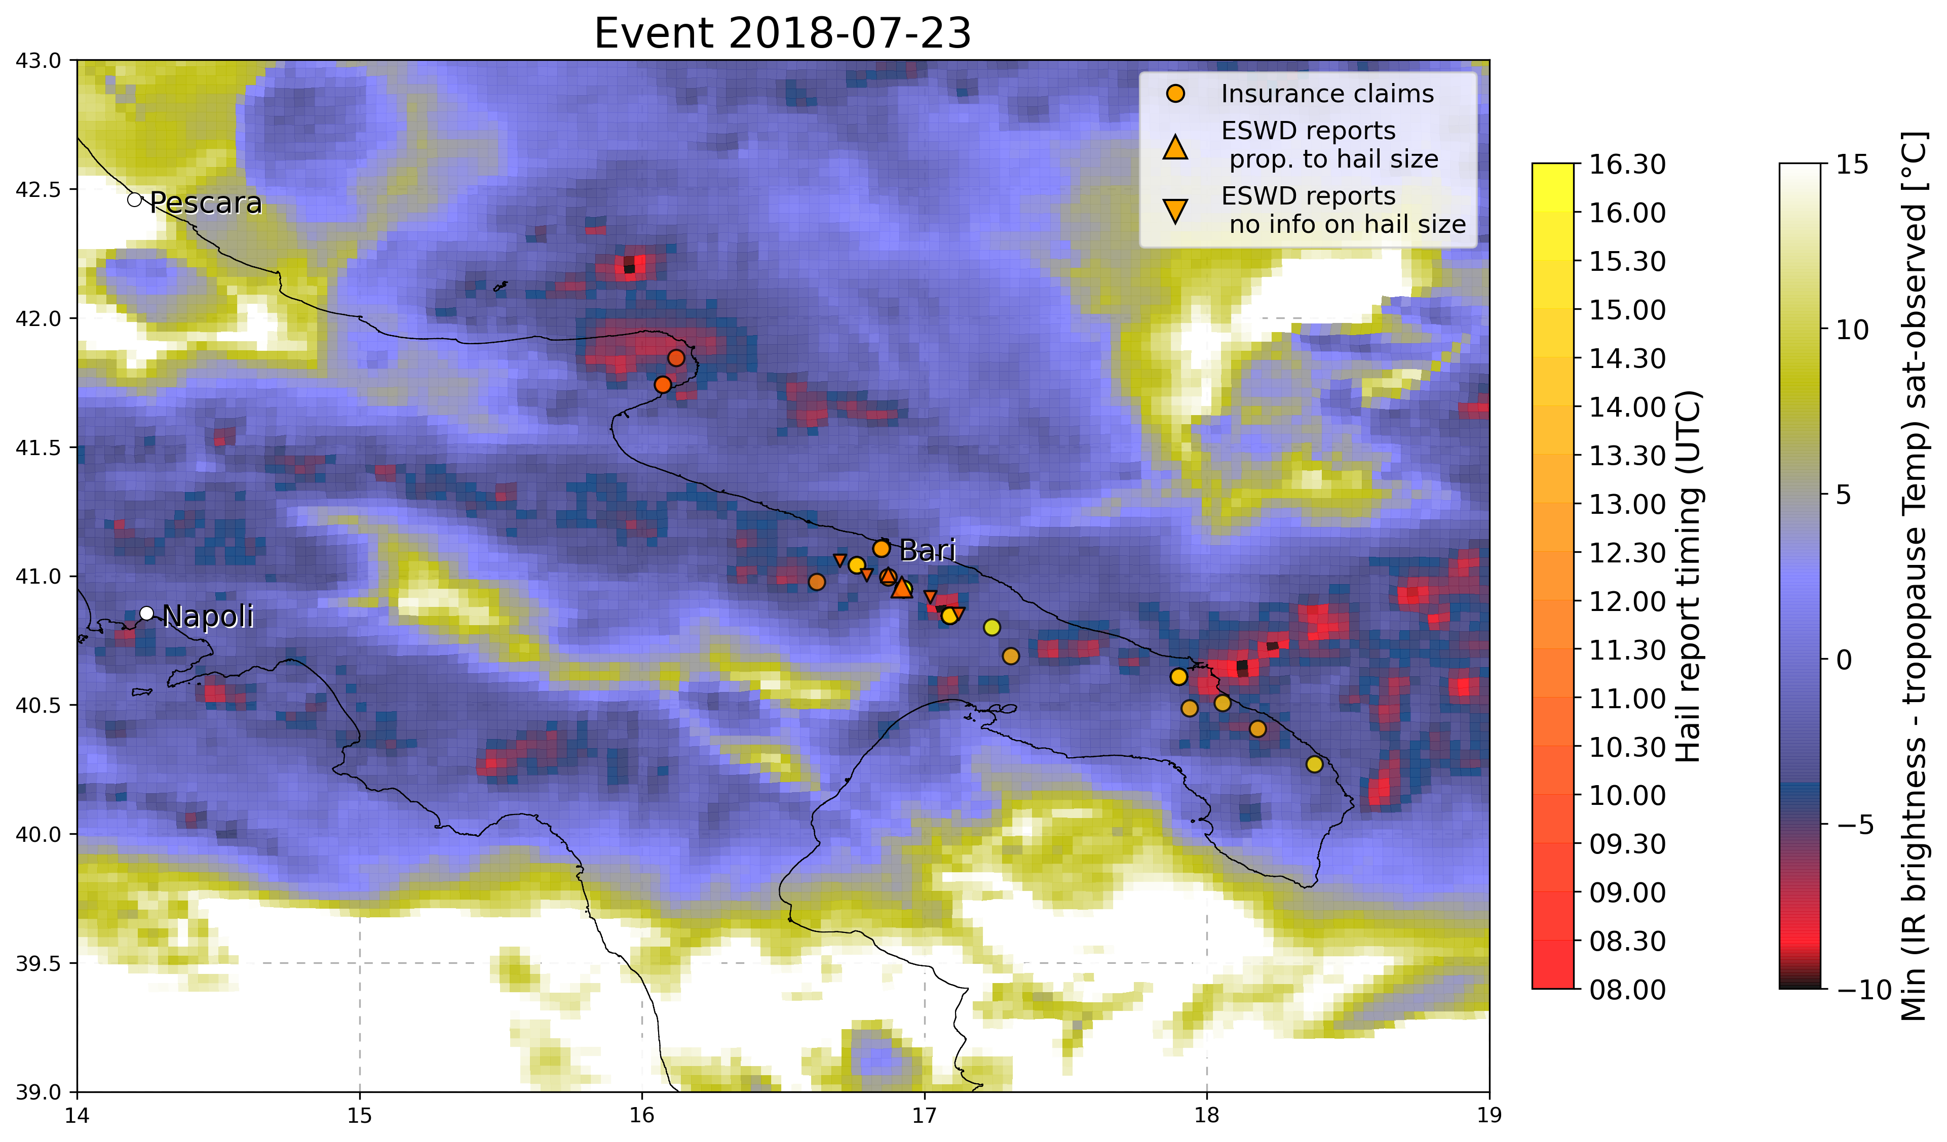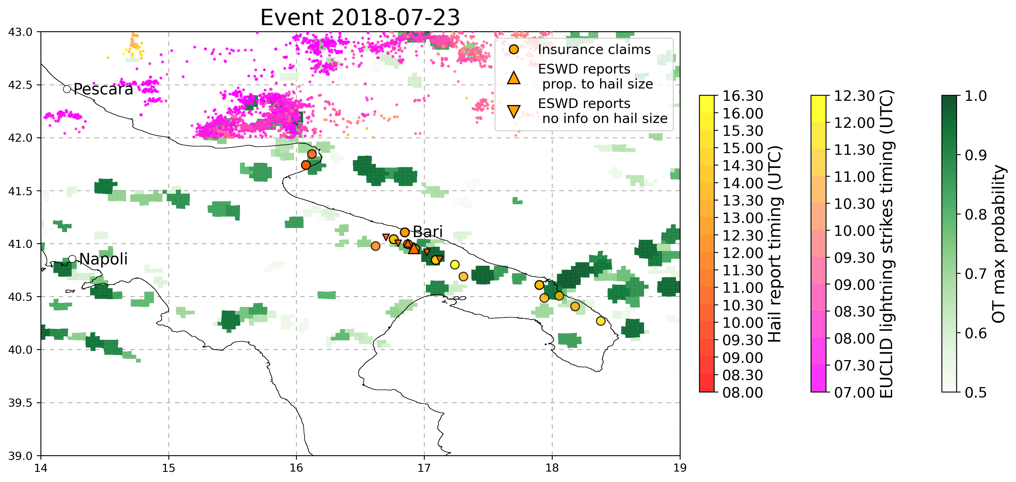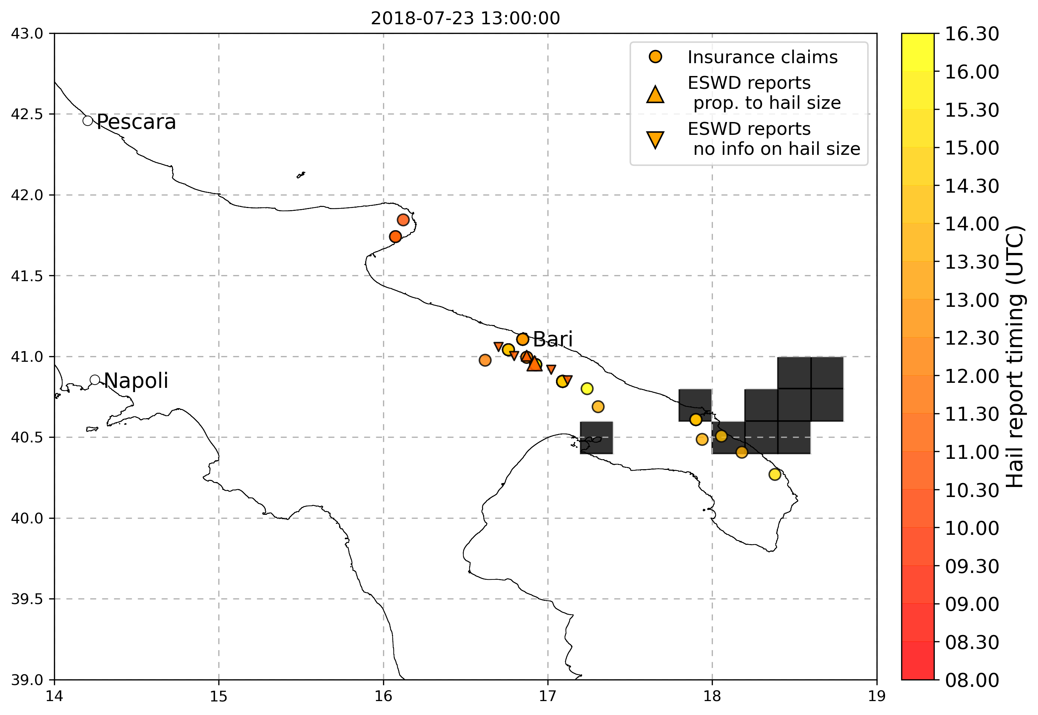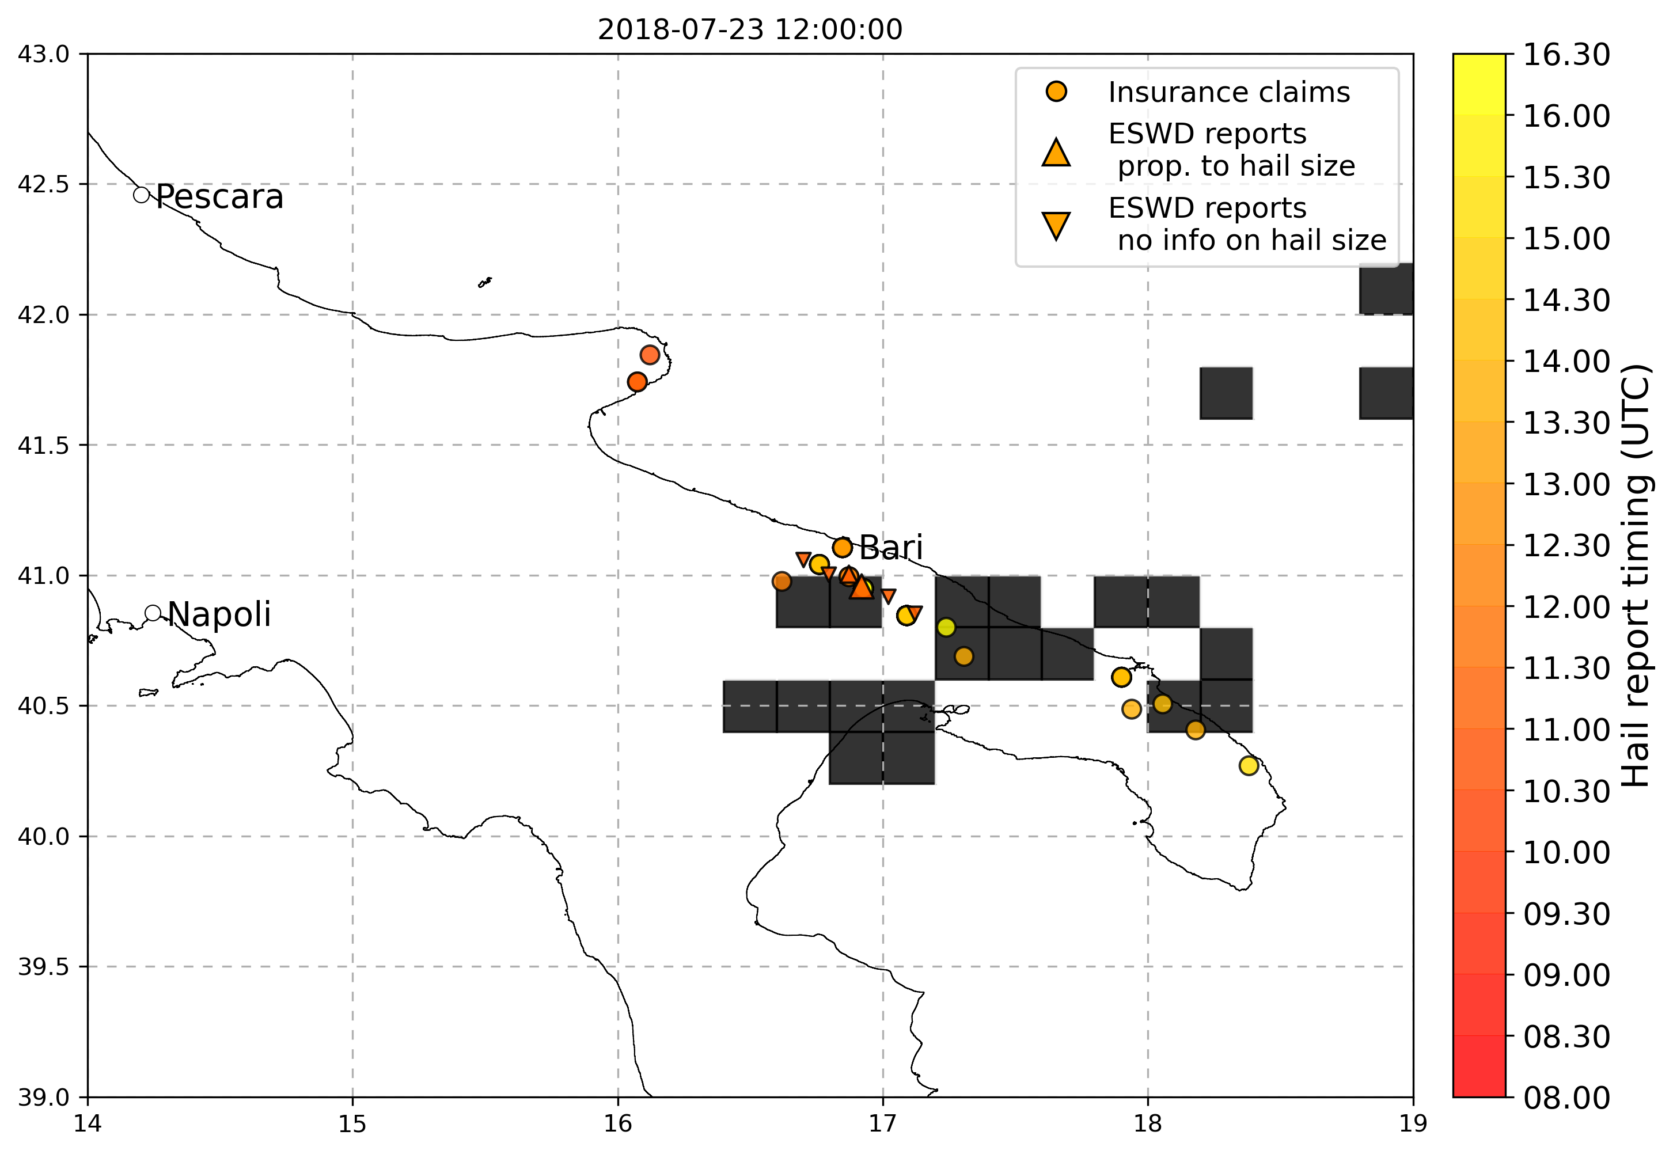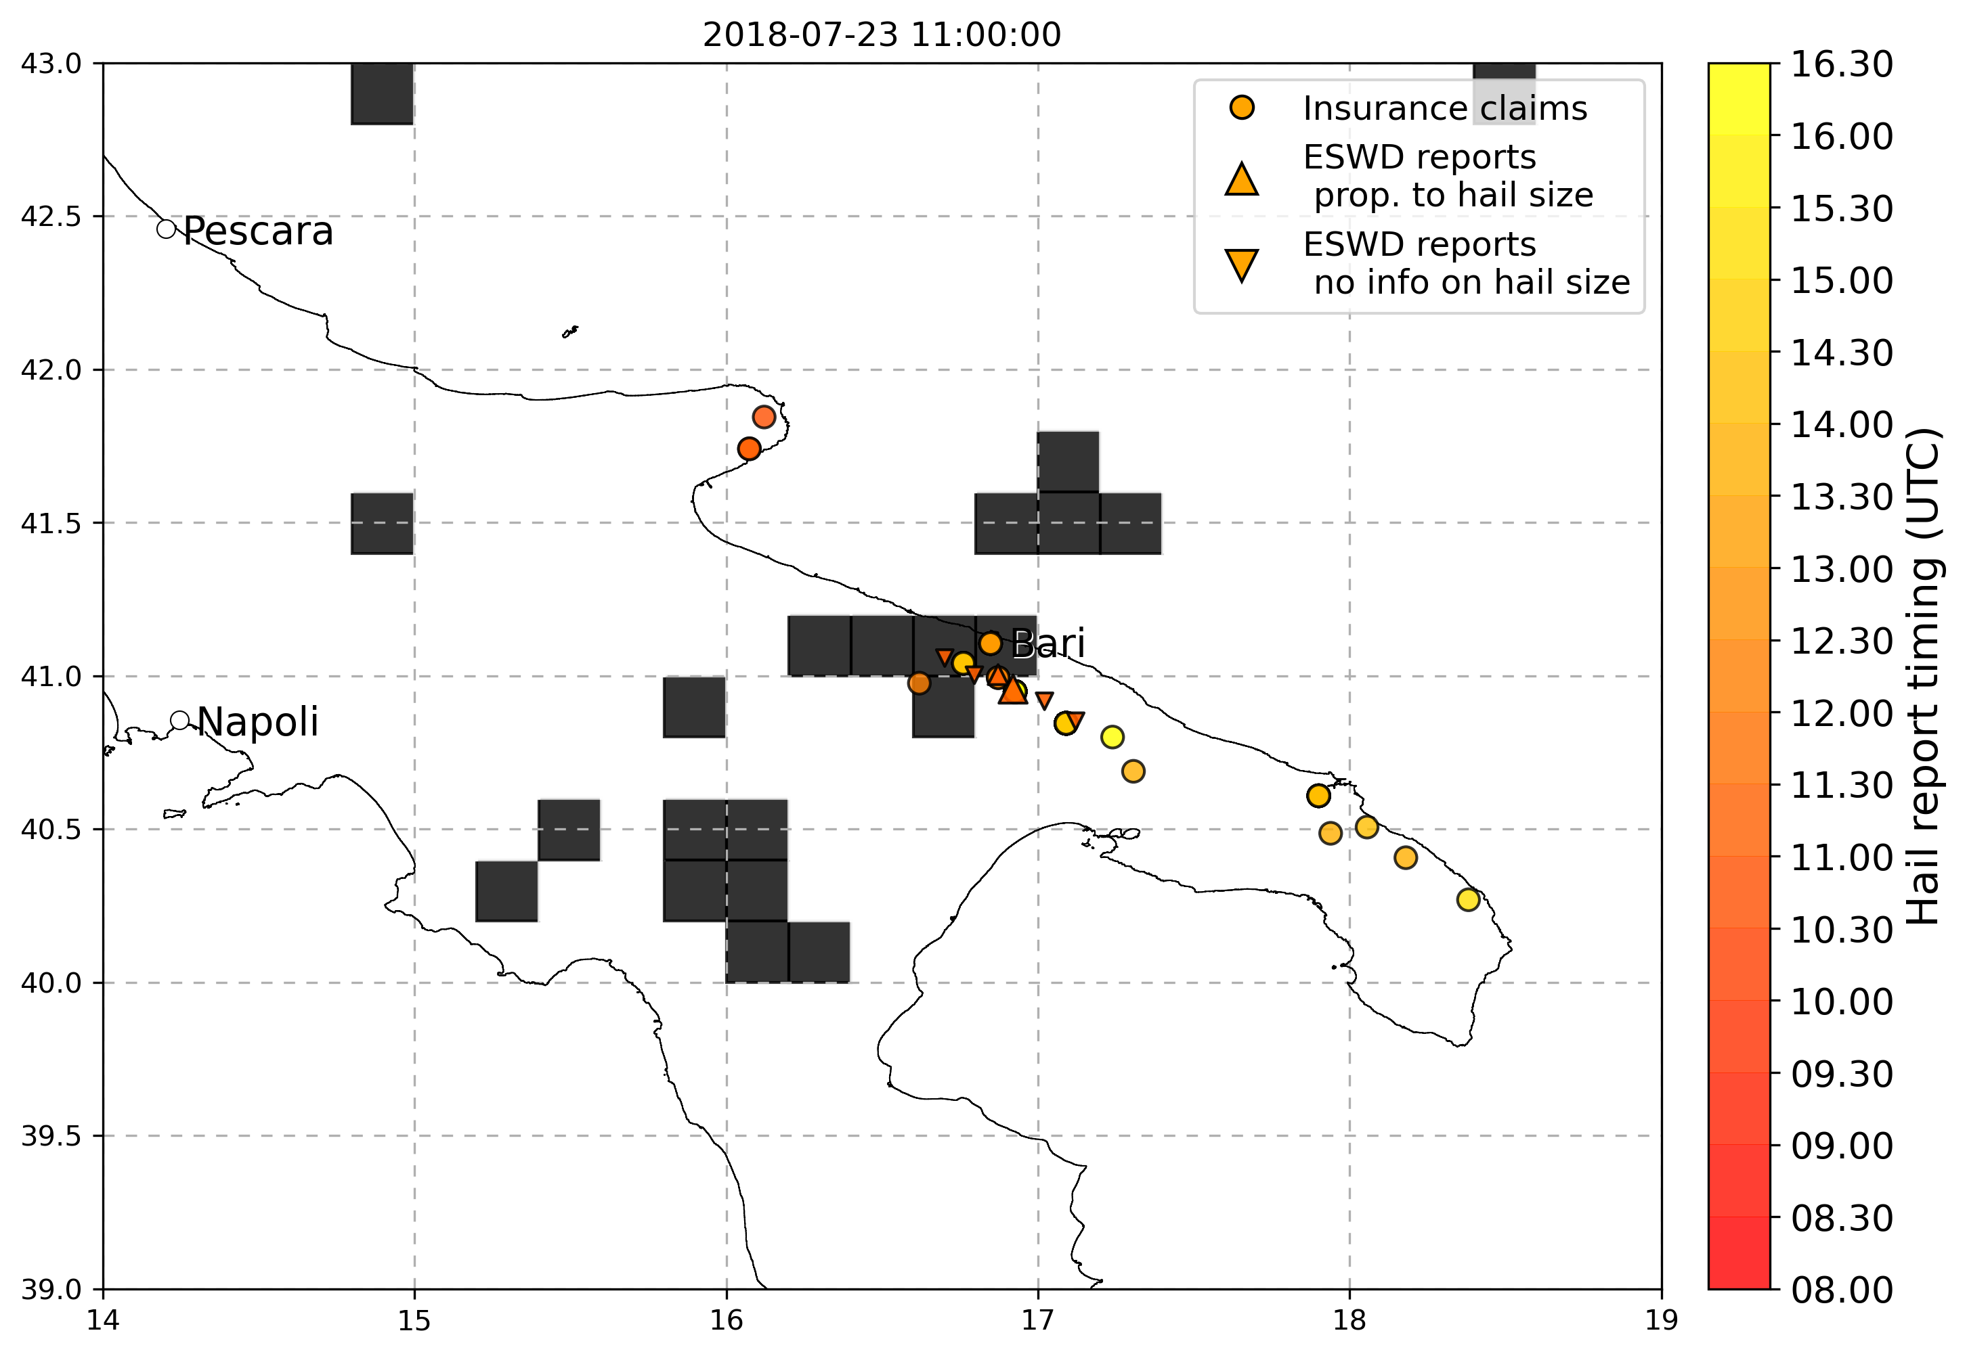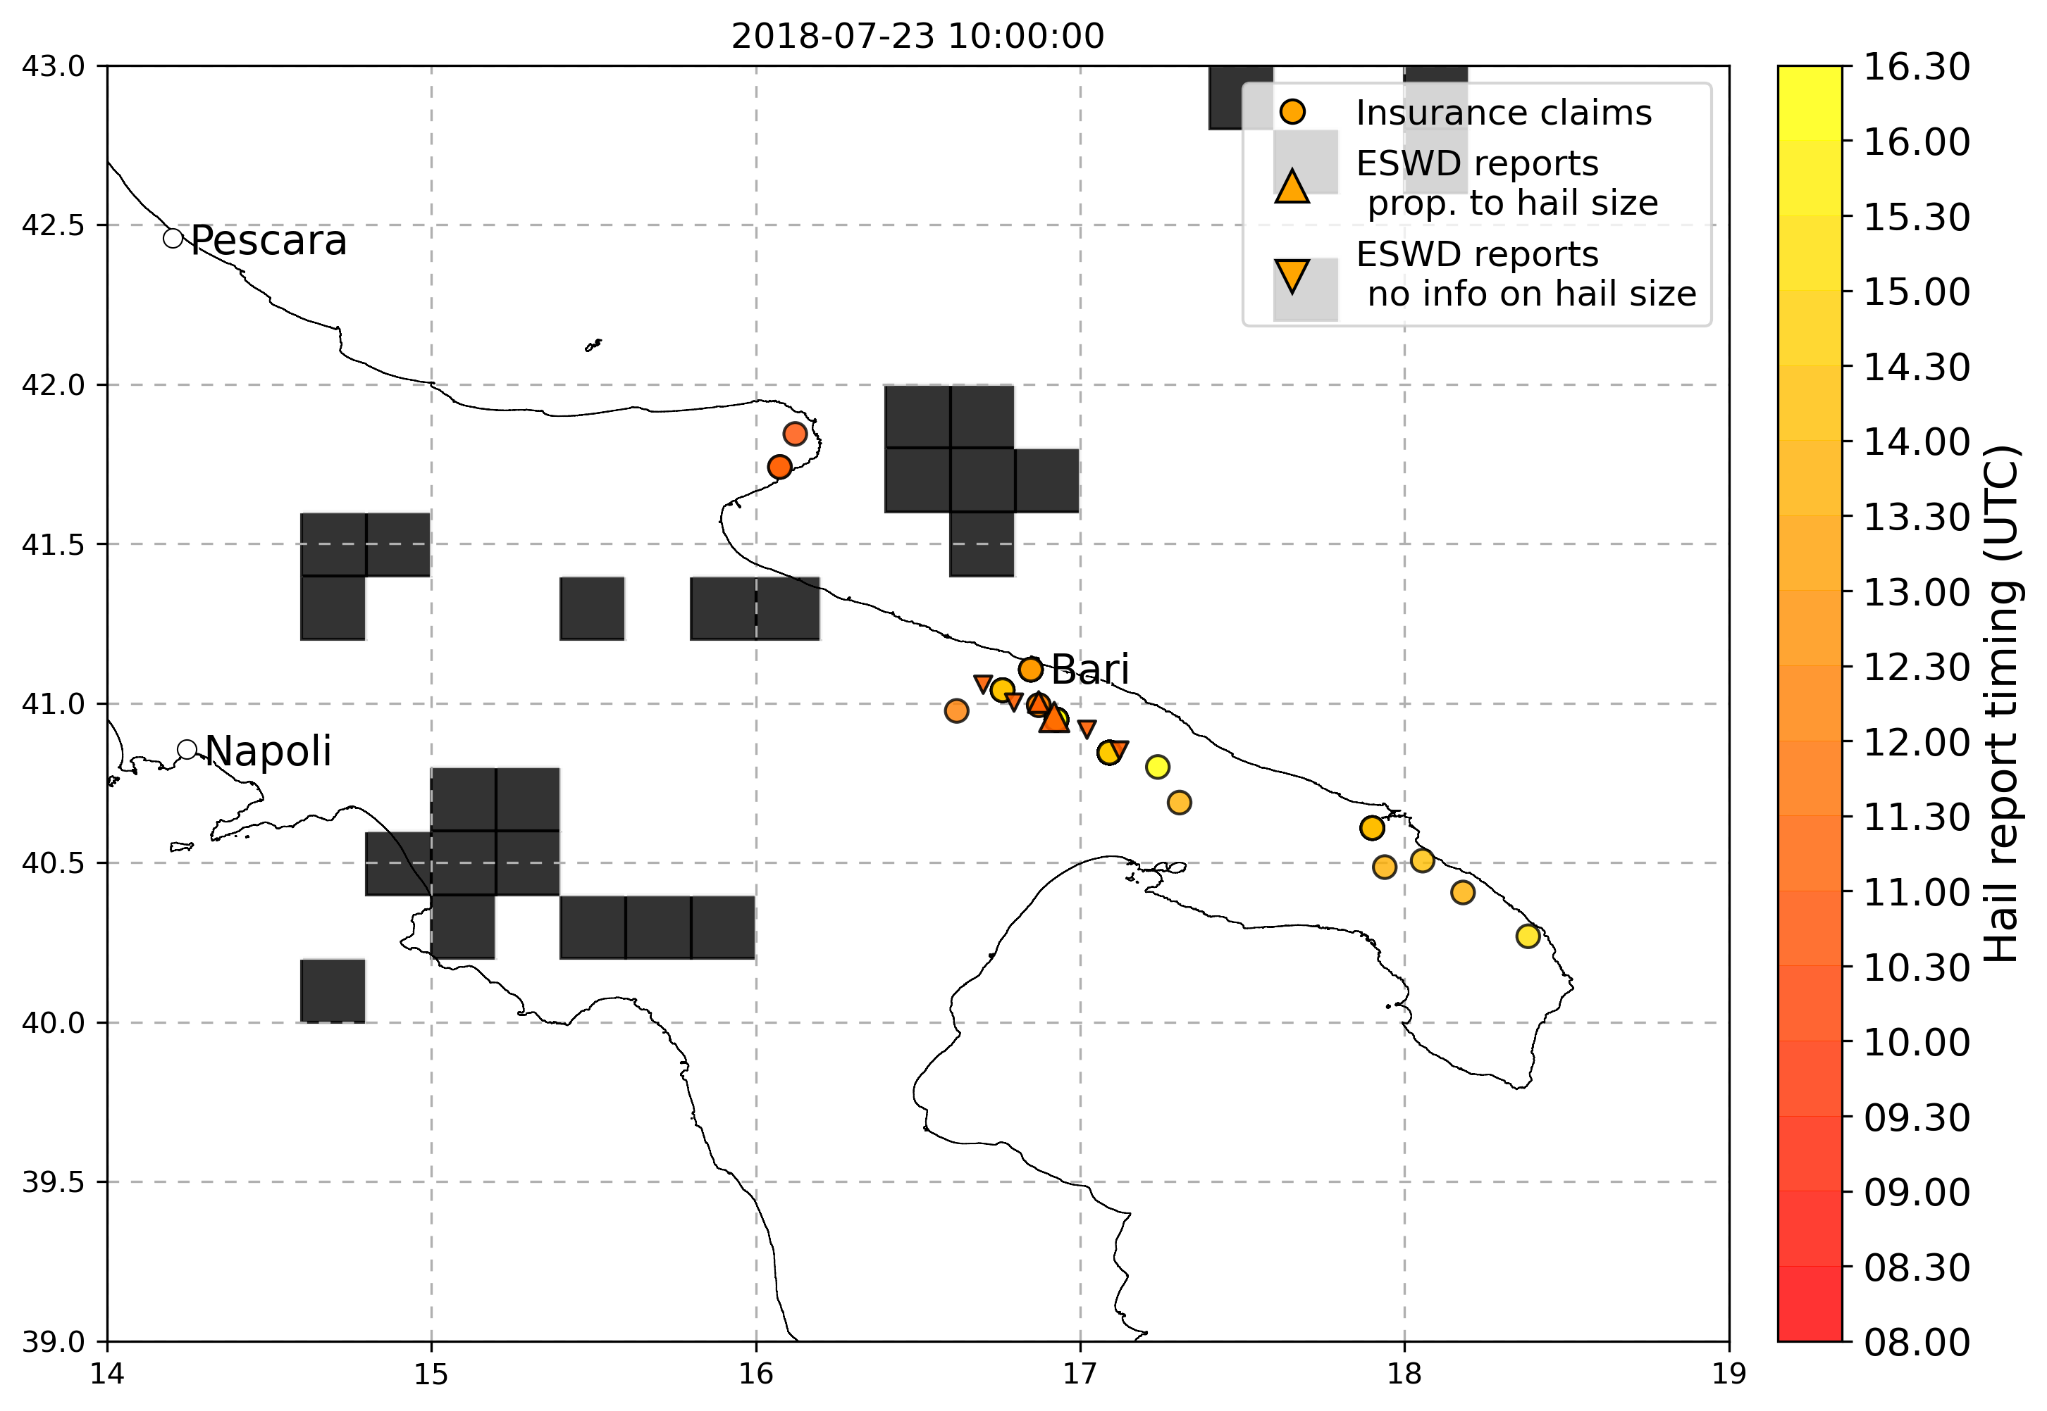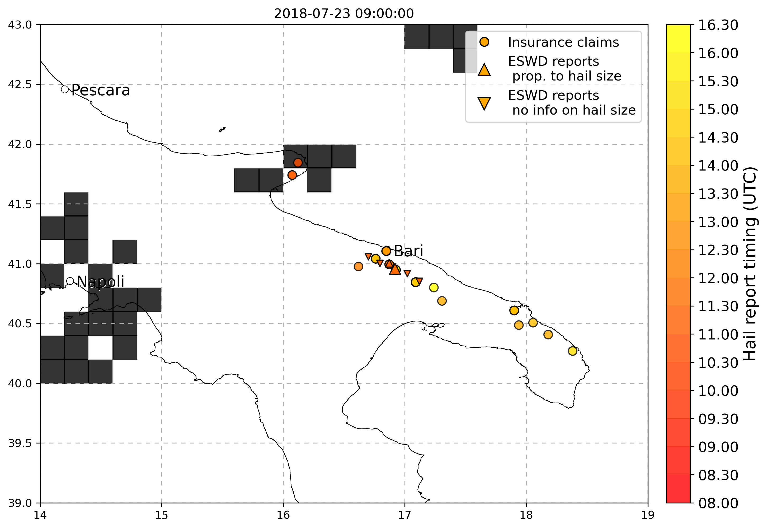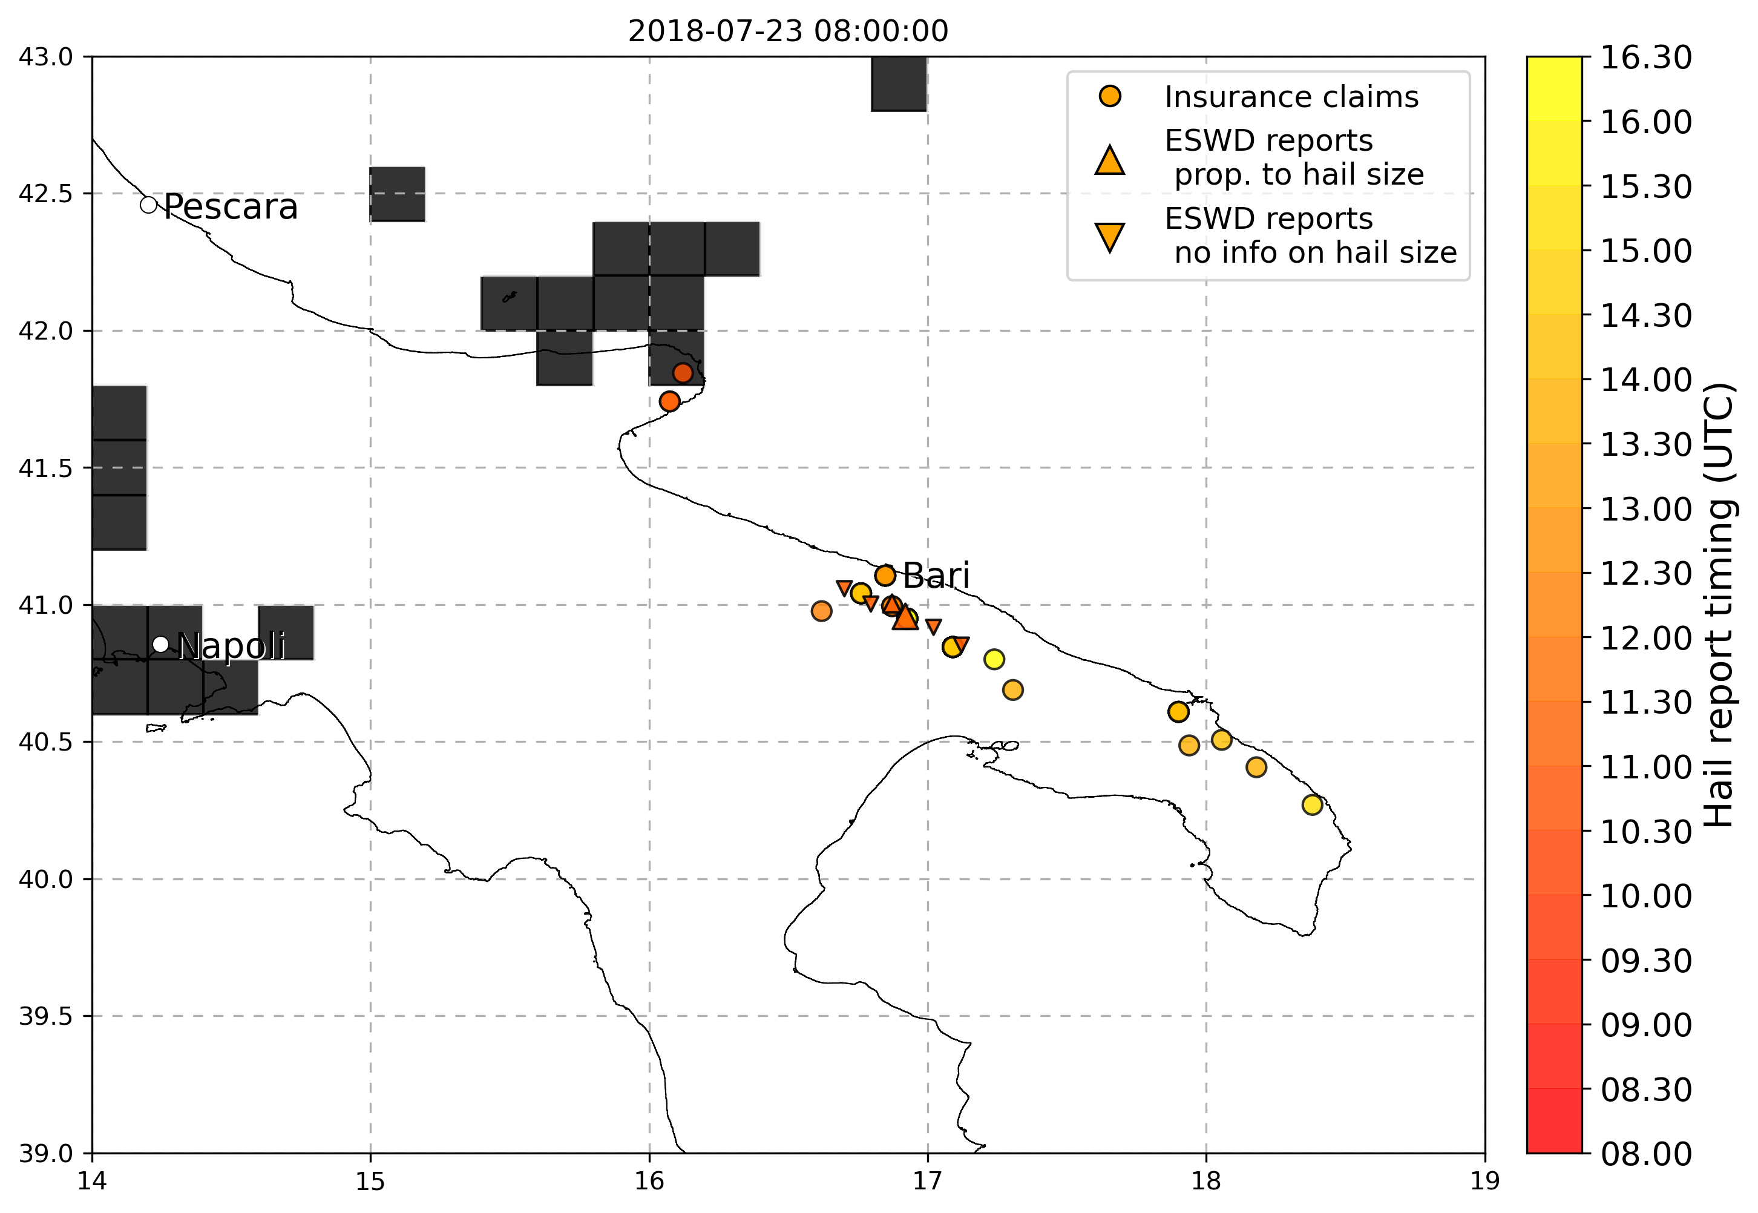

* 9-10 August 2017 Trentino: various eswd/unipol reports in both days, good match with OT max prob and dTmin (better on the 9th), good match with LJ index on the 9th while no LJ occurrences detected during the 10th. SPHERA LI index shows a peak in daily minimum well matched with hail reports on the 9th while on the 10th is a little lower, similarly the Kindex:

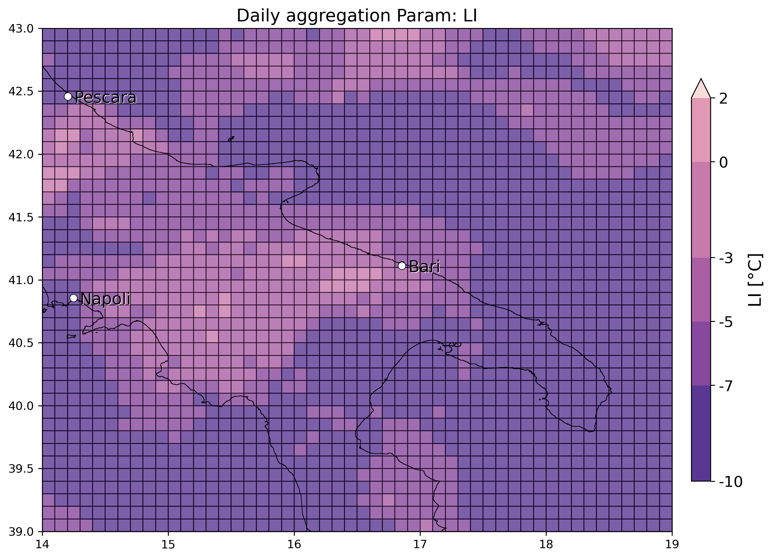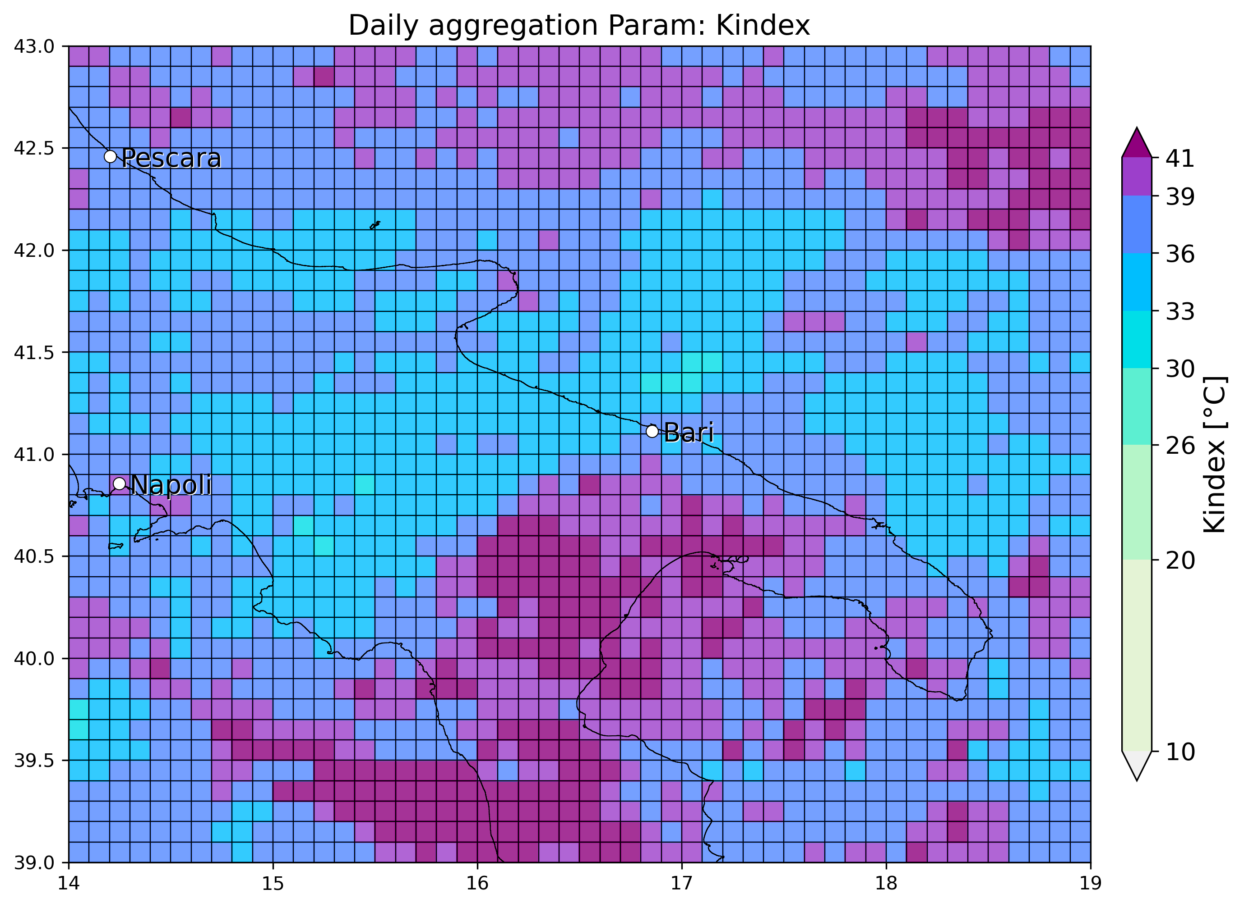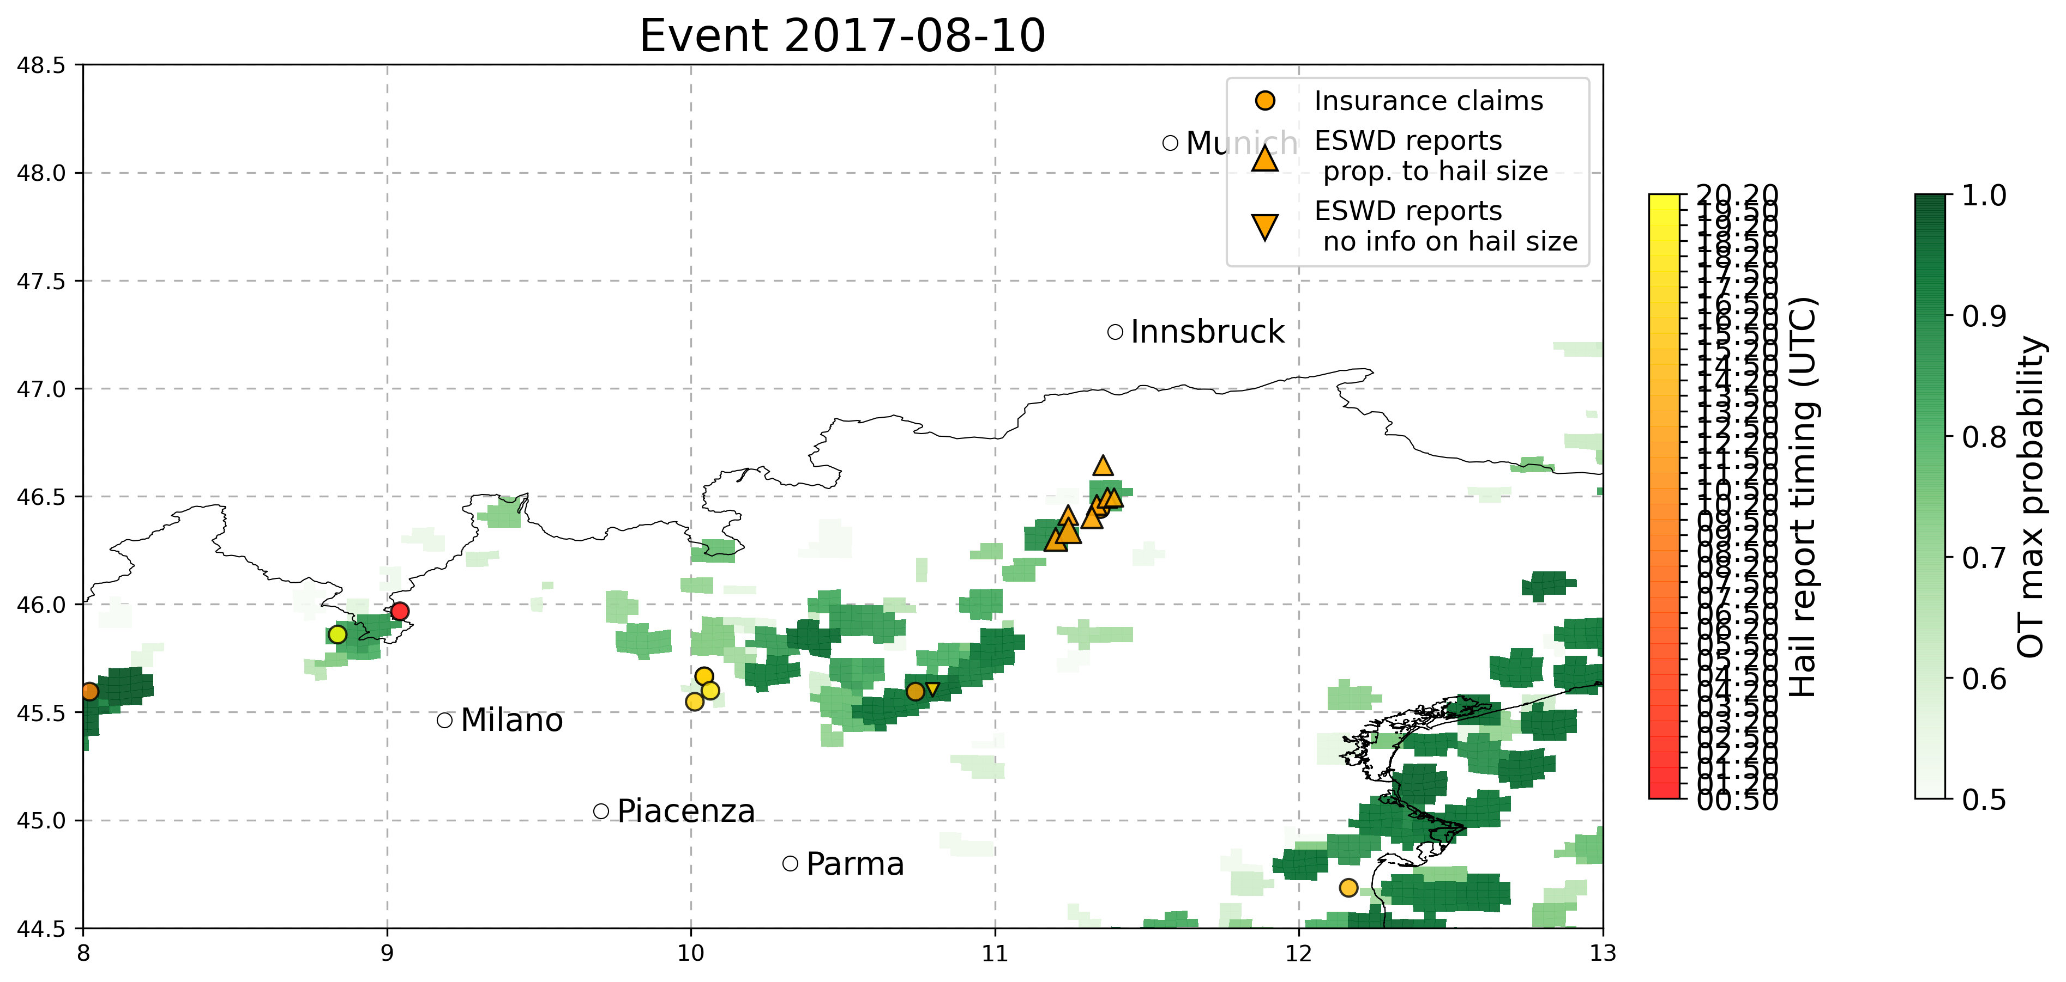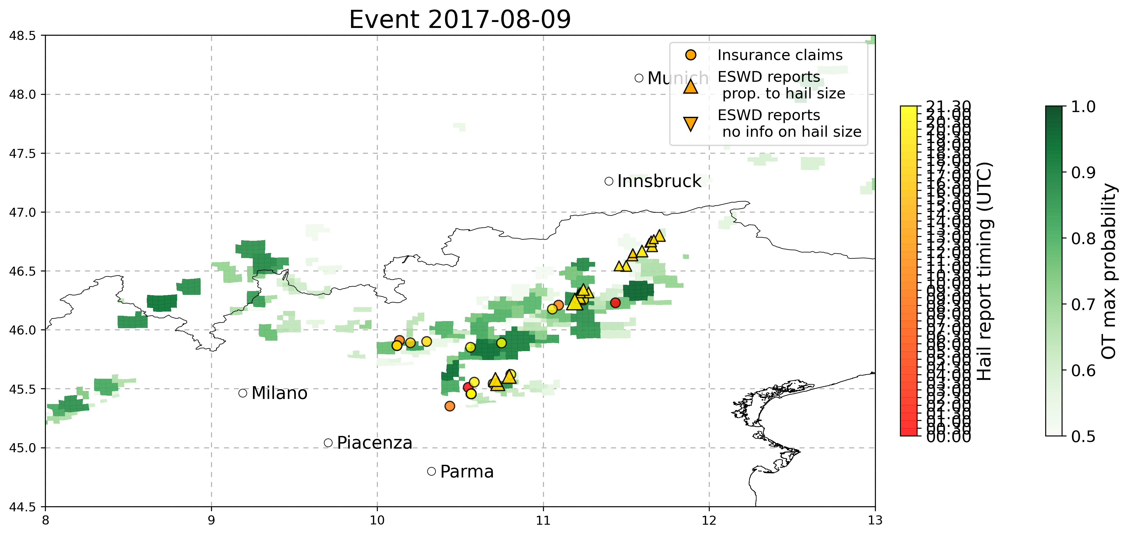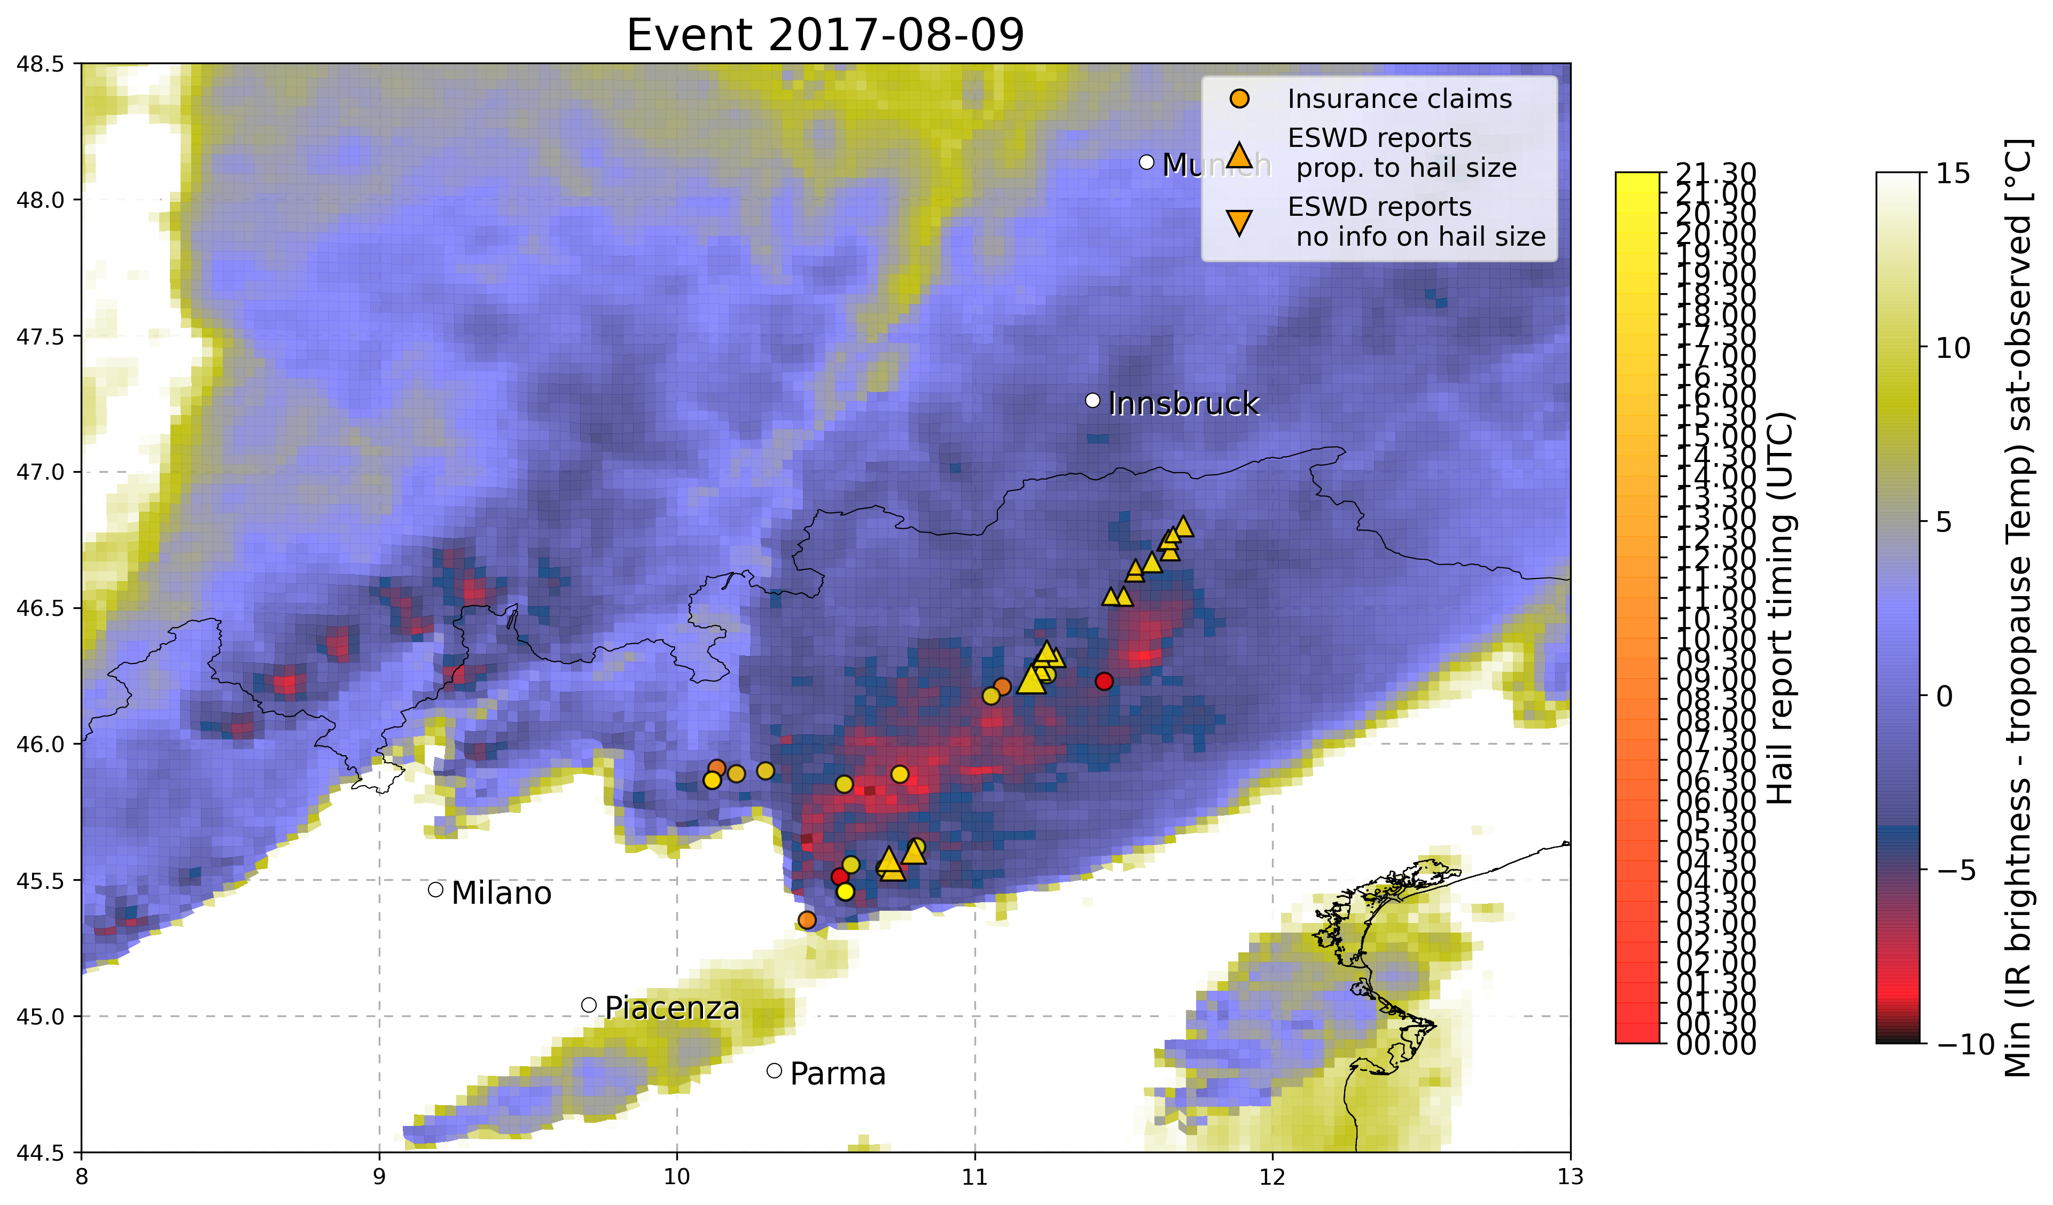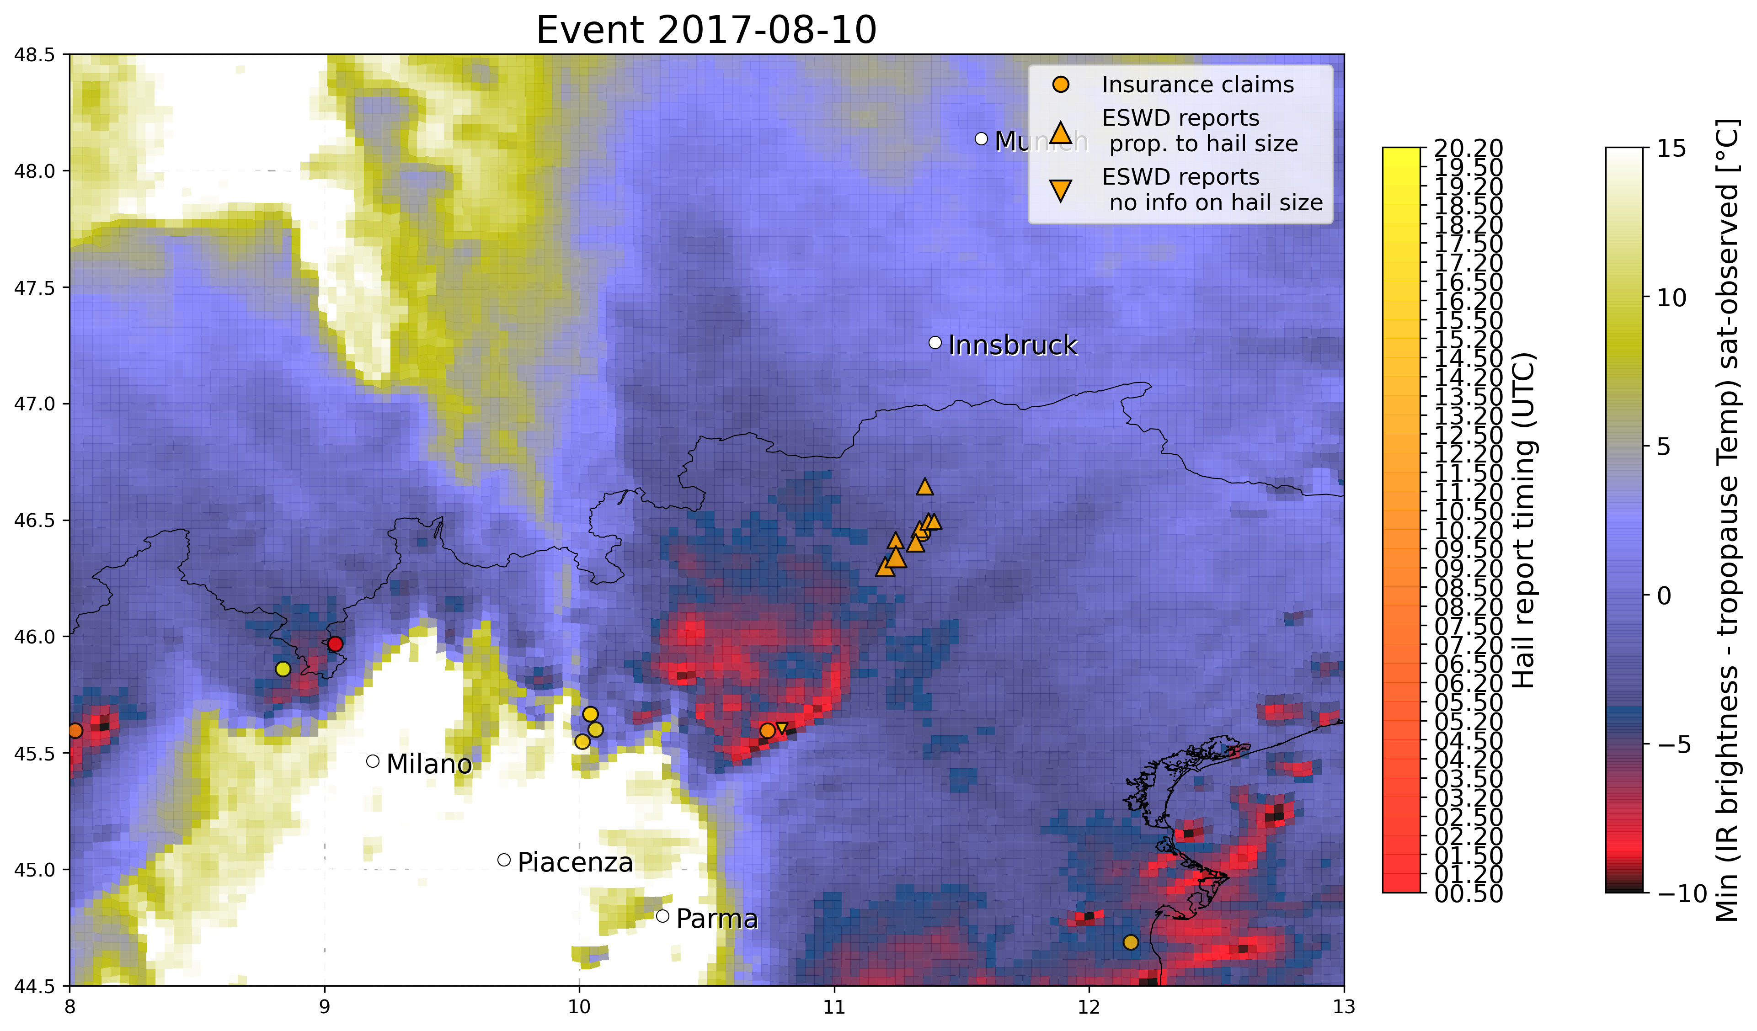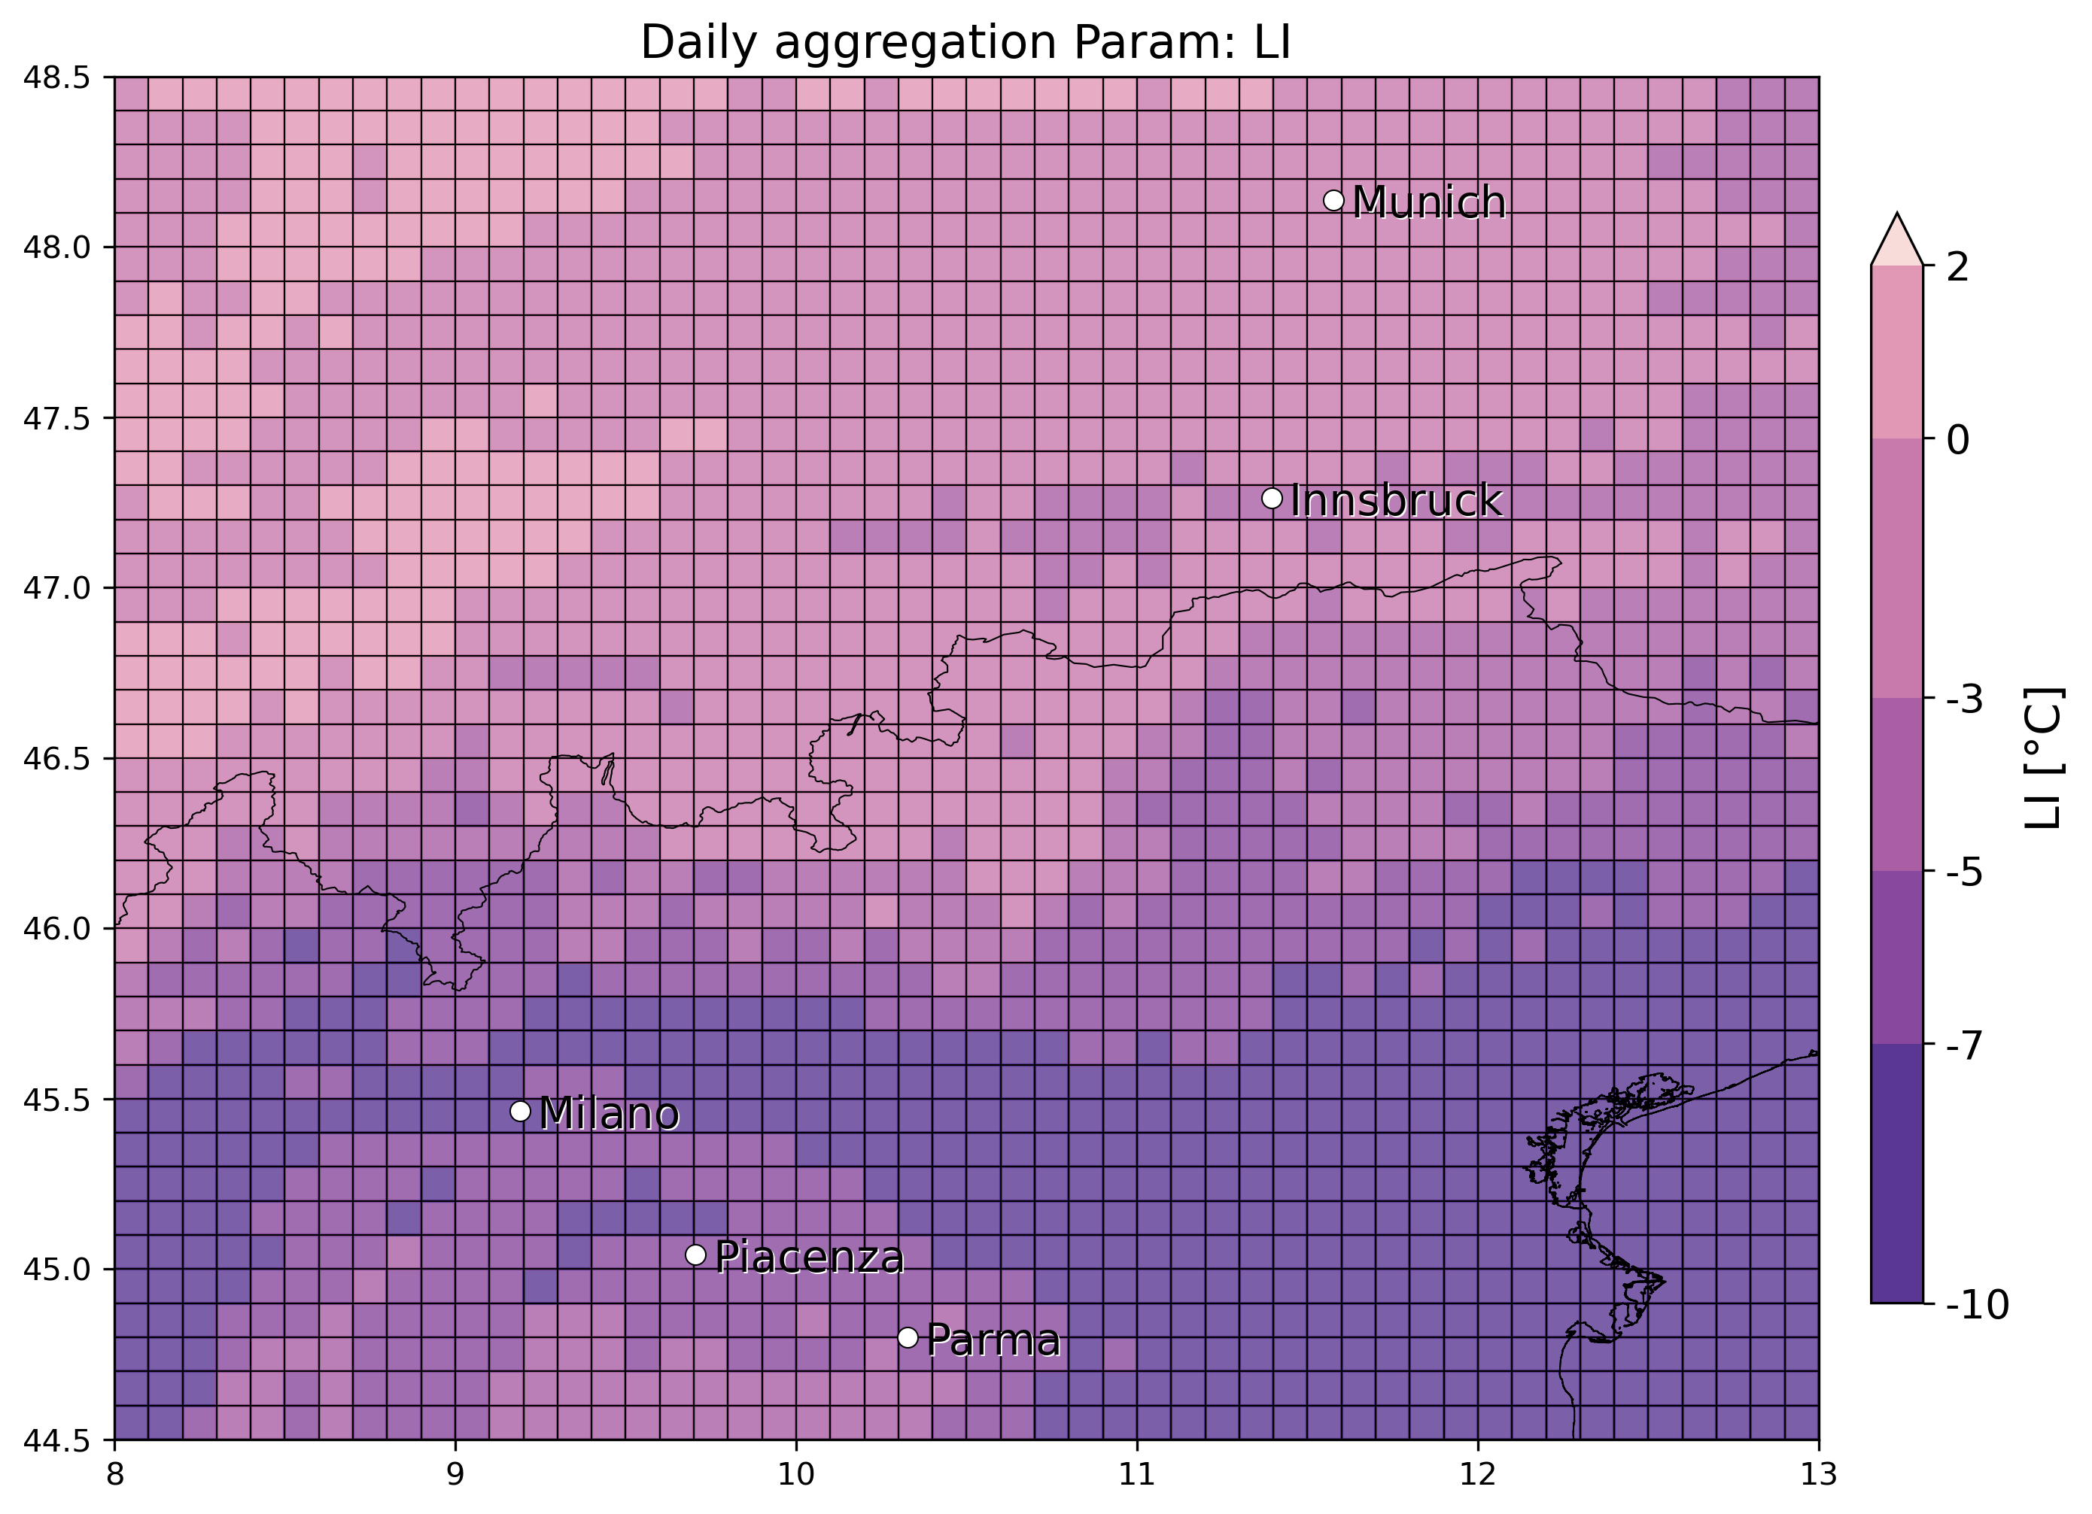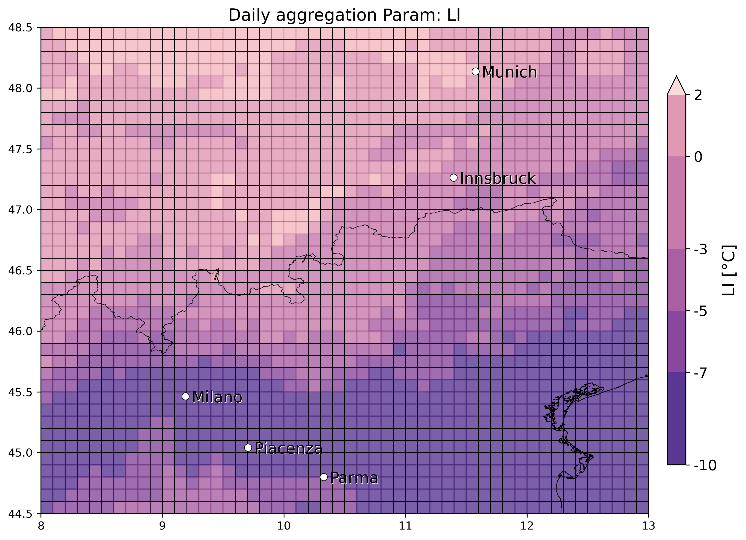

* 28 June 2017 Nord Italy (multiple hailstorms): several eswd/unipol reports in many locations, good match with OT max prob, less with OT dTmin especially for the largest hailstones reported in Vicenza, good match also with LJ index. SPHERA daily LI/Kindex min/max peaks detected in the vicinity of all the hail reports considered.

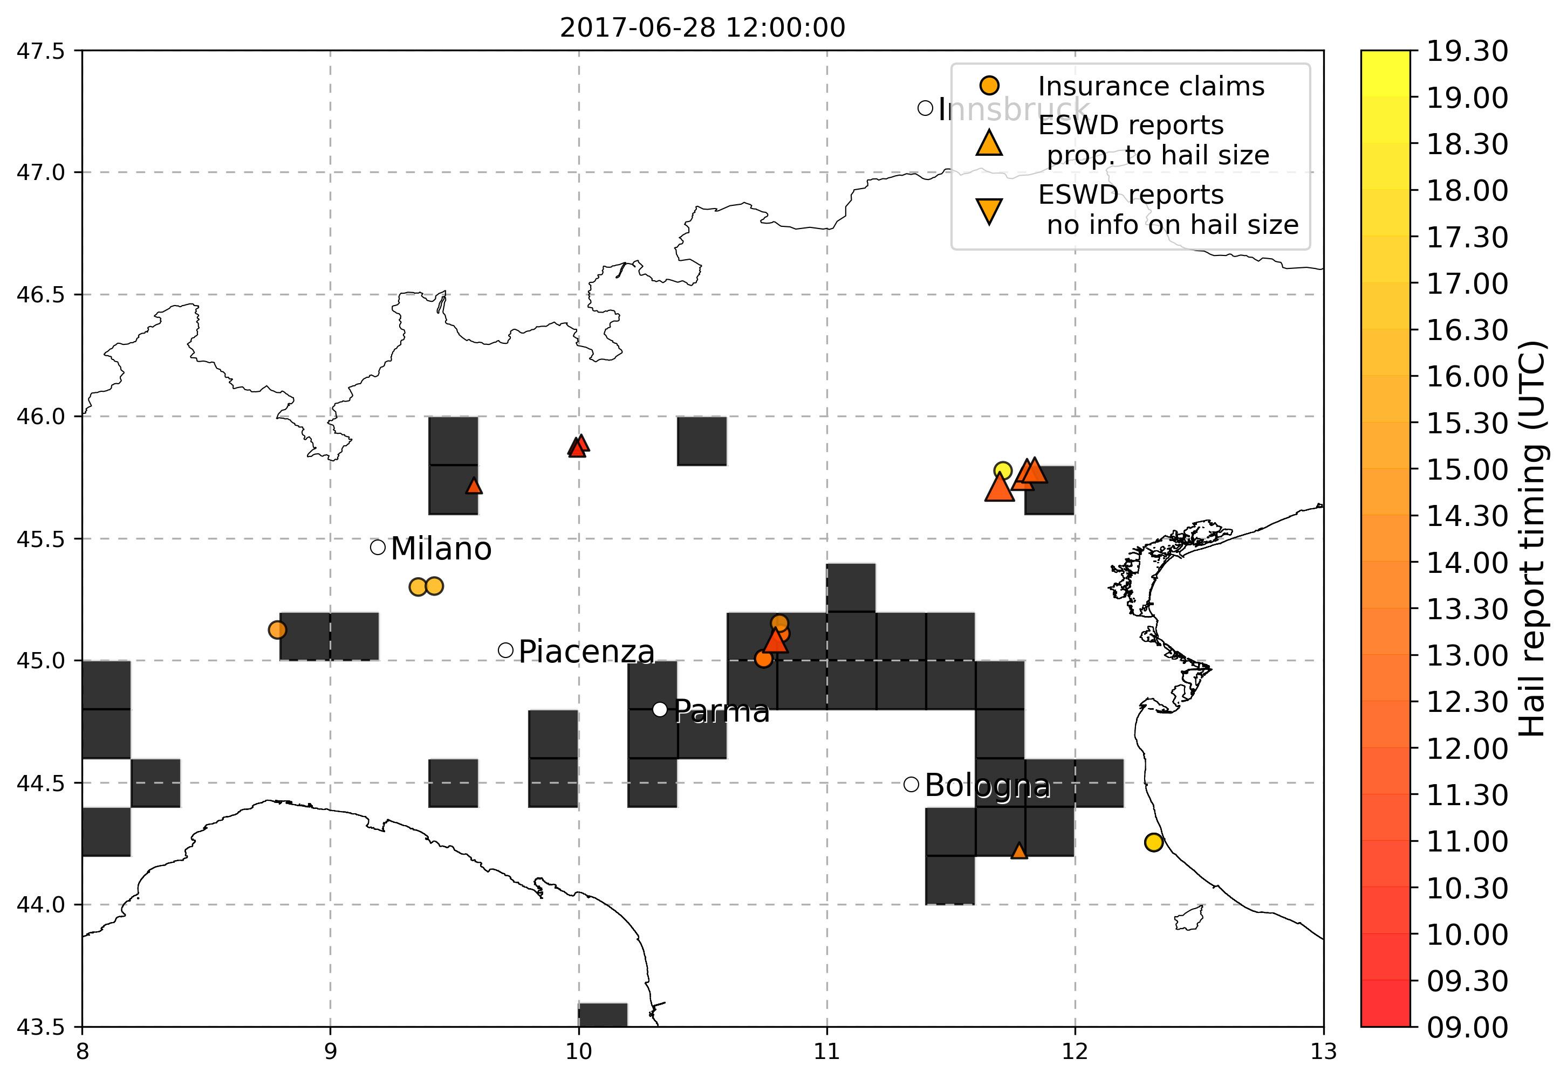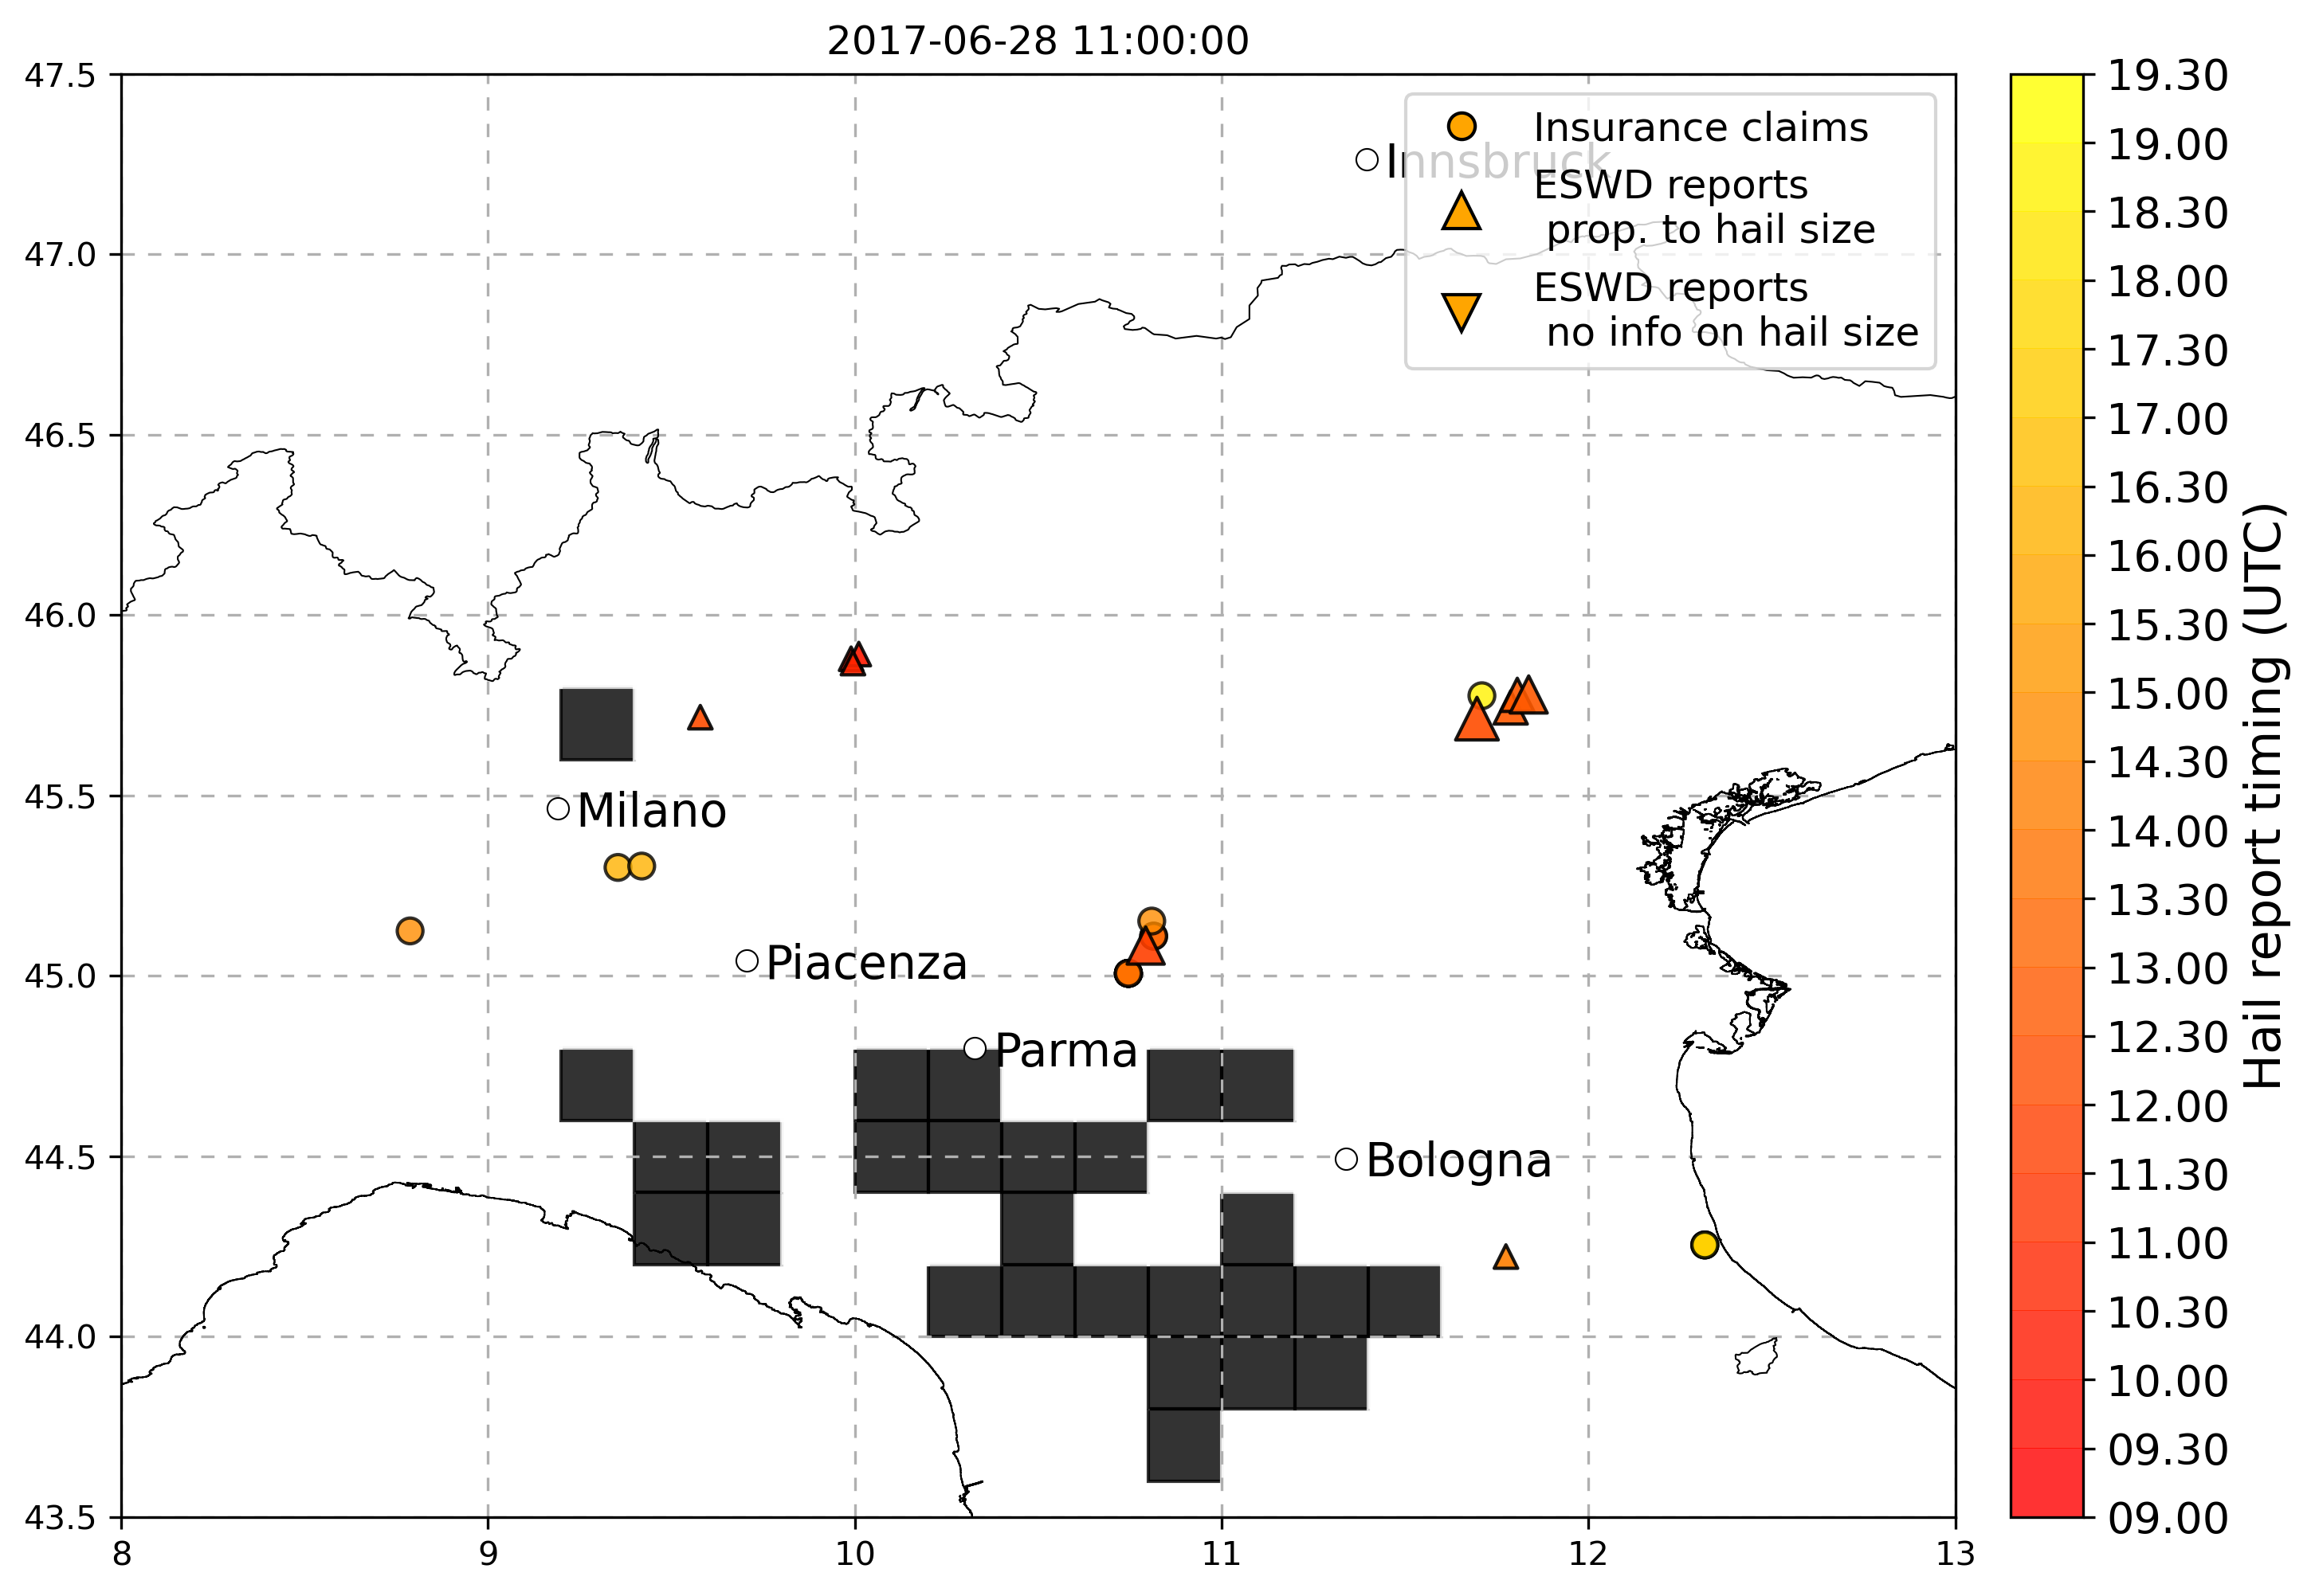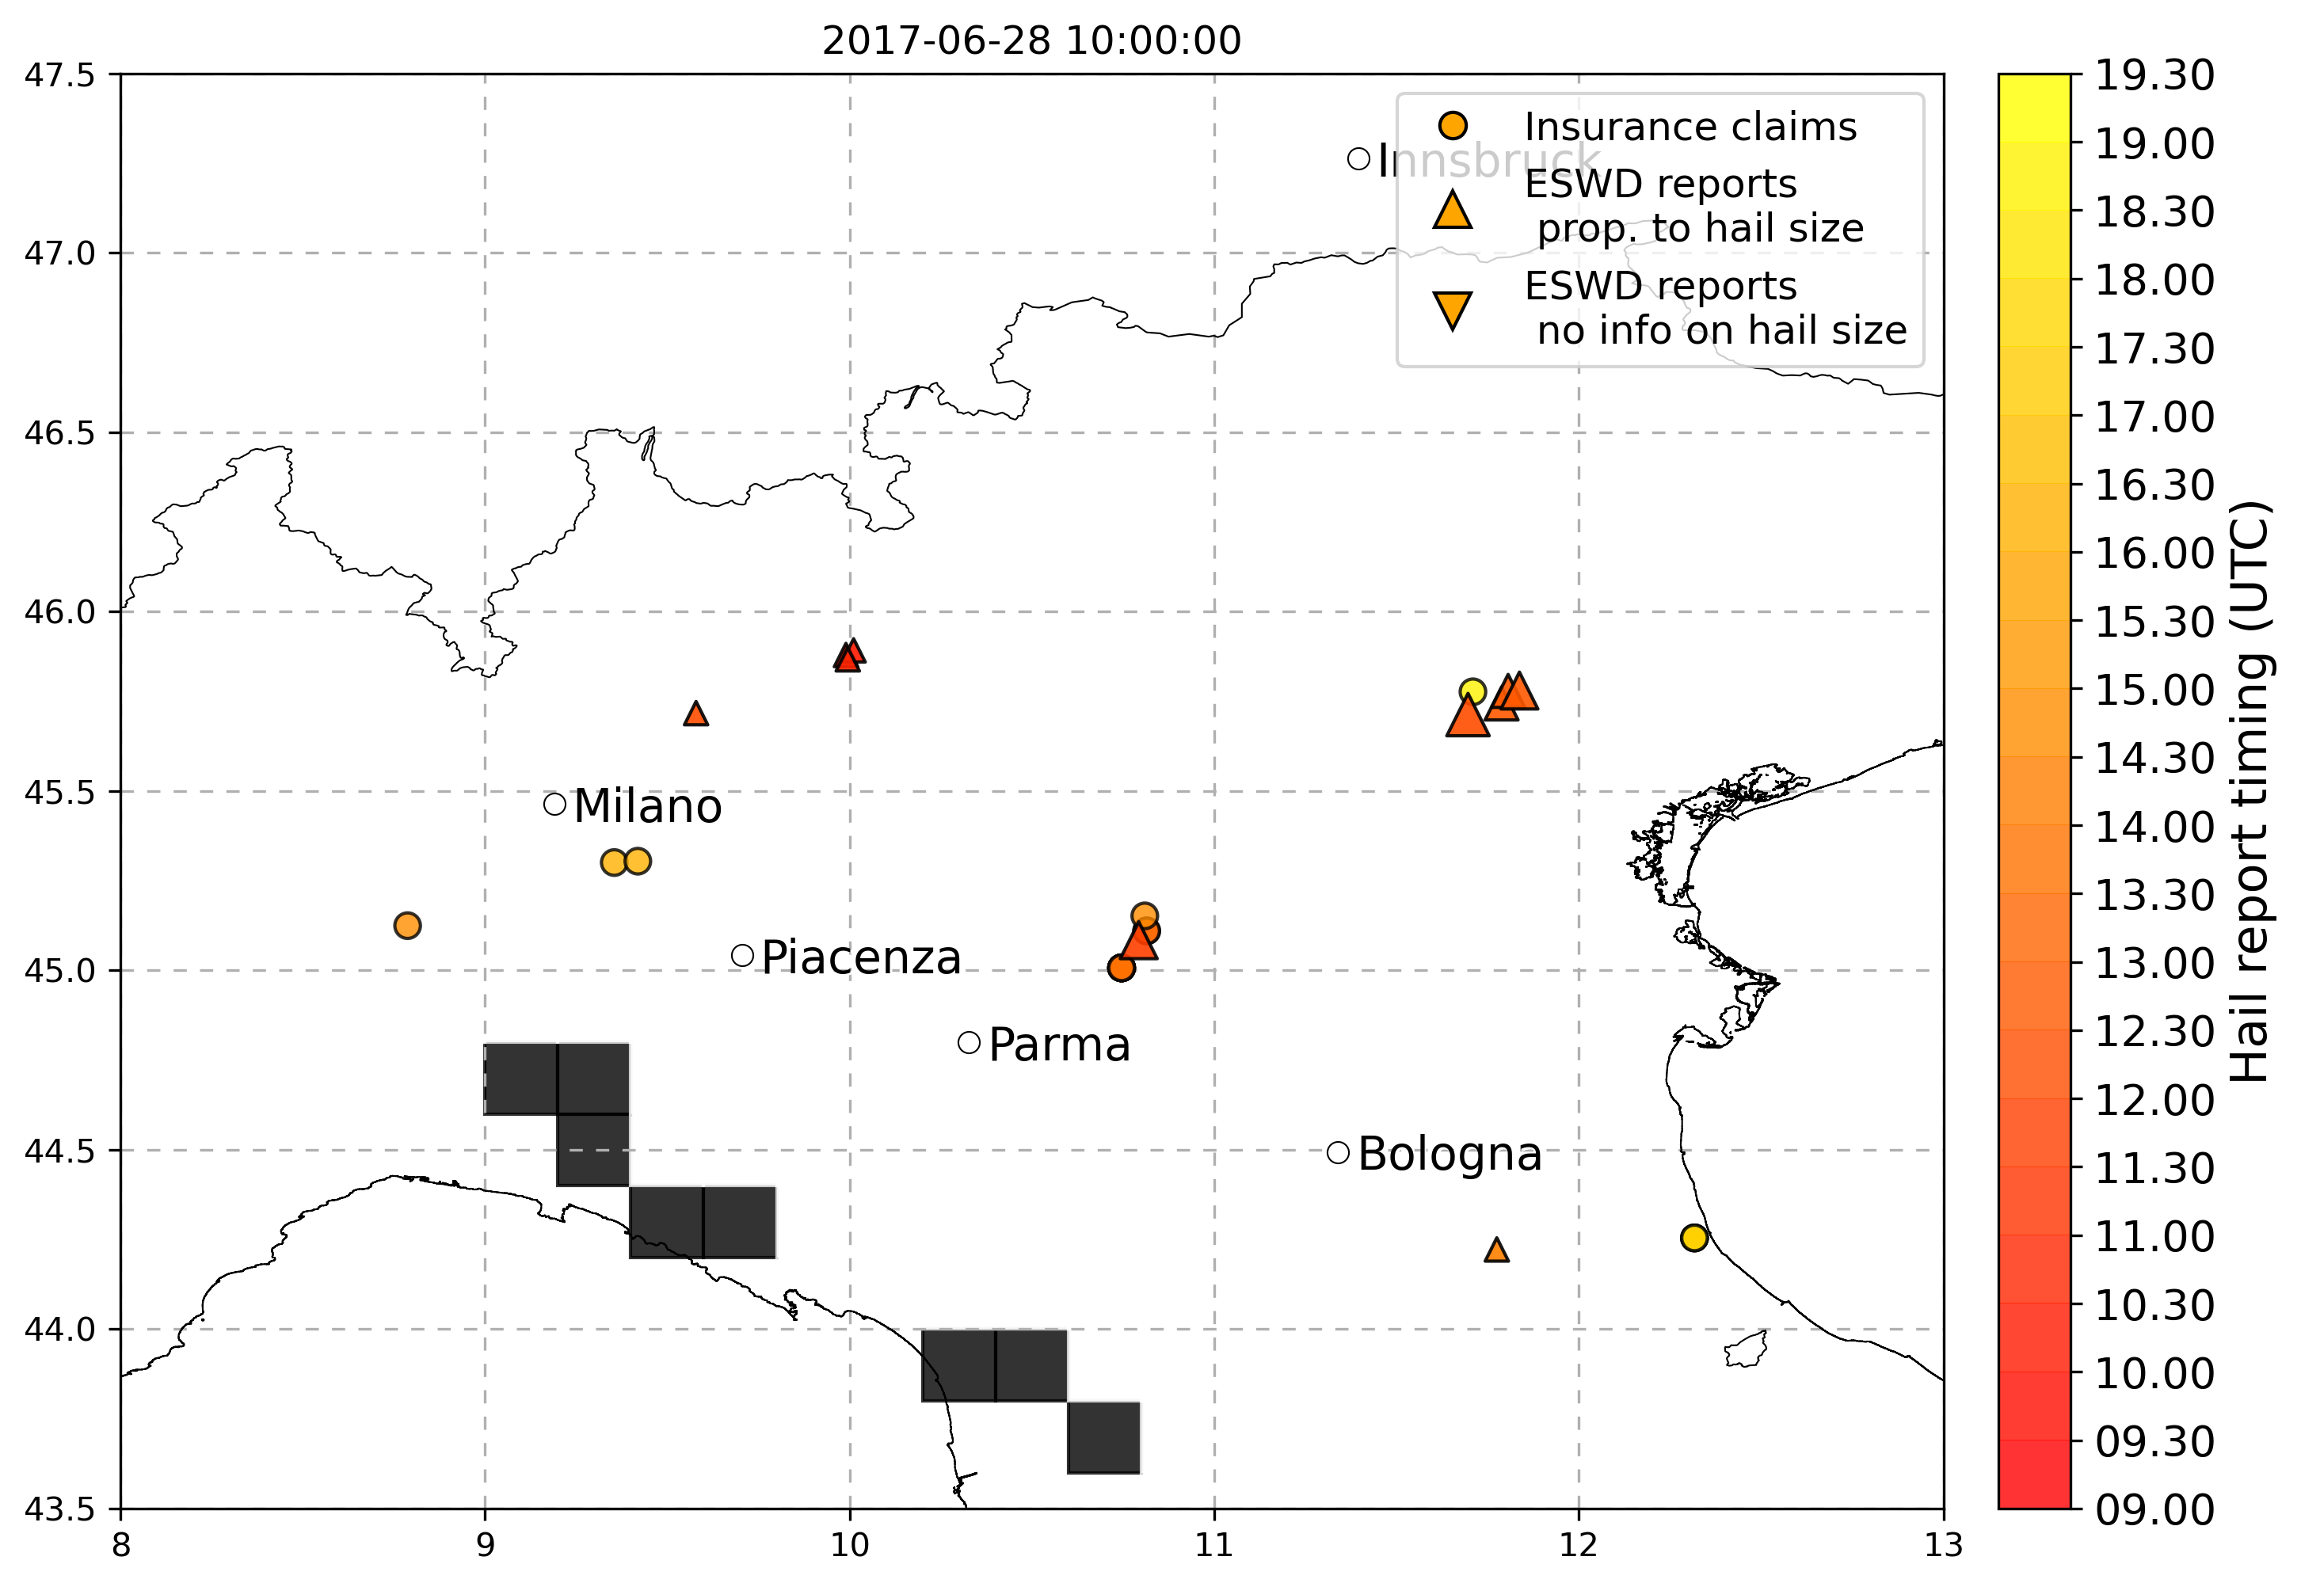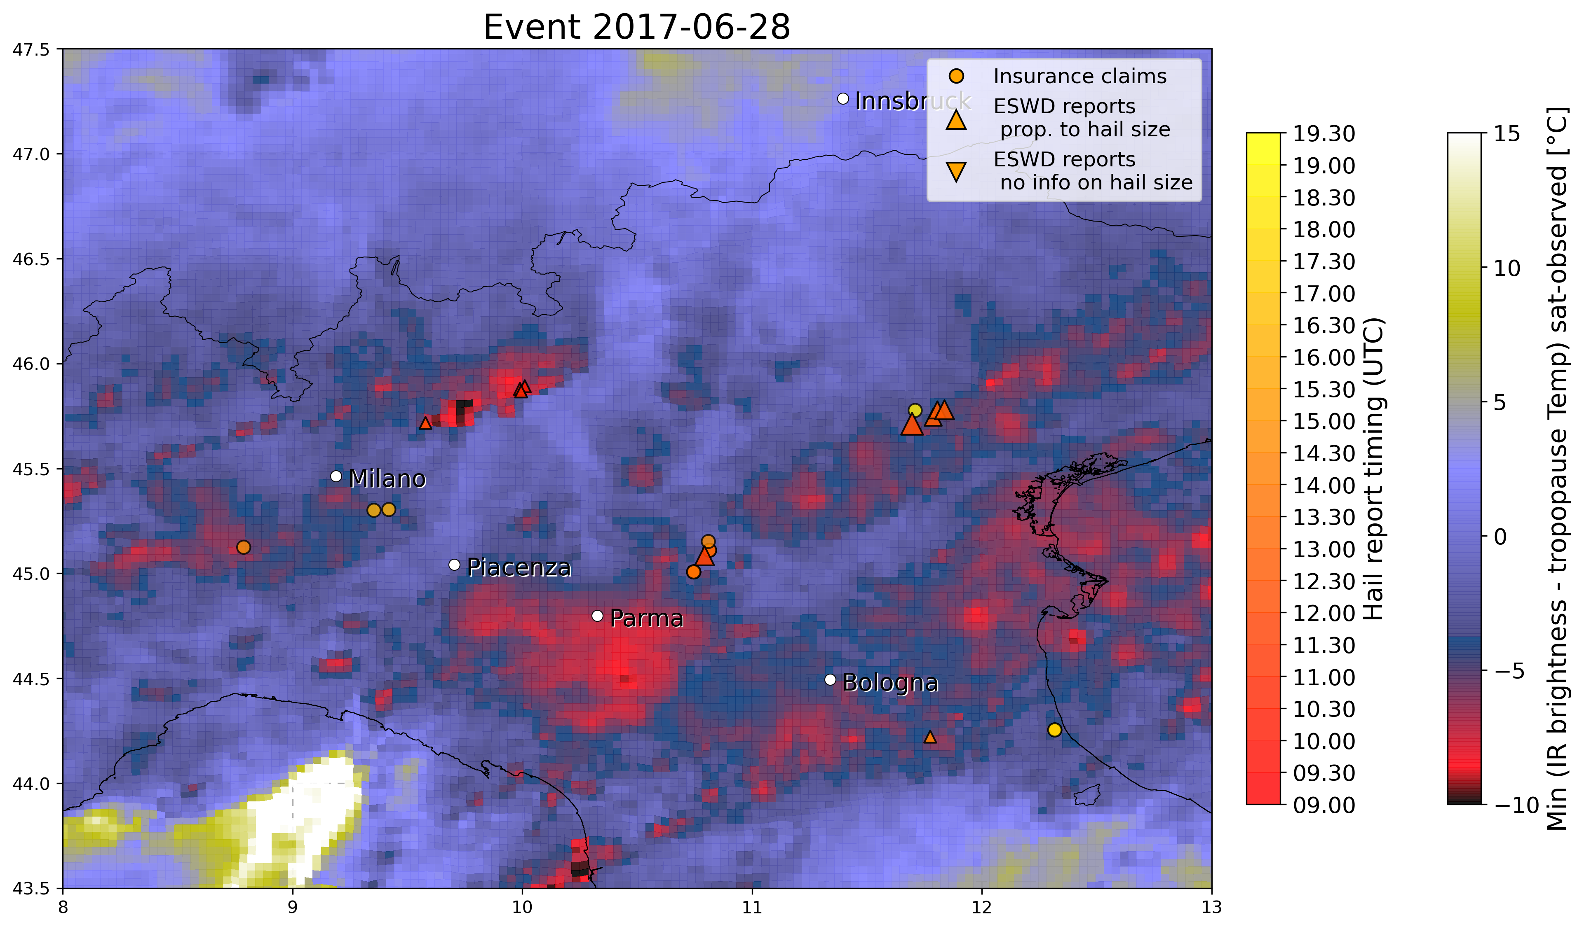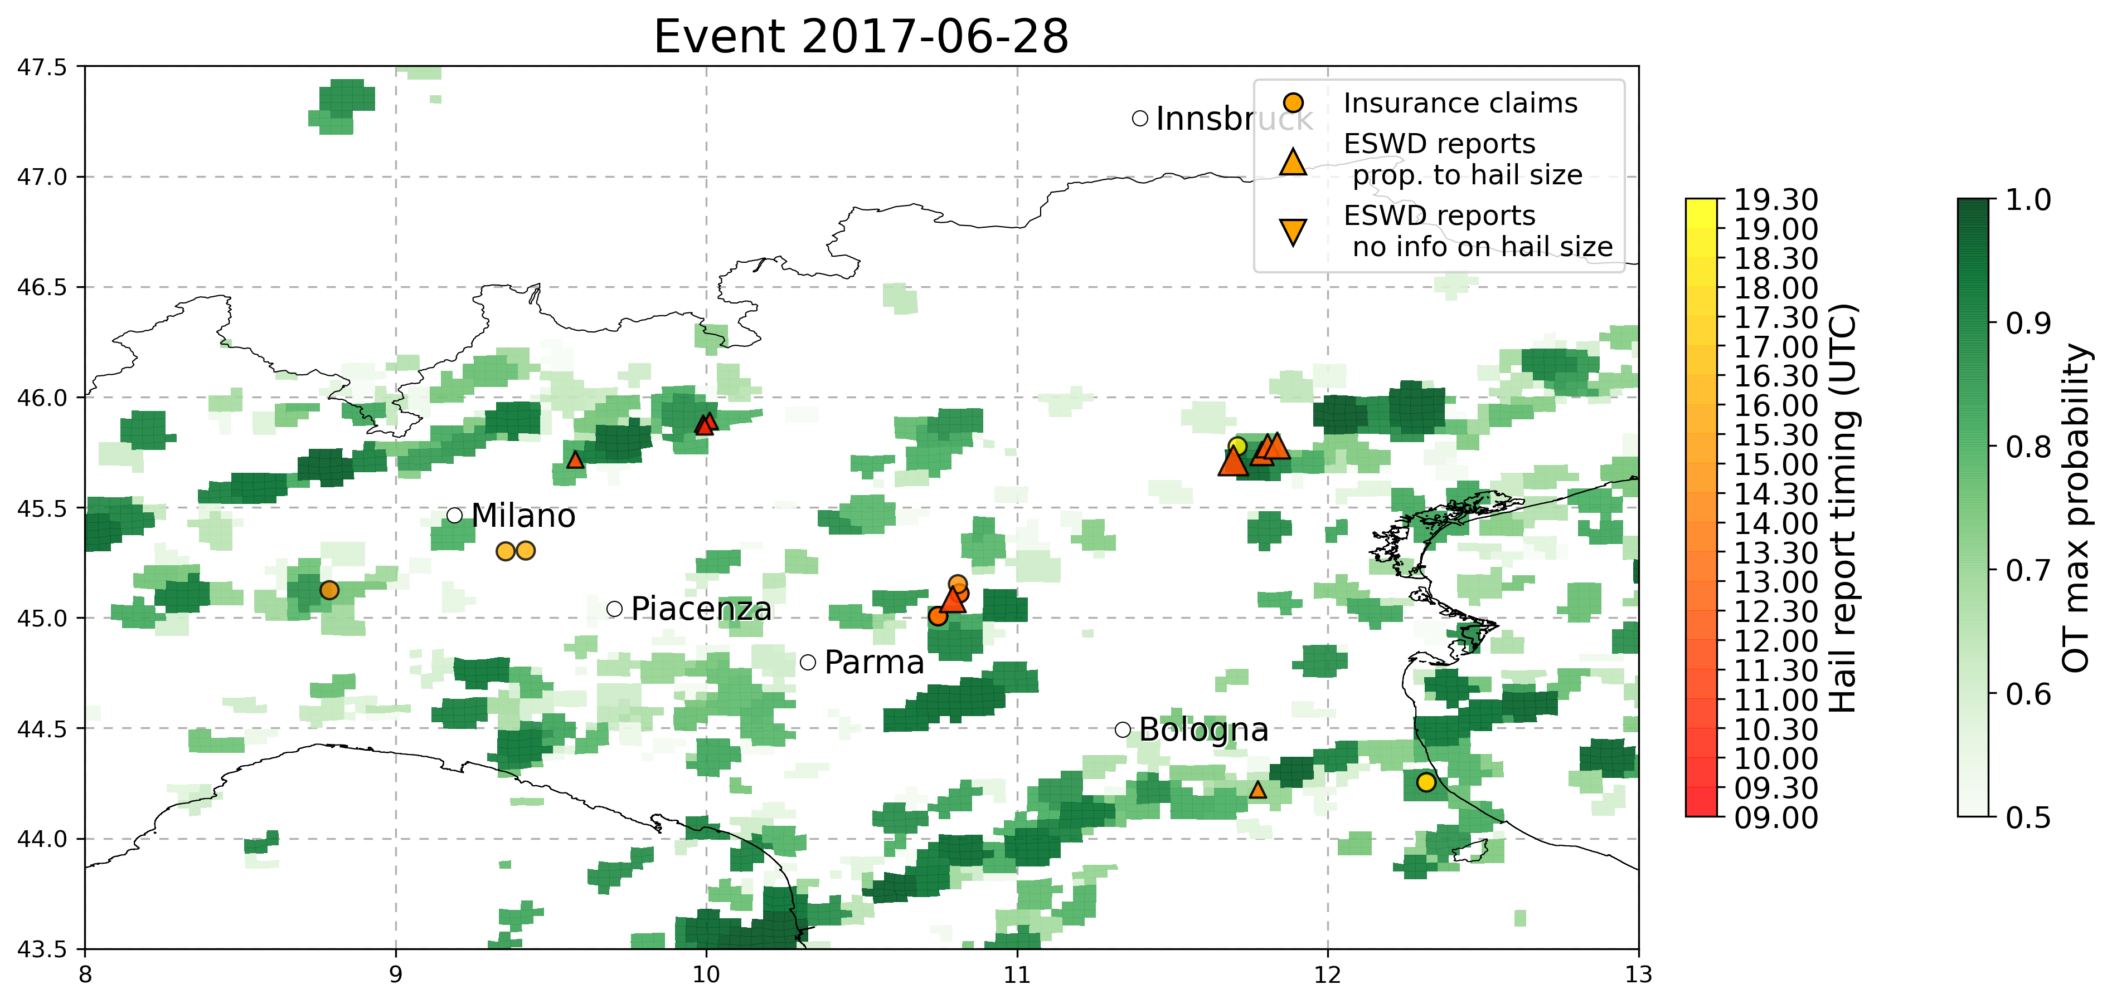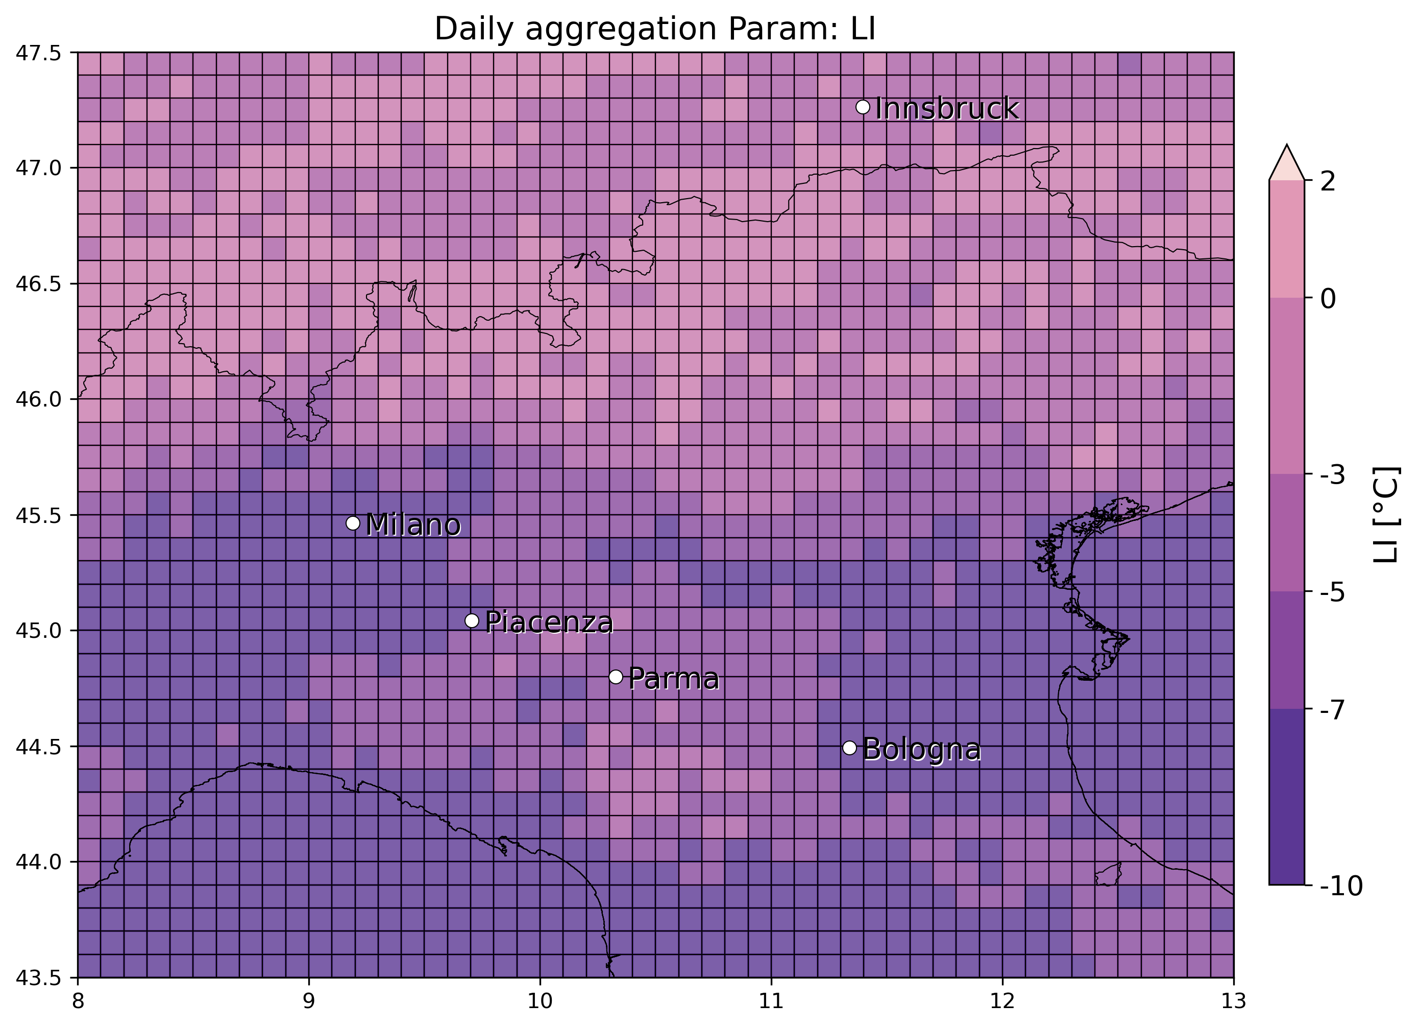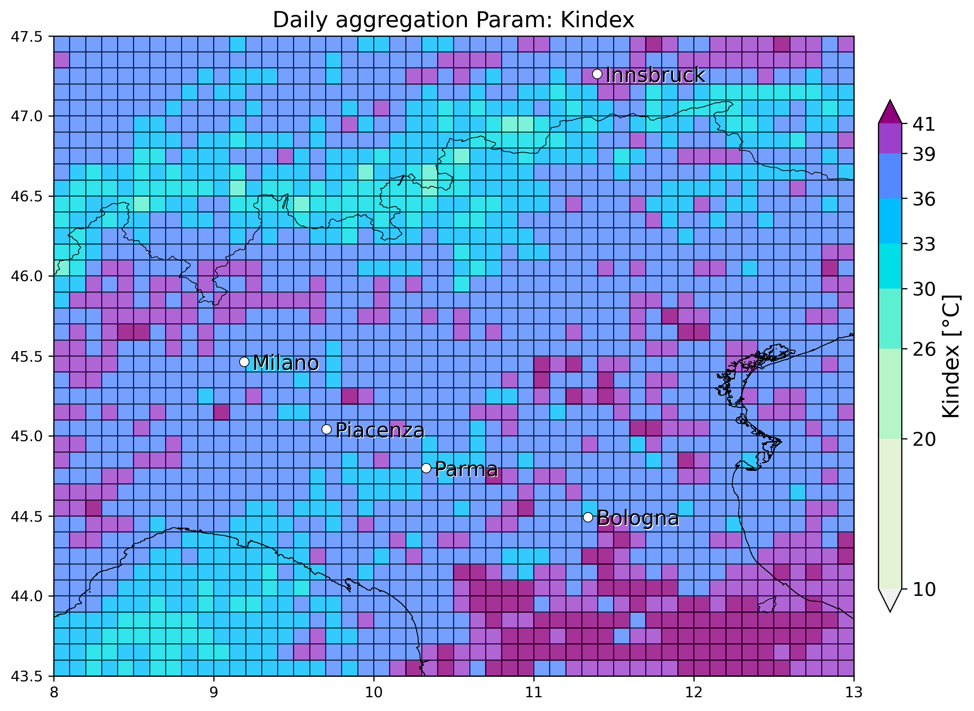

* 27 June 2017, Asti: 1 eswd (8cm) and some unipol reports, match with OT max prob and dTmin with unipol reports but miss eswd one, while very good agreement with LJ index. SPHERA reports a blob in LI/Kindex min/max daily values associated to the event, with significant match withKindex near the event location

